**Analysis of Selected Public Service Innovation 2022: Variety and Issues**

**Nurul Hasanah, Reza Fathurrahman**

University Indonesia, Indonesia

E-mail: nurul.hasanah24@ui.ac.id

* Correspondence: nurul.hasanah24@ui.ac.id

|  |  |
| --- | --- |
| **KEYWORDS** | **ABSTRACT** |
| Innovation; public service; KIPP | To satisfy society’s demands for effective and efficient public services, the Indonesian government through the Ministry of Administrative and Bureaucratic Reform encourages the development of innovation in the public sector by organizing Public Service Innovation Competition (KIPP, *Kompetisi Inovasi Pelayanan Publik*). In 2022, 3.487 innovations were registered to participate in the competition and 99 of the best innovations were selected from various public agencies. The content analysis results show that the types of innovation that won KIPP were dominated by process innovation. Meanwhile the goal of innovation is mostly to increase people’s satisfaction. Most of the innovations cannot be assessed for their outcome because the results of innovation remain at the output level. Half of the KIPP winning innovations have implemented innovation networks by collaboration with other stakeholders, while only 31.31% of innovations have been replicated. Public service innovation is still focused on process innovation and product innovation. In fact, public issues are not only on how individual people may receive services swiftly as possible but also how to empower people to solve more complex social issues. Governments often experience limited resources to address these problems. For this reason, collaboration is needed with non-government actors such as academics, society and the private sector in a network that is able to create innovative solutions. In addition, the government needs to increase the dissemination of worthy replicable innovations by innovation organizers in other regions. With efforts through the establishment of innovation networks and accelerated replication, public service innovations will not only reach short-term impact outcomes but long-term impact, sustainable and effective outcomes in solving public issues. |
|  |
|  | Attribution-ShareAlike 4.0 International (CC BY-SA 4.0)  **[https://jurnal.syntax-idea.co.id/public/site/images/idea/88x31.png](https://creativecommons.org/licenses/by-sa/4.0/)** |

**Introduction**

“Change or die” is a slogan often used by organizations as motivation to be adaptive in facing continuous and inevitable environmental changes. An organization as an open system must pay attention to environmental influences and determine strategies to deal with environmental uncertainty to survive in its environment (Lubis & Huseini, 2009). (Anderson & Anderson, 2002) classify the environment as an external factor that causes change while culture and organizational members as internal factors that encourage organizations to change. (Robbins & Judge, 2013) in more detail explain social trends of consumer demands for new services and products as environmental factor that requires organizations to dynamically follow environmental changes.

The demand to change and adapt to environmental changes is not only experienced by private organizations. Public organizations are also expected to continue to adapt to satisfy the society demands for excellent public service implementation. Technological advances and increasingly demanding needs are the cause of society’s high demands for effective and efficient public services (Rahayu, 2015). Therefore, public sector service innovation is inevitable.

Innovation is a form of change owning special characteristics, namely that it is a new idea or concept to improve the quality of products, processes, or services. Innovation in the public sector is considered a solution to complex problems in the social, political, and economic fields faced by public organizations (Korac, Saliterer, & Walker, 2017). The Indonesian government pays great attention to the development of public service innovation. As it is indicated from the enactment of Ministerial Regulation of Administrative and Bureaucratic Reform Number 30 of 2014 concerning Guidelines for Public Service Innovation which was later replaced by Ministerial Regulation of Administrative and Bureaucratic Reform Number 91 of 2021 concerning Development of Public Service Innovation. The regulation explains that the development of public service innovation is an attempt to realize bureaucratic reform in the public services. Public service innovation is expected to accelerate the improvement of the quality and performance of public services. The goal is to satisfy society’s expectations and demands for effective and efficient public services. In this regulation, public service innovation must be carried out by all ministries, institutions, local governments, BUMN (state-owned enterprise) and BUMD (regional-owned enterprise) through the Public Service Unit (UPP, *Unit Pelayanan Publik*) obliged to carry out public services. As proof of the government’s commitment in developing public service innovation, the Ministry of Administrative and Bureaucratic Reform has been organizing the Public Service Innovation Competition (KIPP) since 2014. KIPP is held as an event to award public service innovations considered new, effective, useful, easy to disseminate and sustainable.

This policy is welcomed by UPP throughout Indonesia, as proven by the increasing number of innovations registered to paticipate in the competition via the SINOVIK application (sinovik.menpan.go.id), a page prepared by the Ministry of Administrative and Bureaucratic Reform to coordinate the competition. Based on SINOVIK data, in 2014 the number of innovations registered to paticipate in the competition was only 515 innovations. This number continues to increase and in 2022 the number of innovations registered with SINOVIK to paticipate in the competition was 3.487 innovations.

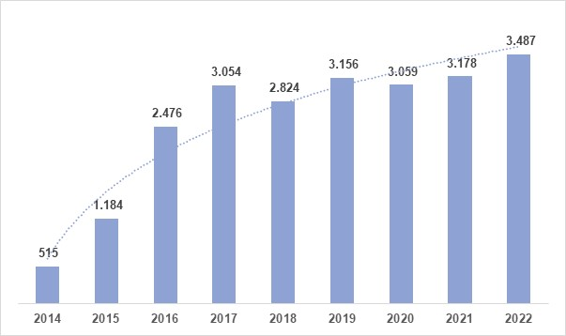

**Figure 1 Number of innovation registrants in SINOVIK application in 2014-2022**

Source: Book Top 99 Indonesian Public Service Innovations 2014-2022 by Ministry of Administrative and Bureaucratic Reform. Processed Data.

Every year since 2014 the Ministry of Administrative and Bureaucratic Reform has determined the 99 best innovations to receive awards, that in 2022, 891 innovations received awards as the best innovations. These figures indicate wide ranges of innovations in public services in Indonesia. However, studies on public service innovation in Indonesia mostly remain focused on specific case studies and technological innovations, thus they have not been able to provide an overall picture of the wide ranges of public service innovations in Indonesia(Elida, Listiyawati, Zain, Sasongko, & Alun, 2023) (Hartanti, Abawajy, & Chowdhury, 2022)(Muksin & Avianto, 2021)(Pratama, 2019)(Rachmawati et al., 2021)(Susilo, Hidayat, & Marta, 2021).

Innovation networks and innovation replication plays are important points in the development of public service innovation in Indonesia. Based on Ministerial Regulation of Administrative and Bureaucratic Reform Number 89 of 2020 concerning Implementation of Public Service Innovation Networks (JIPP, *Jaringan Inovasi Pelayanan Publik*), KIPP results must be disseminated to serve as references for innovation on a national scale. JIPP’s role is to disseminate selected innovations so as to encourage acceleration and replication of public services. Even though KIPP has been held since 2014, the number of JIPPs formed until 2021 has only reached 12 JIPPs with the number of new replications reaching 73 innovations (Deputy for Public Services, Ministry of Administrative and Bureaucratic Reform, 2022). This condition indicates that the government is not yet optimal in developing innovation networks and replicating innovations while these two issues are important factors in the successful implementation of innovations (Aspara, Hietanen, & Tikkanen, 2010)(Li, 2021)(Winter & Szulanski, 2001).

The discussion in this paper comprises of two sections. The first section discusses the variety of public service innovations in Indonesia and the second section discusses innovation problems in Indonesia in the context of innovation networks and innovation replication. The topic of the variety of public service innovations has been published by (Pratama, 2019) and (Muluk & Pratama, 2021). The first publication by Pratama (2020) uses KIPP data from 2014 to 2016 and then classified public service innovation into innovator dimensions, types of innovation, innovation outcomes, areas of innovation, and geographical perspectives. The second research by (Muluk & Pratama, 2021) uses KIPP data from 2014 to 2019 and focuses on analysis of innovation based on the innovators, namely ministries, institutions, BUMN/BUMD, and local governments. In addition to the analysis of innovation based on the type of innovator, this research also discusses the capacity gap and leadership as a challenge in making public service innovation a sustainable innovation.

This paper provides some novelty when compared to the two previously mentioned publications on a similar topic. The first novelty is reviewed from the analyzed KIPP period. The KIPP period derived is only 2022 in order to analyze deeper the public service innovation phenomena. In addition, KIPP 2022 was held 2 years after the publication of Ministerial Regulation of Administrative and Bureaucratic Reform Number 89 of 2020 concerning Implementation of KIPP thus the implementation of policies to build innovation networks and innovation replication can already be analyzed through innovations in 2022. In line with this, the second novelty in this paper is on the focus of the problem to be discussed. Public service innovation issues will be discussed from the context of policy networks and replication. This is important because the establishment of innovation network and innovation replication is one of the performance Indicators for the Ministry of Administrative and Bureaucratic Reform, especially the Deputy for Public Services and influences the success of innovation implementation (Aspara et al., 2010)(Winter & Szulanski, 2001).

**Research methods**

Before analyzing the variety of public service innovations in 2022, a mapping was first carried out on the innovation organizers. To find out the variety of public service innovations winning KIPP, content analysis was carried out using Nvivo 12 software to determine the type of innovation, innovation objectives and innovation outcomes. The KIPP winners analyzed were the winners in 2022 published by the Ministry of Administrative and Bureaucratic Reform in 2022 in the Book of Selected Public Service Innovation 2022. Of the 99 KIPP winners, content analysis was carried out to classify public service innovations under categories described by (Buchheim, Krieger, & Arndt, 2020) and (De Vries, Bekkers, & Tummers, 2016). Thereafter, the implementation of the innovation network and replication of innovations on the 99 innovations was analyzed in-depth. Analysis of types of public service innovation, innovation networks, and innovation replication was supported by literature studies through reviews and reviews of scientific journals, books, and reports supporting analytical sharpness.

**Results and Discussion**

***Variety of Public Service Innovations of KIPP 2022 Winners***

Before analyzing the variety of public service innovations in 2022, a mapping was first carried out on the innovation organizers. Innovation organizers in accordance with Ministerial Regulation of Administrative and Bureaucratic Reform Number 91 of 2021 concerning Development of Public Service Innovation are all government organizations obliged to carry out public service duties, namely BUMN, BUMD, provincial governments, regency governments, and ministries or institutions. Based on KIPP data from 2014 to 2022, the innovation organizers that dominate the KIPP award winners are regency governments. In 2014, 28 innovations (28.28%) of KIPP winners were innovations originating from regencies. This number increased until in 2022 48 innovations from regencies became KIPP winners. The number of local governments government innovation organizers who won in KIPP indicates that local governments government efforts to realize community welfare through improving public services deserve to be appreciated. In addition, local innovation also plays an important role in empowering local communities and increasing local competitiveness in accordance with Government Regulation Number 38 of 2017 concerning Regional Innovation. Pratama (2020) considers the phenomenon of domination of KIPP winners by local governments as innovation organizers to be normal. Local governments are the spearhead of public service policy implementation. Local governments have greater opportunities to identify public service problems more quickly thus the innovations created are expected to be able to become effective and efficient solutions and encourage active community participation (Biljohn & Lues, 2020). For this reason, local governments must have the capacity to create and adapt innovations to increase public trust (Muksin & Avianto, 2021).

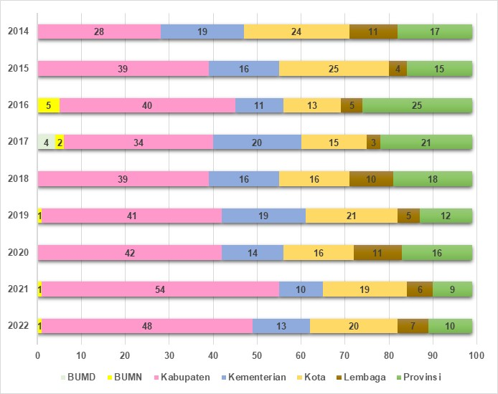

**Figure 2 KIPP 2014-2022 winners based on innovation organizers.**

Source: Book Top 99 Indonesian Public Service Innovations 2014-2022 by Ministry of Administrative and Bureaucratic Reform. Processed Data.

Based on data on the distribution of innovation origins, most innovations still come from local governments on Java Island, namely 44 innovations (56.41%) out of a total of 78 innovations carried out by provincial, regency and city governments. This condition has not changed since 2014 (Pratama, 2020). This condition indicates a capacity gap of public employees in carrying out innovation (Muluk & Pratama, 2021). One of the reasons for the capacity gap is the difference in infrastructure where Java Island is where the capital of Indonesia is located thus development on Java Island is relatively more advanced compared to other islands (Kusumasari, Pramusinto, Santoso, & Fathin, 2019). This argument is strengthened by (Pradana, Susanto, & Kumorotomo, 2022) which states that local governments on Java Island have better budget resources and human resource capacity compared to local governments outside Java Island.

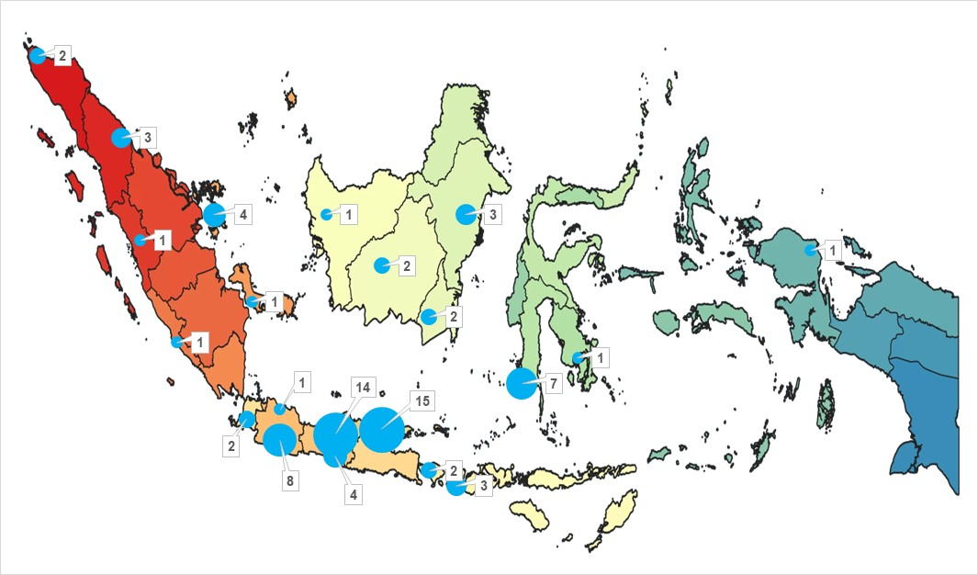

**Figure 3 Distribution of KIPP Winning Innovations by Local Government in 2022**

Source: Book of Selected Public Service Innovation 2022 by Ministry of Administrative and Bureaucratic Reform. Processed Data.

The variety of public service innovations of KIPP 2022 winners based on the analysis results is as follows:

**Table 1 Variety of public service innovations of KIPP 2022 winners**

| **Variety** | **Dimension** | **Total** |
| --- | --- | --- |
| Type of innovation | Process | 39 |
| *Technological process* | *25* |
| *Administrative process* | *14* |
| Products or Services | 31 |
| Governance | 27 |
| Conceptual | - |
| Other | 2 |
| Innovation Goal | Improving effectiveness | 8 |
| Improving efficiency | 1 |
| Solving social problems | 25 |
| Increasing community satisfaction | 47 |
| Involving citizen | 18 |
| Involving private partnership | - |
| Innovation Outcome | Improved efficiency | - |
| Improved effectiveness | 2 |
| Private sector involvement | - |
| Community involvement | 13 |
| Increased community satisfaction | 6 |
| Other | 16 |
| Output | 62 |

The type of innovation most frequently found is process innovation, with 39 innovations consisting of 25 technological process innovations and 14 administrative innovations. (Walker, 2014) summarizes the definition of process innovation as innovation in how a service is provided. Furthermore, (Walker, 2014) also states that process innovation results in changes to the procedures, relationships between organizational members, and governance. In process innovation, new products or services are not produced but the focus is how to improve existing processes to increase efficiency. This is what differentiates process innovation from product innovation.

A total of 25 process innovations identified are technological process innovations. Process innovation occurs within an organization (Prajogo, 2016) and is often identified with the use of information technology to shorten delivery times, increase operational flexibility, and reduce production costs (Nanseki, 2023; Walker, 2014). The technological process innovation identified in the KIPP 2022 winners is changing services initially carried out manually into online-based services. For example, GELIS application by the Sukoharjo Regency Government which provides online library services to maintain the number of library visits during the Covid-19 pandemic, Pantai Balikpapan Application by the Balikpapan City government which provides online population services, and Taspen Pesona application by PT. Taspen Persero to authenticate biometric data for disbursement of Taspen funds. The use of technology in these innovations is carried out to expedite the public service process, expand access to information to the public, and expand the reach of public services.

Administrative process innovation refers to the creation of new ways, methods and forms in performing tasks within the organization. This innovation is closely related to redesigning operational routines (Cinar, Simms, Trott, & Demircioglu, 2022) .Administrative process innovation is characterized by the formation of new organizational structures impacting the business process implementation, work method renewal, and innovative management. Examples of administrative process innovations identified in the KIPP 2022 winners are Gempur Jatim by BPOM (National Agency of Food and Drug Control) which simplifies the process of obtaining POM marketing authorization, Lumbung Pangan Reborn by the Grobogan Regency Government which enhances the function of food barns into zakat collection units, and Posterling by the Bandung Regency Government in the form of animal inspections periodically where animal health officers periodically visit farmers to check the health condition of the livestock.

Product or service innovation is the second most innovation type. In contrast to process technology which is the development of existing work methods, product innovation creates new services (Adjei‐Bamfo, Djajadikerta, Jie, Brown, & Kiani Mavi, 2023). These two innovations often overlap as product innovation is usually accompanied by process innovation that occurs within the organization (Belezas & Daniel, 2023). Examples of identified service innovations are Peduli Lindungi Application as a support for handling Covid-19, Floating Hospital by Airlangga University, and SI KATAM Terpadu-SC by the Ministry of Agriculture (Lanin & Hermanto, 2019).

**Innovation Goal**

The most frequently identified innovation goal is increasing community satisfaction, namely 47 innovations (47.47%). Oliver (2014) in states that community satisfaction is an important indicator for measuring service quality. Improving service quality may increase public trust in the government. The use of technology in public service innovation improves the quality of information, service quality, system quality, and the benefits of public service products (Fathya, Viverita, Hati, & Astuti, 2022). In the description of KIPP 2022 winners’ innovation, increasing community satisfaction is carried out, among others, by simplifying service procedures, reducing service time, and expanding service access through service digitization.

**Innovation Outcome**

Output and outcome are indicators that can be used to measure performance. Output in public service is a service or program resulting from a government activity while outcome is the desired impact of a public service in the form of social reactions and changes that occur in society. In addition, output is related to efficiency while outcome is related to effectiveness (Bleyen et al., 2017; Walters et al (2018) in Dal Mas et al., 2019).

The Public Service Innovation Center for Administrative Institutions uses the output and outcome as indicators of the Public Service Innovation Perception Index (IPIPP, *Indeks Persepsi Inovasi Pelayanan Publik*). The output aspect is measured by the novelty and productivity dimensions while the outcome by the impact and sustainability dimensions. Based on the output and outcome criteria from the references above, 62 innovations (62.62%) cannot be categorized as outcomes but still as outputs, namely providing new services, improving existing services, improving service quality, and simplifying service processes.

**Innovation Network and Replication**

Stakeholder adaptability and collaboration aspects are assessed in the KIPP 2022 with weights of 20% and 5%. Adaptability relates to whether the innovation has been adapted, replicated, or adjusted and implemented by UPP or other agencies. Stakeholder collaboration is the involvement of actors other than UPP involved and contributing in designing, implementing and evaluating the innovation implementation (KemenpanRB, 2022). To meet these criteria, public service innovations should have been implemented for a minimum of 2 years in the categories of inclusive and fair public services and effectiveness in achieving SDG. As for innovations in the handling Covid-19 category, innovations should have been implemented for at least 1 year.

Of the 99 KIPP winners in 2022, 68 innovations (68.69%) have not been replicated and 50 innovations (50.51%) are implemented without collaboration. Replication is identified by innovation implementation in other UPPs and comparative studies by UPPs or other agencies to locations where the innovation is implemented. The collaboration identified is a collaboration between UPP innovation organizers and other government agencies, the public, community groups, universities and the private sector.

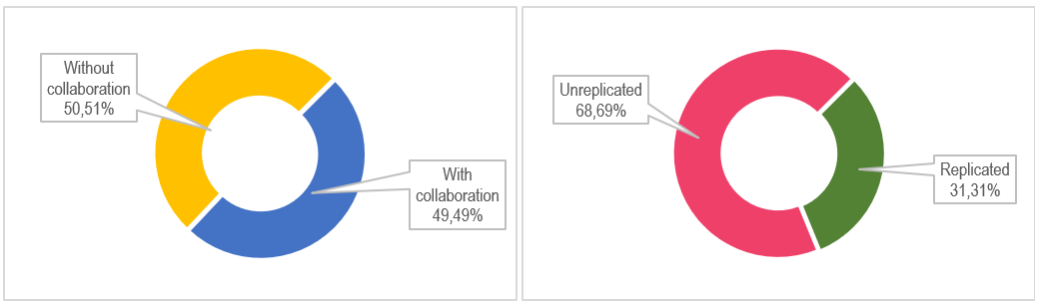

**Figure 3 Percentage of Stakeholder Collaboration (left) and Innovation Replication (right) of KIPP 2022 winners**

Source: Book of Selected Public Service Innovation 2022 by Ministry of Administrative and Bureaucratic Reform. Processed Data

Public service innovation is still focused on process innovation and product innovation. In fact, public issues are not only on how individual people may receive services swiftly as possible but also how to empower people to solve more complex social issues. Governance innovation is a type of innovation potential to be developed in solving these issues. According to Moore & Hartley (2008) there are 5 characteristics of governance innovation that distinguish it from other types of innovation, namely:

1. Governance innovation breaks the boundaries of organizational control over any particular issue by inviting other actors to participate in solving an issue.
2. Governance innovation may potentially mobilize resources that have not previously been fully exploited to satisfy public needs.
3. Through governance innovation, the government can use its capacity and authority to gather, encourage, mobilize, and even force the private sector to contribute to providing public services.
4. Governance innovation provides opportunities for private parties to assume some of the government’s obligations in providing public services. Thus, the type of public service can be adapted to the community needs, notwithstanding strict control by government authorities.
5. Governance innovation with the involvement of other non-government actors is carried out on normative framework basis that allows evaluation in terms of honesty, fairness, impact on society, efficiency and effectiveness.

In 2022, 27 innovations fall under the type of governance innovation. In accordance with the criteria provided by Moore & Hartley (2008). These innovations do not directly provide services to the community as process innovations and technological innovations but are more focused on solving social problems. For example, EKO-TREN innovation by the East Java Provincial Government. This innovation aims to improve the welfare of the community around 550 Islamic boarding schools in East Java Province through job creation and business improvement. In its implementation, EKO TREN involves pentahelix collaboration, namely the East Java Provincial Government, academics, media, the private sector, and society. In March 2023, EKO TREN succeeded in creating jobs for 4.125 people and reduced the number of poor people by 13.240 people. This innovation has been replicated by 8 other regencies/cities. From EKO-TREN innovation we can see that governance innovation has a long-term impact on society. Through the actors involved, more resources are available to address community issues to make a wider impact.

One of the KIPP 2022 categories is the effectiveness of public institutions in achieving Sustainable Development Goals (SDGs). SDG is divided into 4 pillars, namely social development, economics, environment, and law and governance. These four pillars are translated into 17 sustainable development goals. These goals are important issues that have not yet been resolved. However, unfortunately, the Ministry of Administrative and Bureaucratic Reform only gives an assessment weight of 5% for the contribution of innovation to SDG achievements.

Sustainable development issues are complex issues. The government certainly has limited resources to overcome all existing issues. For this reason, an innovation network involving actors other than the government is necessary. Based on existing data, only 49 innovations (49.49%) involve government and non-government actors in their implementation. Even though the government has established regulations regarding JIPP, a network that synergizes government agencies, academics, community institutions and the private sector to develop innovation. However, the complicated and highly hierarchical structure and mechanisms of JIPP appear to be an obstacle in the formation of innovation networks, especially at the regional level.

Torfing (2019) explains that a rigid and hierarchical government structure is one of the factors that hinders the innovation development. The hierarchical structure of government institutions grants authority to a group of decision makers to design solutions deemed appropriate in resolving an issue. However, these decisions may not be on target as they rely too much on their own ideas and therefore do not gain knowledge that emerges from interactions with relevant actors. Collaborative innovation through innovation networks opens public bureaucracy by involving various public and private actors to solve issues creatively.

The existence of innovation network is an absolute requirement for economic innovation (Klijn & Koppenjan, 2012). Hartley (2005) and Considine et al. (2009) in Klijn & Koppenjan (2012) state that innovation networks in collaborative innovation in the provision of public services is one of bureaucratic reform. Thus, it is necessary to identify principles and strategies for innovation network governance in order to accelerate the implementation of public service innovation. Hurmelinna-Laukkanen et al. (2021) use the term network orchestration to explain coordination by actors involved in innovation networks. Within the scope of network orchestration of public service innovation, the government is referred to as the orchestrator, namely the party that regulates and facilitates the actors in the innovation process. Matters that must be considered by the government as an orchestrator to optimize the function of the innovation network, namely (Hurmelinna-Laukkanen et al., 2021):

1. Agenda setting. Agenda setting is a tool for orchestrator to communicate the innovation goals and process to be understandable by the actors involved.
2. Mobilization. Through mobilization, orchestrator motivates various actors to join and contribute by demonstrating the benefits of future cooperation. If the values and goals held by the actors involved in the innovation network are in line with the values and goals of the orchestrator, the mobilization is easier to carry out.
3. Network stabilization. Stabilization in innovation networks is related to building shared culture and values. This really requires the involvement of actors other than the government, including voluntary involvement.
4. Creation and transfer of knowledge. Creation and transfer of knowledge paves the way for actors to share knowledge to create new knowledge in the form of innovation.
5. Coordination. Coordination combines all innovation development activities, namely defining the tasks and roles of each actor, the timeline for the innovation implementation, and the innovation evaluation. The main issue as the focus of coordination is managing innovation coherence and aligning innovation processes and outputs.

From the government perspective as the party responsible for providing public services, Li (2021) describes 6 strategies that can be carried out by the government in encouraging collaborative innovation, namely:

1. Participating/collaboration: The government as the party holding the authority to provide public services ensures that the actors involved in the innovation network share knowledge, expertise, information and other resources in the innovation process.
2. Managing interaction: The government facilitates interaction between actors involved in innovation.
3. Sponsoring resources: The government provides the necessary resources, especially in the form of funding to trigger the emergence of new innovations, implementation and development of innovations.
4. Establishing vision: The government determines the innovation goals and the desired impact of the innovation to direct the actors involved towards the innovation goals achievement.
5. Diplomacy: The government connects innovations created by innovation networks with the society needs.

In innovation network, various actors with different resources and skills interact and collaborate with one another to facilitate the emergence and use of innovations. However, with so many actors involved, innovation implemented through innovation network is not an easy thing. The key to success is effective coordination and organization of innovation actors. The government as the orchestrator holding the authority to regulate innovation development must play a balanced role in regulating and facilitating innovation networks. Extremely strict structures and settings will hinder collaboration in developing innovation. On the other hand, weak control from the government will pose a risk of not achieving the goal of collaborative innovation to improve the quality of public services.

Some literature uses the term collaborative innovation to explain the involvement of non-government actors in implementing innovation. Callens (2023) states that collaborative innovation is the involvement of non-government actors such as private companies, non-profit organizations, and the public in creating public service innovations of better quality than previous services. The involvement of non-government actors in public service innovation is necessary due to the limited resources owned by the government and the government’s inability to cope with the increasing demands of society. In line with this, Lopes & Farias (2022) states that interaction between actors involved in innovation increases the effectiveness of innovation implementation in solving public service issues. With the various actors involved, the success of the innovation network is influenced by new perspectives and ideas presented as alternative solutions, interactions and agreements of the actors involved, and commitment to implementing the innovation (Callens & Verhoest, 2023).

The replication of KIPP 2022 winners innovation has only reached 31.31%, which is another issue that needs the government’s attention. Based on the Performance Report of the Deputy for Public Services of the Ministry of Administrative and Bureaucratic Reform in 2021, there are 2 obstacles that cause a low rate of innovation replication by local governments. The first obstacle, innovation replication is something that is unfamiliar and difficult to understand. The second obstacle is the limited budget to implement innovation. In accordance with the results of research by Dimand (2022), the level of innovation adoption, especially by local governments, is influenced by organizational characteristics and resource capacity. Organizational characteristics include the vision and budgeting system while resource capacity relates to the extent to which the organization is familiar with new concepts in the innovation. Replication is considered difficult as it is considered to be the repeated use of an existing innovation. In fact, replication does not mean imitating the whole but can also be considered as modification taking into account the ability to implement innovations and the suitability of the innovations with the conditions of society. These considerations need to be made because even though innovation is replicated, the results obtained may differ depending on the policies employed by the government (Sandfort & Moulton, 2020).

Innovation is something new. Replication is a strategy that involves exploration and the capability to find new models and determine the appropriate components to be implemented according to the conditions in which the innovation is implemented. For this reason, replicating innovation requires a lot of effort and time (Winter & Szulanski, 2001). Budget limitation is one of the obstacles in replicating innovation. Involving other actors through innovation networks may overcome this condition. The involvement of other actors in the innovation implementation provides opportunities of other available sources of budget besides the government budget. Apart from implementing innovation networks, the limitations of replication can be overcome by developing the adaptive capabilities of the innovation replication implementers (Greenhalgh & Papoutsi, 2019). Implementers of innovation replication must be trained to build capacity to develop existing innovations and not just follow existing conditions through the development of creative culture (Vickers et al., 2017). Not only from the innovation replication implementer factor, but an innovation with high replication rate is also a compatible, affordable, beneficial and triable innovation. (Arshi et al., 2021).

In the context of innovation replication in the public sector, United Nation (2006) explains that the replication process is a form of innovation transfer. This implies the transfer of ideas, knowledge, skills, and lessons learned from the implementation of an innovation. This description concludes that the important point of replicating innovation is not transferring innovation but the idea behind an innovation. Innovation is basically a change so the capacity to adapt, anticipate and be open to change is needed to realize innovation replication. Kartika (2022) explains the factors that public organizations need to consider before deciding whether an innovation is replicable. These considerations are the impact of innovation on the region where the innovation is implemented, the suitability of the innovation with the region potential and characteristics, the complexity of replication, and legal support for the innovation implementation. Apart from these considerations, Rippetoe & Rogers (1987) in Prabowo et al. (2022) states that innovation replication as a form of innovation acceptance is influenced by relative superiority, compatibility, complexity, triability and observability.

Based on the output and outcome criteria from the references above, 62 innovations (62.62%) cannot yet be categorized as outcomes but remain as output. Sanderson (1996) states that innovations that remain oriented towards increasing the number of people served, increasing state revenues in the form of taxes, reducing the duration of service, and improving the community health status are innovations at the output level. These 62 innovations have not had a long-term impact on the existing issues thus they cannot be classified as innovations that have provided outcomes. 37 other innovations have provided outcomes in the form of increasing community satisfaction scores with services, community empowerment, solving environmental issues, and increasing community income (Sanderson, 1996).

Public service innovations oriented towards improving the quality of public services should be appreciated. In accordance with Law Number 25 of 2009 concerning Public Services, the scope of services provided by the government to the public is not limited to administrative services but also goods and services. This is reinforced by Ministerial Regulation of Administrative and Bureaucratic Reform No. 89 of 2020 concerning JIPP and Ministerial Regulation of Administrative and Bureaucratic Reform No. 7 of 2021 concerning KIPP that public service innovation is not only about administrative services that provide direct benefits but also indirect services. Public service innovations that only focus on administrative services, if it is not developed, will only reach the outcome level and are potentially unsustainable (Dal Mas et al., 2019).

**Conclusion**

The Indonesian government through the Ministry of Administrative and Bureaucratic Reform pays great attention to the development of public service innovation. This attention is manifested by holding KIPP event, one of the objectives of which is to give appreciation to innovation organizers, either ministries, institutions and local governments. This competition has proven to increase enthusiasm for the development of public service innovation as evidenced by the increasing number of innovations registered to participate in KIPP from year to year.

Enthusiasm for creating innovations is extremely high even though the innovations produced are still output oriented. While yet ideal, this condition deserves appreciation where the innovation organizers have tried to improve the quality of services in the administrative field whose impact can be enjoyed directly by the community as service users. In the future, innovation development should be more oriented towards solving social issues in society. Issues related to education, poverty, and the environment are complex issues. Governments often experience limited resources to address these issues. For this reason, collaboration is needed with non-government actors such as academics, society, and the private sector in a network capable to create innovative solutions.

A good innovation is an innovation with a high degree of adaptability and replication. Innovation replication is not limited to “doing the exact same thing” but can also be done by modifying innovations corresponding to local conditions. The government needs to increase the dissemination of worthy replicable innovations by innovation organizers in other regions. One form of activity that can be carried out is by exhibiting the best innovations that have been selected from the previous KIPP. With efforts through the establishment of innovation networks and accelerated replication, public service innovations will not only reach short-term impact outcomes but long-term impact, sustainable and effective outcomes in solving public issues.

**Bibliography**

Adjei‐Bamfo, Peter, Djajadikerta, Hadrian Geri, Jie, Ferry, Brown, Kerry, & Kiani Mavi, Reza. (2023). Public procurement for innovation through supplier firms’ sustainability lens: A systematic review and research agenda. *Business Strategy and the Environment*, *32*(1), 387–407.

Anderson, Dean, & Anderson, Linda Ackerman. (2002). *Beyond change management: Advanced strategies for today’s transformational leaders*. John Wiley & Sons.

Aspara, Jaakko, Hietanen, Joel, & Tikkanen, Henrikki. (2010). Business model innovation vs replication: financial performance implications of strategic emphases. *Journal of Strategic Marketing*, *18*(1), 39–56.

Belezas, Fernando, & Daniel, Ana Dias. (2023). Innovation in the sharing economy: A systematic literature review and research framework. *Technovation*, *122*, 102509.

Biljohn, Maréve Inge Madlyn, & Lues, Liezel. (2020). Citizen participation, social innovation, and the governance of local government service delivery: findings from South Africa. *International journal of public administration*, *43*(3), 229–241.

Buchheim, Laurin, Krieger, Alexander, & Arndt, Sarah. (2020). Innovation types in public sector organizations: a systematic review of the literature. *Management Review Quarterly*, *70*, 509–533.

Cinar, Emre, Simms, Christopher, Trott, Paul, & Demircioglu, Mehmet Akif. (2022). Public sector innovation in context: A comparative study of innovation types. *Public Management Review*, 1–29.

De Vries, Hanna, Bekkers, Victor, & Tummers, Lars. (2016). Innovation in the public sector: A systematic review and future research agenda. *Public administration*, *94*(1), 146–166.

Elida, Sri Syabanita, Listiyawati, Lilis, Zain, Desvira, Sasongko, Agus Eko Tejo, & Alun, Ikrima Natasha. (2023). Measuring the impact of public service innovation on user satisfaction. *International Journal of Research in Business and Social Science (2147-4478)*, *12*(2), 560–568.

Fathya, Vita Nurul, Viverita, Viverita, Hati, Sri Rahayu Hijrah, & Astuti, Rifelly Dewi. (2022). Customer satisfaction with electronic public services: An 18 years of systematic literature review. *International Review on Public and Nonprofit Marketing*, 1–54.

Hartanti, Fera Tri, Abawajy, Jemal H., & Chowdhury, Morshed. (2022). Evaluating Public Service Delivery Smartness and Impact on Citizens’ Well-Being. *IEEE Access*, *10*, 69106–69124.

Korac, Sanja, Saliterer, Iris, & Walker, Richard M. (2017). Analysing the environmental antecedents of innovation adoption among politicians and public managers. *Public Management Review*, *19*(4), 566–587.

Kusumasari, Bevaola, Pramusinto, Agus, Santoso, Anang Dwi, & Fathin, Cinintya Audori. (2019). *What shapes public sector innovation?*

Lanin, Dasman, & Hermanto, Nailuredha. (2019). The effect of service quality toward public satisfaction and public trust on local government in Indonesia. *International Journal of Social Economics*, *46*(3), 377–392.

Li, Yanwei. (2021). A framework in analysing the strategies for governing innovation networks for public innovation. *Policy Studies*, *42*(2), 193–209.

Lubis, Hari S. B., & Huseini, Martani. (2009). Pengantar Teori Organisasi. *Depok: Departemen Ilmu Administrasi*.

Muksin, Ahmad, & Avianto, Bhakti Nur. (2021). Governance Innovation: One-Stop Integrated Service To Enhance Quality Service And Public Satisfaction. *Theoretical & Empirical Researches in Urban Management*, *16*(1).

Muluk, Mujibur Rahman Khairul, & Pratama, Muhammad Rizki. (2021). Viešojo Sektoriaus Inovacijos Besivystančioje Šalyje: Viešųjų Paslaugų Inovacijų Konkurencijos Pažanga Ir Iššūkiai Indonezijoje. *Viesoji Politika ir Administravimas*, *20*(4), 452.

Nanseki, Teruaki. (2023). *Agricultural Innovation in Asia: Efficiency, Welfare, and Technology*. Springer Nature.

Pradana, I. Putu Yoga Bumi, Susanto, Ely, & Kumorotomo, Wahyudi. (2022). Analyzing the critical factors for innovation sustainability in the public sector: evidence from Indonesia. *International Journal of Public Sector Management*, *35*(7), 733–748.

Prajogo, Daniel I. (2016). The strategic fit between innovation strategies and business environment in delivering business performance. *International journal of production Economics*, *171*, 241–249.

Pratama, Arif Budy. (2019). The landscape of public service innovation in Indonesia: A comprehensive analysis of its characteristic and trend. *Innovation & Management Review*, *17*(1), 25–40.

Rachmawati, Rini, Mei, Estuning Tyas Wulan, Nurani, Idea Wening, Ghiffari, Rizki Adriadi, Rohmah, Amandita Ainur, & Sejati, Martina Ayu. (2021). Innovation in coping with the COVID-19 pandemic: The best practices from five smart cities in Indonesia. *Sustainability*, *13*(21), 12072.

Rahayu, Amy Yayuk Sri. (2015). *Manajemen Perubahan dan Inovasi*.

Robbins, Stephen P., & Judge, Timothy A. (2013). Organizational Behavior (17th Editi). *England: Pearson Education Limited*.

Susilo, Daniel, Hidayat, Endik, & Marta, Rustono Farady. (2021). Village public innovations during COVID19 pandemic in rural areas: Phenomena in Madura, Indonesia. *Cogent Social Sciences*, *7*(1), 1905919.

Walker, Richard M. (2014). Internal and external antecedents of process innovation: A review and extension. *Public Management Review*, *16*(1), 21–44.

Winter, Sidney G., & Szulanski, Gabriel. (2001). Replication as strategy. *Organization science*, *12*(6), 730–743.