**Antihistamine As an Adjunctive Treatment In Acne Vulgaris: A Systematic Review And Meta-Analysis**

**Denny Saptono Fahrurodzi, Kunlawat Thadanipon, Sasivimol Rattanasiri, Ammarin Thakkinstian**

Universitas Muhammadiyah Surakarta, Indonesia, Mahidol University, Thailand

Email: dsf795@ums.ac.id, kunlawat.tha@mahidol.ac.th, sasivimol.rat@mahidol.ac.th, ammarin.tha@mahidol.ac.th

* Correspondence: dsf795@ums.ac.id

|  |  |
| --- | --- |
| **KEYWORDS** | **ABSTRACT** |
| Antihistamine; acne vulgaris | Approximately one-tenth of the global population suffer from acne vulgaris, which is a skin disease with considerable psychological impact. Recently, antihistamines have been used in the treatment of acne. However, their overall treatment effects for this indication remain unclear. This systematic review and meta-analysis aim to evaluate the clinical efficacy and safety of the antihistamines in the treatment of acne vulgaris. The following databases were searched: PubMed, Scopus, Embase, Cochrane Central Register of Controlled Clinical Trials, and Google Scholar. We included the randomized controlled trials on acne vulgaris patients which compared any H1- antihistamine drug in combination with other medications to placebo, no treatment, or other medications, with acne lesion (non-inflammatory and inflammatory) counts, acne severity score, patient satisfaction, acne flare, or adverse events as an outcome of interest. Six studies contributing to 388 patients were included, involving two H1 antihistamines (i.e., levocetrizine and desloratadine), isotretinoin, azithromycin, and topical azelaic acid cream. From the network meta–analysis, levocetirizine+isotretinoin was better than the isotretinoin alone in the inflammatory lesion count, but not in the non-inflammatory lesion count. The desloratadine+isotretinoin retained the best balance in terms of non-inflammatory lesion count, inflammatory lesion count, acne flare, and mucocutaneous adverse events. The desloratadine+isotretinoin and levocetirizine+isotretinoin were considered safe. |
|  |
|  | Attribution- ShareAlike 4.0 International (CC BY-SA 4.0)  **https://jurnal.syntax-idea.co.id/public/site/images/idea/88x31.png** |

**Introduction**

Worldwide, 9.4% of the global population suffers from acne, make acne has position as the eighth most prevalent diseases worldwide and one of the common skin diseases that is highly affected in adolescents in the general population (Tan & Bhate, 2015), as shown by the studies from Pakistan (adolescents versus adults: 65% vs 28%) (Ali et al., 2019) and China (74.3% vs 25.7%) (Shen et al., 2012). Furthermore, acne vulgaris is more prevalent in male than female adolescents (Al-Kubaisy, Abdullah, Kahn, & Zia, 2014), while females are more prone to acne in adults (Tanghetti et al., 2014) (Holzmann & Shakery, 2013). Although acne vulgaris does not have impact on mortality, it has impact on psychological health, where patients develop depressive symptoms, lower self-attitude, more feelings of uselessness, fewer feelings of pride, lower self-worth, and lower body satisfaction (Dalgard, Gieler, Holm, Bjertness, & Hauser, 2008) (Al Robaee, 2009) due to the chronicity, and they spend approximately 400 million Euros annually to treat acne (Radtke, Schäfer, & Augustin, 2010).

The pathogenesis of acne involves the interplay of 4 factors, which are: (1) follicular hyperkeratinization, (2) sebum production, (3) Cutibacterium acnes, and (4) inflammation and immune response (Zaenglein, 2018); Goh et al, 2019). Firstly, follicular hyperkeratinization is the phenomenon of shedding of keratinocytes in abnormal speed that happens in the follicular infundibulum (i.e., the uppermost part of hair follicle). Linoleic acid, which is an essential fatty acid in the skin, regulates follicular keratinization. Follicular hyperkeratinization is induced by the low levels of linoleic acid. In individuals with acne, levels of linoleic acid are decreased (Goh et al, 2019). Secondly, sebum production by sebocytes that may lead to acne (Lai, Chang, Lai, Chen, & Chang, 2012). Sebocytes are the cells responsible for producing sebum. They have several receptors for signaling molecules, such as corticotropin-releasing hormone receptor, melanocortin-1 and -5 receptor, µ-opiate receptor, vasoactive intestinal peptide receptor, cannabid receptors, and histamine 1 receptor (H1) receptor, which belongs to the peptide hormone and neurotransmitter receptors group. H1 receptor has a role in the synthesis of squalene (i.e., the major lipid component of sebum) by sebocytes, where its ligand, antihistamine, can reduce squalene synthesis (Pelle et al., 2008); (Zouboulis, 2009). Sebum production is mainly regulated by androgen, but other substances also take part, including histamine. Next, C. acnes produces lipases, proteases, hyaluronidases, and chemotactic factors which induce inflammation and hypersensitivity response (Zaenglein, 2018). Lastly, inflammation is also seen in the formation of acne lesions. There is an increased amount of CD4+ T-cells and interleukin-1 (IL-1) perifollicularly before the advent of hyperkeratinization in acne-prone sites. Through releasing lysosomal enzymes and generating reactive oxygen species, neutrophils promote inflammatory response, where levels of neutrophils in the skin and plasma may correlate with acne severity. Papules, nodules, and cysts are formed by the entrance of lymphocytes (predominantly T helper cells) and neutrophils.

Acne severity grade is classified based on the number of papules, pustules, and nodules adapted from the American Academy of Dermatology in South-East Asia Region. If the number of papules and pustules is few and there are no nodules, patients are classified as mild acne. Next, patients are classified as moderate acne if they have several papules or pustules, and few nodules. Finally, severe acne is the condition when there are many nodules.

Usually, clinical history and physical examination that shows open comedones, closed comedones, papular, pustular, and nodular lesions to make a diagnosis of acne vulgaris and to grade its severity is used (Goh et al., 2015).

Commons treatment goals are to fix the altered follicular keratinization pattern, reduce sebaceous gland activity, reduce C. acnes, and reduce inflammation. In summary, for acne treatment, topical treatments are recommended for mild acne, oral antibiotics are added in moderate acne, and oral isotretinoin is recommended for treating severe acne (Nast et al., 2012). However, these medications have unwanted side-effects. For example, the adverse effects of topical treatments are erythema, dryness, stinging/burning, itching, and scaling. Additionally, oral antibiotics’ adverse effect might include anorexia, vomiting, hypersensitivity, hepatotoxicity, and rashes (Nast et al, 2016). For isotretinoin, the most prevalent side effects involve the mucocutaneous, musculoskeletal, and ophthalmic systems, generally mimicking symptoms of hypervitaminosis A. Also, isotretinoin intake may precipitate keloid formation and it has teratogenic effects. Efforts to develop new alternatives in acne vulgaris treatment have been made to reduce those side effects. One of them is through oral antihistamines.

According to their approved indications, antihistamines are prescribed to relieve allergy. An allergy is an immune response to exogenous substances (i.e., allergens). The immune response is usually oversensitive in patients with allergies. Histamine is released in response to allergen exposure and causes allergy symptom. Antihistamines are a class of drugs that act by preventing the effects of histamine, so they can relieve allergy symptoms such as nasal congestion, runny nose, itching, hives, and skin rashes (medlineplus.gov, 2020).

One of the most widely used antihistamines for allergies and other minor irritations is diphenhydramine (DPH), which prevents histamine receptor binding by acting as a receptor antagonist. DPH has specificity for H1 receptor. By examining the existence of H1 receptors and assessing the effect of DPH on cellular squalene levels, researchers investigated the responses of cultured sebocytes to antihistamines and found that antihistamine not only acts as an effective anti-inflammatory drug but also decreases lipogenesis in sebocytes (Pelle et al, 2008). These effects may have benefit in reducing the need for recommended medications in acne treatment and led to several randomized control trials (RCTs) studying the efficacy of antihistamines in patients with acne vulgaris (Lee et al., 2014) (Yosef, Dawoud, & Gharib, 2017); (Pandey & Agrawal, 2019); (Van et al., 2019).

There have been 39 systematic reviews on standard treatment of acne vulgaris that covered various acne treatments such as minocycline, topical retinoids, topical azelaic acid, combined oral contraceptive pills, blue-light therapy, spironolactone, tetracycline, benzoyl peroxide, isotretinoin, and antihistamines, the last two of which is relevant with our research question. In 2018, a systematic review regarding isotretinoin as a treatment for acne vulgaris was published. The review authors did not find any clear evidence from the trials that isotretinoin improved acne severity compared with standard oral antibiotics and topical treatment when assessed by a decrease in total inflammatory lesion count. In addition, isotretinoin may result in increased minor adverse effects (Costa et al., 2018). Another systematic review without meta-analysis by (Wang, 2015) included one in-vitro study (Pelle et al., 2008) and one RCT study (Cheung, C. M. K., Chiu, P. -Y., & Lee, 2011) and stated that antihistamine had potential to treat acne It was conducted in 2015 by an exhaustive search using MEDLINE-Ovid, CINAHL, UptoDate, Web of Science, Google Scholar, MEDLINE-PubMed, ClinicalKey, and ProQuest with keywords: acne vulgaris and antihistamine. The studies were selected if they were done on humans or human tissues, evaluated the effects of antihistamines on sebum production, and were published it in English from 2008 onwards. Data pooling by meta-analysis was not performed.

There were also several previous RCTs showed the efficacy in acne vulgaris treatment using H1 antihistamines combined with isotretinoin (e.g., desloratadine + isotretinoin and levocetirizine + isotretinoin) compared to an active treatment (e.g., isotretinoin).

Existing evidence for antihistamines in the treatment of acne from previous systematic reviews remains unclear that there is uncertainty over their overall and comparative treatment effects in acne vulgaris with regard to both efficacy and safety. Additionally, the newer RCTs were not included and there was only one antihistamine included. Due for that reason, we conducted a systematic review and applied network meta-analysis (NMA) because there is more than one type of antihistamines used for this purpose and we want to show which one is the best.

**Research Methods**

**Search strategy**

We performed a literature search on electronic databases. The search strategy was designed to retrieve all available RCTs of antihistamines used in acne vulgaris patients published in the literature. PubMed, Scopus, Embase, Cochrane Central Register of Controlled Clinical Trials (CENTRAL), and Google Scholar databases were searched. The search terms applied to all databases were developed in the Patient, Intervention, Comparator, and Outcome (PICO) format. The search terms “acne” and all possible H1-antihistamines were used in the patient and intervention domains, respectively, but those for the comparator and outcome domains were omitted to increases the sensitivity of the searches. The search within each domain were combined with the Boolean operator “OR” and thoses between the domains with the Boolean operator “AND”. The final search was done on November 1, 2020.

**Inclusion and exclusion**

We include randomized controlled trial studies, the study in adolescent or adult patients diagnosed with acne vulgaris by any diagnostic method, and study comparing in adolescent or adult patients diagnosed with acne vulgaris by any diagnostic method other medications to placebo, or no treatment, or other active treatments, and studies which had at least one of the following outcomes: non-inflammatory lesion (comedones), inflammatory lesion (papules, pustules, and nodules), acne severity score, patient satisfaction, adverse events, and acne flare. We exclude study with insufficient data for pooling after 3 attempts of contacting the author every 2 weeks and published in languages which the reviewers could not translate. Full articles were reviewed if a decision could not be made based on the abstracts. Screening of title and abstract were done by two reviewers (D.S.F.) and (K.T). Full text review were done by two reviewers (D.S.F.) and (K.T) for relevant articles. Full articles were reviewed if a decision could not be made based on the abstracts. The revised Cochrane Risk-of-bias tool for Randomized Trials (RoB 2.0) was used to assess the risk of bias of selected studies (Sterne et al., 2019).

**Statistical Analysis**

Meta-analysis was performed on the pairs of interventions with at least 2 studies. The risk ratios (RR) for each outcome were pooled using a fixed-effect model by inverse variance method if the heterogeneity was low (i.e., p-value of Cochrane Q test > 0.1 and I2 < 25%). Otherwise, a random-effects model by the DerSimonian and Laird method was applied (Yoopetch et al., 2023). All of the analyses were performed using Stata version 16.1 (StataCorp. 2019. Stata Statistical software: Release 16. College Station, TX; StataCorp LLC).

**Results and Discussions**

**Study selection**

Studies were identified by database, clinical-trials database, and Google Scholar searching, with a total of 3,202. From database searching 3,180 records were found, including 30 from MEDLINE via PubMed, 2,568 from Scopus, and 582 from Embase. From clinical trial registry, 10 records were found from Cochcrane Central. Lastly, 12 records were found from Google Scholar. Among these 3,202 records, 471 duplicates were found and removed, leaving 2,731 records for screening which further excluded 2,723 records.

Afterwards, 8 records were reviewed by their full-text, of which 2 were ineligible, resulting in a final 6 eligible articles to be included in this review. We listed the excluded studies and reasons for their exclusion according to the Preferred Reporting Items for Systematic Reviews and Meta-analysis (PRISMA) flowchart which is showed in Figure 1.

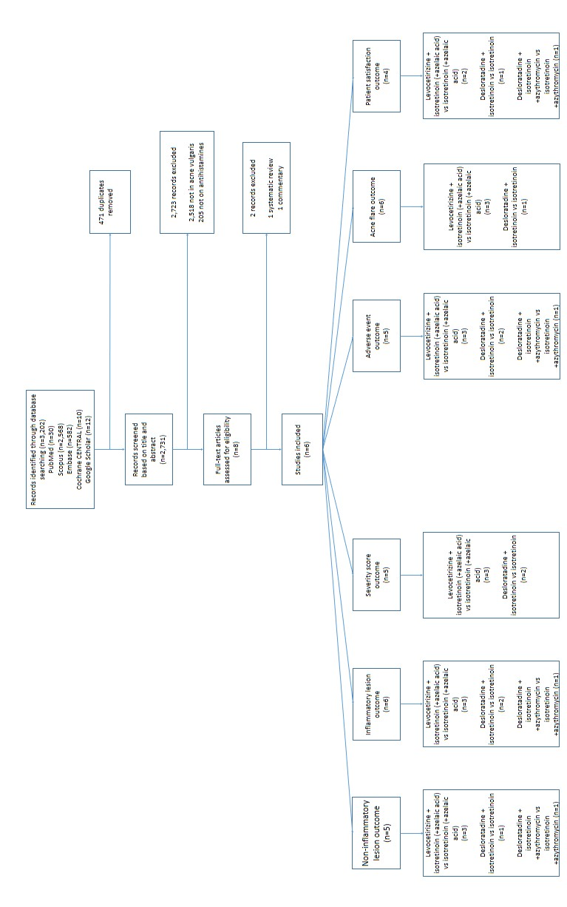

Figure 1 PRISMA flowchart for study selection

**Characteristics of included study**

**The characteristics of 6 eligible studies were summarized in Table 1a. and 1b.**

The studies included 408 acne vulgaris patients, and were published between 2014-2019. Two of these studies were conducted in Vietnam (Van Thai et al, 2019; Van Thuong et al, 2019) and one each from Nepal (Pandey et al, 2019), Iraq (Dhaher & Jasim, 2018), Egypt (Yosef et al, 2017), and South Korea (Lee et al, 2014).

All the studies were single-center, parallel RCTs. Five studies were conducted in clinics (Yosef et al, 2017; Pandey et al, 2019; Van Thai et al, 2019; Van Thuong et al, 2019; Dhaher & Jasim, 2018), and one in a university hospital (Lee et al, 2014). Percentage of male patients ranged from 38.7% to 63.3%. Mean age was reported in 6 studies, ranging from 19 to 22.35 years. However, only 2 studies (Yosef et al, 2017; Van Thai. 2019) reported mean BMI, which were 20.35 and 23.64 kg/m2.

Non-inflammatory lesion count was reported in the 5 studies (Lee et al, 2014; Yosef et al, 2017; Pandey et al, 2019; Van Thai et al, 2019; Van Thuong et al, 2019;) and inflammatory lesion count in all 6 studies. Acne severity score was reported in 5 studies, all of which used GAGS score as the measurement tool. Patient satisfaction was reported in 4 studies by using 4-point scale in all of studies. Acne flare was reported in 4 studies, by assessing the presence of nodule at one end. Two of them reported it in 4-point scale (Lee et al, 2014; Pandey et al, 2019) while the other as a dichotomous outcome (Yosef et al, 2017; Van Thai. 2019). Lastly, adverse events were reported in all studies.

Non-inflammatory lesion count, inflammatory lesion count, acne severity score, acne flare, and adverse events were assessed at 2, 4, 8, 12 weeks after treatment in Lee et al (2014) study, while in Yosef et al (2017) study those outcomes were assessed every 4 weeks, and finally at 16 weeks after treatment. Pandey & Agrawal (2019) assessed those outcomes at 4, 8, and 12 weeks after treatment. Van Thai et al (2019) assessed non- inflammatory lesion count, inflammatory lesion count, acne severity score, acne flare, and adverse events at 3, 4, 8, and 12 weeks after treatment. In Dhaher & Jasim (2018) study, non-inflammatory lesion count, inflammatory lesion count, and adverse events were assessed every 4 weeks, for 12 weeks after treatment, while Van Thuong et al (2019) assessed inflammatory lesion count, acne severity score, and adverse events at 2, 4, 8, 12, and 16 weeks after treatment. Patient satisfaction was assessed at 12 weeks in Lee et al (2014), Dhaher & Jasim (2018), and Pandey & Agrawal (2019) studies and at 16 weeks in Yosef et al (2017) after treatment. Authors used 12 weeks’ time point for non-inflammatory lesion count, inflammatory lesion count, acne severity score, acne flare, and adverse events in the analyses in Lee et al (2014) and Pandey & Agrawal (2019) studies, while in Yosef et al (2017), authors used 16 weeks’ time point for those outcomes in analyses. Next, authors used 12 weeks’ time point for non-inflammatory lesion count, inflammatory lesion count, acne severity score, acne flare, and adverse events in Van Thai et al (2019) study. In Dhaher & Jasim (2018) study, authors used 12 weeks’ time point for non-inflammatory lesion count, inflammatory lesion count, and adverse events in analyses. Lastly, authors used 16 weeks’ time point for inflammatory lesion count, acne severity score, and adverse events in Van Thuong et al (2019) study in analyses. For patient satisfaction, authors used 12 weeks’ time point in Lee et al (2014), Dhaher & Jasim (2018), and Pandey & Agrawal (2019) studies and at 16 weeks’ time point in Yosef et al (2017) in analyses. Briefly, authors used final time point for each outcome, because at that time the final effects of drug action should be shown.

**Table 1a. Characteristics of included studies**

|  |  |  |  |  |  |  |  |  |  |  |  |
| --- | --- | --- | --- | --- | --- | --- | --- | --- | --- | --- | --- |
| **First**  **author,**  **year** | **Country** | **N** | **Setting** | **Center** | **Design** | **Treatment arms** | **Treatment duration (weeks)** | **%**  **Male patients** | **Mean age (years)** | **Mean BMI**  **(kg/m2)** | **Mean duration of acnes**  **(months)** |
| Lee et al, 2014 | South  Korea | 40 | University  Hospital | Single | Parallel | 2 | 12 | 40 | 21.45 | NR | 56.4 |
| Yosef et al, 2017 | Egypt | 50 | Clinic | Single | Parallel | 2 | 16 | NR | 19.34 | 23.64 | 39.96 |
| Dhaher & Jasim , 2018 | Iraq | 76 | Clinic | Single | Parallel | 2 | 12 | 42.21 | 19 | NR | 25.5 |
| Pandey & Agrawal , 2019 | Nepal | 100 | Clinic | Single | Parallel | 2 | 12 | 34 | 21.67 | NR | 34.8 |
| Van Thai, 2019 | Vietnam | 60 | Clinic | Single | Parallel | 2 | 12 | 63.3 | 22.35 | 20.35 | 27 |
| Van Thuong, 2019 | Vietnam | 62 | Clinic | Single | Parallel | 2 | 16 | 37.12 | 21.98 | NR | 32.68 |

*NR: Not reported

**Table 1b. Characteristics of included studies**

|  |  |  |  |  |  |  |
| --- | --- | --- | --- | --- | --- | --- |
| **First author, year** |  | **Outcomes assessment timing after treatment (weeks)** | | | |  |
|  | **Non-inflammatory**  **lesion count** | **Inflammatory**  **lesion count** | **Acne severity score** | **Patient**  **satisfaction** | **Acne**  **flare** | **Adverse events** |
| Lee et al, 2014 | 2, 4, 8, 12 | 2, 4, 8, 12 | 2, 4, 8, 12 | 12 | 2, 4, 8, 12 | 2, 4, 8, 12 |
| Yosef et al, 2017 | 4, 8, 12, 16 | 4, 8, 12, 16 | 4, 8, 12, 16 | 16 | 4, 8, 12, 16 | 4, 8, 12, 16 |
| Dhaher & Jasim ,  2018 | 4, 8, 12 | 4, 8, 12 | NR | 12 | NR | 4, 8, 12 |
| Pandey & Agrawal ,  2019 | 4, 8, 12 | 4, 8, 12 | 4, 8, 12 | 12 | 4, 8, 12 | 4, 8, 12 |
| Van Thai, 2019 | 3, 4, 8, 12 | 3, 4, 8, 12 | 3, 4, 8, 12 | NR | 3, 4, 8, 12 | 3, 4, 8, 12 |
| Van Thuong, 2019 | NR | 2, 4, 8, 12, 16 | 2, 4, 8, 12, 16 | NR | NR | 2, 4, 8, 12, 16 |

*NR: Not reported

**Treatments**

Among 6 studies, there were 4 types of treatments in total listed as follows:

1. Monotherapy isotretinoin

Oral isotretinoin with dosage 20 mg/day Combination of isotretinoin and topical

treatment, Oral isotretinoin with dosage 5 mg/day, plus 20% topical azelaic acid

cream, Combination of H1-antihistamines and other treatments, Oral

levocetirizine with dosage 5 mg/day, plus oral isotretinoin with dosage 20 mg/day,

Oral levocetirizine with dosage 5 mg/day, plus oral isotretinoin with dosage 20

mg/day plus topical azelaic acid with concentration 20% in cream formulation,

Oral desloratadine with dosage 5 mg/day, plus oral isotretinoin with dosage 20

mg/day, Oral desloratadine with dosage 5 mg/day, plus oral isotretinoin and oral

azithromycin with dosage 5 mg/day and 500 mg/day respectively.

1. Combination of isotretinoin with antibiotic

Isotretinoin and azithromycin with dosage 5 mg/day and 500 mg /day respectively.

One study used a topical treatment, i.e., 20% azelaic acid cream, in combination with oral drugs (Van Thai et al, 2019). However, as topical drugs are not the main treatment in moderate to severe acne vulgaris, the treatments containing azelaic acid cream were considered to be in the same treatment group as the corresponding oral treatments without azelaic cream in the meta-analyses.

Isotretinoin was the most common comparator, which was found in 5 studies, followed by isotretinoin plus oral azithromycin that was found in 1 study. Meanwhile for intervention, most studies used an antihistamine plus isotretinoin, that was found in 5 studies. Only 1 study used antihistamine plus azithromycin and isotretinoin combination.

All of the included studies were 2-armed RCTs. Three studies compared levocetirizine plus isotretinoin (with or without topical azelaic acid cream) to isotretinoin (with or without topical azelaic acid cream), 2 studies compared desloratadine plus isotretinoin to isotretinoin, and 1 study compared desloratadine plus azithromycin and isotretinoin combination to azithromycin plus isotretinoin. Furthermore, most studies used 12 weeks of treatment duration, which were reported in 4 studies (Lee et al, 2014; Pandey & Agrawal, 2019; Van Thai, 2019; Dhaher and Jasim, 2018) and 2 studies (Yosef et al, 2017; Van Thuong, 2019) used 16 weeks of treatment duration.

**Discussion**

To compare treatment effects of H1-antihistamines on acne, including 3 of combination of H1-antihistamines and other treatments, the systematic review and NMA was performed. Six studies met the eligibility criteria and included in data pooling on 7 outcomes. The results can be summarized as follows.

In pairwise meta-analysis of levocetirizine + isotretinoin vs isotretinoin alone, the pooled USMD (95% CI) results of non-inflammatory and inflammatory lesion counts, and severity score, were -2.53 (-4.38, -0.68), -3.19 (-4.83, -1.55), and -3.63 (-5.25, -2.02), respectively. Meanwhile, the pooled RR (95% CI) results from pairwise meta-analysis of levocetirizine + isotretinoin vs isotretinoin alone of acne flare and mucocutaneous adverse events were 0.59 (0.10, 3.29) and 0.99 (0.96, 1.03), respectively. Authors found difficulties to find the covariables that may contribute in heterogeneity, because some meta-regression results showed error and others failed to produce ≥ 50% reduction of τ2. In NMA, the pooled mean difference (95% CI) of non-inflammatory lesion count, inflammatory lesion count, and severity score for desloratadine + isotretinoin treatment was -12.14 (-18.71, -5.56), -4.09 (-9.52, 1.34), and -3.24 (-5.09, -1.39) respectively compared to isotretinoin alone. Meanwhile, for levocetirizine + isotretinoin, the pooled mean difference (95% CI) of each outcome respectively, was -2.64 (-5.06, -0.22), -3.36 (-7.72, 0.99), and -3.63 (-5.25, -2.02), compared to isotretinoin alone. Finally, the result of pooled mean difference (95% CI) of each outcome was -9.50 (-16.50, -2.49), 0.73 (-7.65, 6.20), and 0.39 (-2.06, 2.85) respectively, for desloratadine + isotretinoin compared with levocetirizine + isotretinoin. The pooled RR (95% CI) of acne flare, mucocutaneous adverse events, and patient satisfaction for desloratadine + isotretinoin was 0.17 (0.01, 6.15), 0.41 (0.12, 1.46), and 1.64 (0.88, 3.05) respectively compared to isotretinoin alone. Meanwhile, for levocetirizine + isotretinoin, the pooled RR (95% CI) of each outcome respectively, was 0.58 (0.08, 4.01), 0.90 (0.45, 1.80), and 1.10 (0.77, 1.57), compared to isotretinoin alone. Lastly, the result of pooled RR (95% CI) of each outcome was 0.29 (0.01, 17.41), 0.46 (0.11, 1.93), and 1.49 (0.73, 3.06) respectively, for desloratadine + isotretinoin compared with levocetirizine + isotretinoin. Based on surface under the cumulative ranking curve (SUCRA) score, desloratadine + isotretinoin has lowest mucocutaneous adverse events and acne flare, and reduced most non-inflammatory and inflammatory lesion counts, followed by levocetirizine + isotretinoin. In contrast, levocetirizine + isotretinoin has reduce most severity score, followed by desloratadine + isotretinoin. Isotretinoin alone had lowest performance for all outcomes.

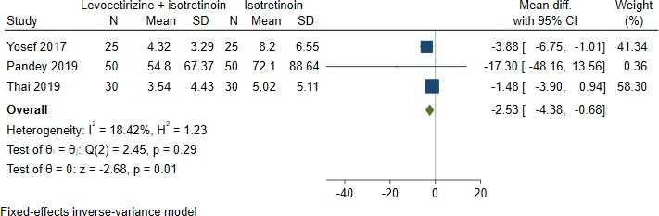

**Figure 2. Results for pairwise meta-analysis for non-inflammatory lesion count**

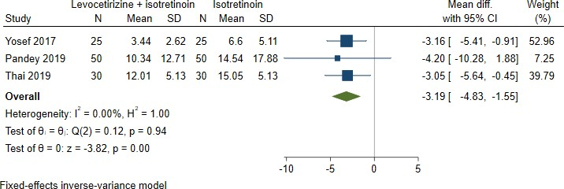

**Figure 3.** **Results for pairwise meta-analysis for inflammatory lesion count**

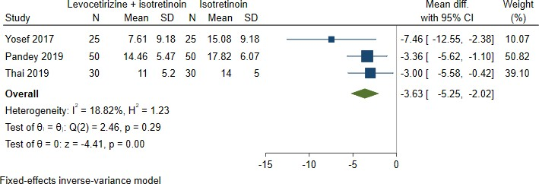

**Figure 4. Results for pairwise meta-analysis for acne severity score**

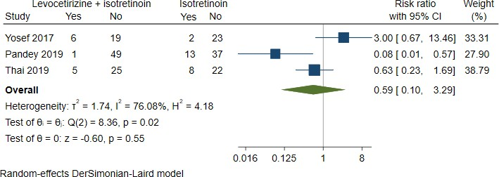 **Figure 5. Results for pairwise meta-analysis for acne flare**

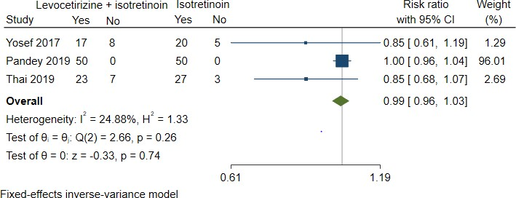 **Figure 6. Results for pairwise meta-analysis for mucocutaneous adverse events**

**Table 2** **Unstandardized mean difference of all treatment comparisons for non-inflammatory lesion count estimated from network meta-analysis**

|  |  |  |  |
| --- | --- | --- | --- |
| **Reference Drug** |  | **USMD** |  |
| **ISO** | **ISO+LEVO** | **ISO+DESLO** |
| **ISO** | 1.0 | -2.64  (-5.06,-0.22) | -12.14  (-18.71,-5.56) |
| **ISO+LEVO** |  | 49.2 | -9.50  (-16.50,-2.49) |
| **ISO+DESLO** |  |  | 99.8 |

* Values in each off-diagonal cell are USMD (95% CI) of non-inflammatory lesion count from mixed treatment comparisons of treatment in column heading relative to treatment in row heading. Each diagonal cell contains SUCRA.

**Table 3 Unstandardized mean difference of all treatment comparisons for inflammatory lesion count estimated from network meta-analysis**

|  |  |  |  |
| --- | --- | --- | --- |
| **Reference Drug** |  | **USMD** |  |
| **ISO** | **ISO+LEVO** | **ISO+DESLO** |
| **ISO** | 6.8 | -3.36 (-7.72, 0.99) | -4.09 (-9.52, 1.34) |
| **ISO+LEVO** |  | 67.6 | 0.73 (-7.65,6.20) |
| **ISO+DESLO** |  |  | 75.6 |

*Values in each off-diagonal cell are USMD (95% CI) of inflammatory lesion count from mixed treatment comparisons of treatment in column heading relative to treatment in row heading. Each diagonal cell contains SUCRA

**Table 4 Unstandardized mean difference of all treatment comparisons for acne severity score estimated from network meta-analysis**

|  |  |  |  |
| --- | --- | --- | --- |
| **Reference Drug** |  | **USMD** |  |
| **ISO** | **ISO+LEVO** | **ISO+DESLO** |
| **ISO** | 0.0 | -3.63 (-5.25,-2.02) | -3.24 (-5.09,-1.39) |
| **ISO+LEVO** |  | 81.3 | 0.39 (-2.06, 2.85) |
| **ISO+DESLO** |  |  | 68.7 |

*Values in each off-diagonal cell are USMD (95% CI) of acne severity score from mixed treatment comparisons of treatment in column heading relative to treatment in row heading. Each diagonal cell contains SUCRA

**Table 5** **Risk Ratio of all treatment comparisons for acne flare estimated from network meta-analysis**

|  |  |  |  |
| --- | --- | --- | --- |
| **Reference Drug** |  | **RR (95% CI)** |  |
| **ISO** | **ISO+LEVO** | **ISO+DESLO** |
| **ISO** | 21.9 | 0.58  (0.08,4.01) | 0.17  (0.01, 6.15) |
| **ISO+LEVO** |  | 49.8 | 0.29  (0.01,17.41) |
| **ISO+DESLO** |  |  | 78.2 |

* Values in each off-diagonal cell are RR (95% CI) of acne flare from mixed treatment comparisons of treatment in column heading relative to treatment in row heading. Each diagonal cell contains SUCRA

**Table 6** **Risk Ratio of all treatment comparisons for mucocutaneous adverse estimated from network meta-analysis**

|  |  |  |  |
| --- | --- | --- | --- |
| **Reference Drug** |  | **RR (95% CI)** |  |
| **ISO** | **ISO+LEVO** | **ISO+DESLO** |
| **ISO** | 22.8 | 0.90  (0.45,1.80) | 0.41  (0.12,1.46) |
| **ISO+LEVO** |  | 38.8 | 0.46  (0.11,1.93) |
| **ISO+DESLO** |  |  | 88.4 |

*Values in each off-diagonal cell are RR (95% CI) of mucocutaneous adverse events from mixed treatment comparisons of treatment in column heading relative to treatment in row heading. Each diagonal cell contains SUCRA

**Table 7** **Risk Ratio of all treatment comparisons for patient satisfaction estimated from network meta-analysis**

|  |  |  |  |
| --- | --- | --- | --- |
| **Reference Drug** |  | **RR (95% CI)** |  |
| **ISO** | **ISO+LEVO** | **ISO+DESLO** |
| **ISO** | 18.6 | 1.10  (0.77,1.57) | 1.64  (0.88,3.05) |
| **ISO+LEVO** |  | 42.8 | 1.49  (0.73,3.06) |
| **ISO+DESLO** |  |  | 88.6 |

* Values in each off-diagonal cell are RR (95% CI) of patient satisfaction from mixed treatment comparisons of treatment in column heading relative to treatment in row heading. Each diagonal cell contains SUCRA

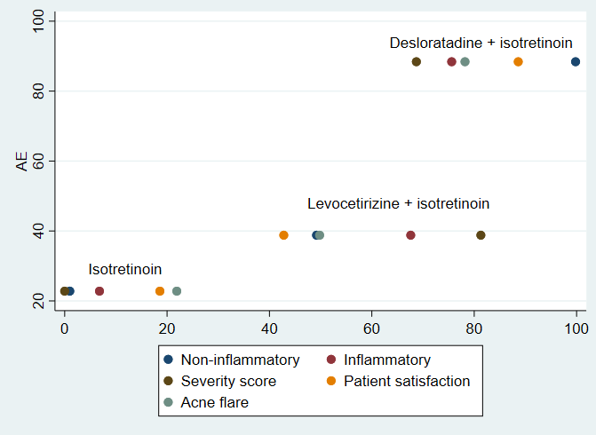

**Figure 7.** **Treatments ranking plot for non-inflammatory lesion count, inflammatory lesion count, acne severity score, patient satisfaction, and acne flare in comparison with mucocutaneous adverse events**

**Clinical implications**

The new information provided by the present systematic review can be described as follows. It has included 5 RCTs, more patients (348 patients) and one treatment (levocetirizine + isotretinoin), which were not included in the previous systematic review in 2015.24 Moreover, to the best of our knowledge, NMA on acne vulgaris treatment was performed for the first time in the present review. By applying NMA, all treatments can be compared indirectly with each other despite some of them may have never been compared directly in a primary study, and by their probability of being the best treatment, they can also be ranked. The previous systematic review only described non-inflammatory and inflammatory lesion counts, severity score, acne flare, mucocutaneous adverse events, and patient satisfaction without pooling by meta-analysis. Whereas pairwise and network meta-analyses were also performed on the outcomes that were mentioned before in the present review. As a result, new information on the relative treatment effects according to these outcomes can be applied not only by itself, but also in conjunction with the mucocutaneous adverse events in treatment ranking.

**To interpret the pooled USMD from pairwise meta-analysis, levocetirizine**

+ isotretinoin might show some clinical benefit compared to isotretinoin alone in inflammatory lesion count (reduced 3 lesions). However, levocetirizine + isotretinoin was clinically not different compared to isotretinoin alone in non-inflammatory lesion count (reduced 3 lesions) and in GAGS score (reduced 4 points). Inflammatory lesions are usually easily recognized by a raised of skin area, especially if the patient has excessive amount of nodules, they tend to feel uncomfortable with their face condition. Furthermore, the inflammatory lesion left scars on patients face. While non- inflammatory lesion, they usually not clinically visible. They recognized as “blackheads” and “whiteheads” comedones. Due of that fact, reducing 3 inflammatory lesions were clinically better than only reducing 3 non-inflammatory lesions. In short, reducing inflammatory lesions will make patient more comfortable rather than reducing non-inflammatory that barely visible. For GAGS score, the minimal clinically important difference (MCID) has never been reported in the literature. So authors attempted to determine it roughly by counting how much score is associated with moving from one severity grade to another. For instance, the global score for mild acne ranged from 1 to 18. For moderate acne, the score ranged from 19-30. Meanwhile, severe acne score ranged 31-39. Lastly, very severe acne if the score >39. As we can see, it takes around 10 units to move from one grade. As the result, we assumed a MCID of 10 points for Global Acne Grading System (GAGS) score. Consequently, levocetirizine + isotretinoin, which achieved lower GAGS score by 4 points, was not clinically different compared to isotretinoin alone to decrease overall acne severity.

However, all of the primary studies reported that the treatments were given, antihistamine + isotretinoin as intervention and isotretinoin as control, at the same time. Moreover, the onset of action antihistamine occurs 1-2 hours after oral administration while that of isotretinoin takes several weeks. In brief, antihistamine has shorter onset. Additionally, each outcome was assessed every 2-4 weeks. However, the time point that the authors chose for the analyses was at 12 weeks or 16 weeks, which was the final assessment time point. Thus, the additional treatment effects of antihistamines may not be presented since the effects isotretinoin, which is much more potent, should have already taken place at the time of assessment.

The reported adverse events were not severe (no need to be hospitalized) and the chance to get mucocutaneous adverse events between desloratadine + isotretinoin and levocetirizine + isotretinoin compared to isotretinoin alone was not different. In addition, drowsiness, the most well-known side-effect of antihistamine, was not reported. Therefore, we may conclude that an addition of a standard-dose antihistamine to isotretinoin is considerably safe in the short term. Authors then tried to rank the treatments to link the efficacy and the adverse events.

When ranking for non-inflammatory lesion count, inflammatory lesion count, patient satisfaction, and acne flare outcomes were applied to mucacutaneous adverse events reaction, desloratadine + isotretinoin looked like the best treatment with the best balance between 5 outcomes, followed by levocetirizine + isotretinoin. While for severity score was applied to mucacutaneous adverse events reaction, levocetirizine + isotretinoin was the best treatment with the best balance between 2 outcomes, followed by desloratadine + isotretinoin. Meanwhile, isotretinoin acne was ranked as the third for all outcomes, i.e., worst. Regarding the different ranking between acne lesion count reduction and severity score as GAGS score depends on the involved body parts of lesion and types of lesions but not directly on the number of lesions, it is not always in agreement with the lesion counts. Therefore, it is not necessary to have same rank for acne lesion reduction and acne severity score. These findings can be used as a guide for physicians in selecting well-balanced for acne vulgaris treatment. Based on these, desloratadine + isotretinoin and levocetirizine + isotretinoin might be a useful acne vulgaris treatment.

Acne patient might use the antihistamines combine with isotretinoin to reduce acne lesion, especially for inflammatory lesion. The administration of these drugs probably are more comfortable due to all of them administered orally.

Despite of the fact that combination of antihistamine with mostly isotretinoin has potential to treat acne vulgaris, we found very few of clinical trials and only one systematic review without meta-analysis regarding the usage of antihistamine as acne vulgaris treatment (Wang L, 2015). This might be that most physicians still use current guide to cure acne and still not recognize the potential of adding an antihistamine to acne vulgaris treatment and published in less known journal. Additionally, all of the primary studies used antihistamines in combination with other drug. Therefore, further studies on antihistamine alone might be conducted in the future.

**Strengths and limitations**

The strength of the present systematic review was present review was the first review that allowed network meta-analysis of antihistamine as the acne treatment. In addition, newer treatments were added to those from previous systematic review, and the application of network meta-analysis allows the comparison and ranking of all treatments. However, there are also some limitations in this review. First, the number of included primary studies were small. Secondly, many studies were associated with some concern of bias. Lastly, the sample sizes of the included studies seemed to be rather small.

**Conclusion**

Levocetirizine + isotretinoin had clinically better compared to isotretinoin alone in inflammatory lesion count. However, levocetirizine + isotretinoin was clinically not different compared to isotretinoin alone in non-inflammatory lesion count. Desloratadine + isotretinoin retained the best balance between achieving non- inflammatory lesion count, inflammatory lesion count, acne flare, and mucocutaneous adverse events. Desloratadine + isotretinoin and levocetirizine + isotretinoin were safe to use. While for balance achieving severity score and mucocutaneous adverse events, levocetirizine + isotretinoin was the best treatment. Further studies on antihistamine alone might be conducted in the future.

**References**

Al-Kubaisy, Waqar, Abdullah, Nik Nairan, Kahn, Sabzali Musa, & Zia, Maram. (2014). Sociodemographic characteristics of acne among university students in Damascus, Syria. *Epidemiology Research International*, *2014*.

Al Robaee, Ahmad A. (2009). Assessment of general health and quality of life in patients with acne using a validated generic questionnaire. *Acta Dermatovenerol Alp Panonica Adriat*, *18*(4), 157–164.

Ali, Faiz, Hasni, Muhammad Shafi, Ali, Shah Zain, Nadeem, Muhammad, Khan, Anwer, & Mehak, Tehmina. (2019). 5. Determination of various risk factors associated with acne vulgaris infection in Quetta, Pakistan. *Pure and Applied Biology (PAB)*, *8*(3), 1919–1924.

Cheung, C. M. K., Chiu, P. -Y., & Lee, M. K. O. (2011). Online social networks: Why do students use facebook? *Computers in Human Behavior*, *27*, 1337–1343. https://doi.org/http://doi. org/10. 1016/j. chb. 2010. 07. 028, 2011

Costa, Caroline S., Bagatin, Ediléia, Martimbianco, Ana Luiza C., da Silva, Edina M. K., Lúcio, Marília M., Magin, Parker, & Riera, Rachel. (2018). Oral isotretinoin for acne. *Cochrane Database of Systematic Reviews*, (11).

Dalgard, Florence, Gieler, Uwe, Holm, Jan Øivind, Bjertness, Espen, & Hauser, Stuart. (2008). Self-esteem and body satisfaction among late adolescents with acne: results from a population survey. *Journal of the American Academy of Dermatology*, *59*(5), 746–751.

Dhaher, Samer A., & Jasim, Zahraa M. (2018). The adjunctive effect of desloratadine on the combined azithromycin and isotretinoin in the treatment of severe acne: Randomized clinical trial. *Journal of Dermatology and Dermatologic Surgery*, *22*(1), 21–25.

Goh, Chee Leok, Abad‐Casintahan, Flordeliz, Aw, Derrick Chen Wee, Baba, Roshidah, Chan, Lee Chin, Hung, Nguyen Thanh, Kulthanan, Kanokvalai, Leong, Hoe Nam, Medina‐Oblepias, Marie Socouer, & Noppakun, Nopadon. (2015). South‐East Asia study alliance guidelines on the management of acne vulgaris in South‐East Asian patients. *The Journal of dermatology*, *42*(10), 945–953.

Holzmann, R., & Shakery, K. (2013). Postadolescent acne in females. *Skin pharmacology and physiology*, *27*(Suppl. 1), 3–8.

Lai, Jiann Jyh, Chang, Philip, Lai, Kuo Pao, Chen, Lumin, & Chang, Chawnshang. (2012). The role of androgen and androgen receptor in skin-related disorders. *Archives of dermatological research*, *304*, 499–510.

Lee, Hae Eul, Chang, In Kyu, Lee, Young, Kim, Chang Deok, Seo, Young Joon, Lee, Jeung Hoon, & Im, Myung. (2014). Effect of antihistamine as an adjuvant treatment of isotretinoin in acne: a randomized, controlled comparative study. *Journal of the European Academy of Dermatology and Venereology*, *28*(12), 1654–1660.

Nast, A., Dreno, B., Bettoli, V., Degitz, K., Erdmann, R., Finlay, A. Y., Ganceviciene, R., Haedersdal, M., Layton, A., & López‐Estebaranz, J. L. (2012). European evidence‐based (S3) guidelines for the treatment of acne. *Journal of the European Academy of Dermatology and Venereology*, Vol 26, bll 1–29. Blackwell Publishing Ltd Oxford, UK.

Pandey, D., & Agrawal, S. (2019). Efficacy of isotretinoin and antihistamine versus isotretinoin alone in the treatment of moderate to severe acne: a randomised control trial. *Kathmandu Univ Med J*, *17*(65), 14–19.

Pelle, Edward, McCarthy, James, Seltmann, Holger, Huang, Xi, Mammone, Thomas, Zouboulis, Christos C., & Maes, Daniel. (2008). Identification of histamine receptors and reduction of squalene levels by an antihistamine in sebocytes. *Journal of Investigative Dermatology*, *128*(5), 1280–1285.

Radtke, Marc A., Schäfer, Ines, & Augustin, Matthias. (2010). Pharmakoökonomie der Akne–Bewertung von Nutzen und Wirtschaftlichkeit. *JDDG: Journal der Deutschen Dermatologischen Gesellschaft*, *8*, S105–S114.

Shen, Yiwei, Wang, Tinglin, Zhou, Cheng, Wang, Xiaoyan, Ding, Xiaolan, Tian, Shan, Liu, Ying, Peng, Guanghui, Xue, Shuqi, & Zhou, June. (2012). Prevalence of acne vulgaris in Chinese adolescents and adults: a community-based study of 17,345 subjects in six cities. *Acta dermato-venereologica*, *92*(1), 40–44.

Sterne, Jonathan A. C., Savović, Jelena, Page, Matthew J., Elbers, Roy G., Blencowe, Natalie S., Boutron, Isabelle, Cates, Christopher J., Cheng, Hung Yuan, Corbett, Mark S., & Eldridge, Sandra M. (2019). RoB 2: a revised tool for assessing risk of bias in randomised trials. *bmj*, *366*.

Tan, Jerry K. L., & Bhate, K. (2015). A global perspective on the epidemiology of acne. *British Journal of Dermatology*, *172*, 3–12.

Tanghetti, Emil A., Kawata, Ariane K., Daniels, Selena R., Yeomans, Karen, Burk, Caroline T., & Callender, Valerie D. (2014). Understanding the burden of adult female acne. *The Journal of clinical and aesthetic dermatology*, *7*(2), 22.

Van, Thuong Nguyen, Thi, Lan Duong, Trong, Hao Nguyen, Van, Tro Chau, Minh, Trang Trinh, Minh, Phuong Pham Thi, Huu, Nghi Dinh, Le Huyen, My, Hau, Khang Tran, & Gandolfi, Marco. (2019). Efficacy of oral isotretinoin in combination with desloratadine in the treatment of common vulgaris acne in vietnamese patients. *Open Access Macedonian Journal of Medical Sciences*, *7*(2), 217.

Wang, Lorraine. (2015). Antihistamine: A Useful Medication with Minimal Adverse Drug Reactions to Improve Acne Symptoms and Reduce Sebum Production. *School of Physician Assistant Studies*, *508*.

Yoopetch, Panida, Anothaisintawee, Thunyarat, Gunasekara, Agampodi Danushi M., Jittikoon, Jiraphun, Udomsinprasert, Wanvisa, Thavorncharoensap, Montarat, Youngkong, Sitaporn, Thakkinstian, Ammarin, & Chaikledkaew, Usa. (2023). Efficacy of anti-tuberculosis drugs for the treatment of latent tuberculosis infection: a systematic review and network meta-analysis. *Scientific Reports*, *13*(1), 16240.

Yosef, Ayman, Dawoud, Noha M., & Gharib, Khaled. (2017). Preliminary evaluation of the clinical efficacy of antihistamines as an adjuvant treatment to isotretinoin for acne vulgaris. *Journal of the Egyptian Women’s Dermatologic Society*, *14*(1), 49–55.

Zaenglein, Andrea L. (2018). Acne vulgaris. *New England Journal of Medicine*, *379*(14), 1343–1352.

Zouboulis, Christos C. (2009). Sebaceous gland receptors. *Dermato-endocrinology*, *1*(2), 77–80.