**Measurement of Vibration Levels and Geometric Quality of Reconditioned Lathe Products with Variations In Basic Machining Elements**

**Hendra1, Admon Dani2, Dedi Suryadi3, Hernadewita4**

1Universitas Sultan Ageng Tirtayasa Banten, Indonesia, 2,3Teknik Universitas Bengkulu, Indonesia, 4Universitas Mercubuana Jakarta, Indonesia

Email: [hendra@untirta.ac.id](mailto:hendra@untirta.ac.id)

* Correspondence: hendra@untirta.ac.id

|  |  |
| --- | --- |
| **KEYWORDS** | **ABSTRACT** |
| spindle rotation, cutting depth, vibration, product geometry quality | Machining parameters are something that must be considered, where machining parameters are related to vibrations (chatters) that occur during the cutting process. Vibration (chatter) can affect the quality of the geometry of the resulting product. To find out this, it is necessary to test the influence of machining parameters on the vibration level and quality of product geometry. Measurement of vibration level values and product geometry quality is carried out at variations of 60 rpm, 215 rpm, 330 rpm and 1140 rpm, with variations in cutting depth of 0.5 mm, 1 mm, 2 mm and 3 mm. The results of the cutting process with the influence of machining parameters (spindle rotation and cutting depth) on vibration, the most optimal value with a low vibration level is obtained, namely in the cutting process with spindle rotation parameters (n) 1140 rpm, and cutting depth (a) 1 mm produces a vibration value of 2.1 mm / s. However, for the most optimal cutting process, the highest vibration level value is produced, that is, in the cutting process with spindle rotation parameters (n) 215 rpm and cutting depth (a) 3 mm resulting in a vibration value of 3.4 mm / s. From the results of measuring the vibration level, it is obtained that the vibration level value has exceeded the permissible tolerance limit. However, for the influence of machining parameters on the quality of product geometry, results are obtained with the quality of product geometry that is still within the permissible tolerance limits, namely at spindle rotation (n) 1140 rpm. For the results of measuring the quality of product geometry at spindle rotation (n) 60 rpm, 215 rpm and 330 rpm, the quality results of product geometry obtained have exceeded the permissible tolerance limit. |
|  |
|  | Attribution- ShareAlike 4.0 International (CC BY-SA 4.0)  **https://jurnal.syntax-idea.co.id/public/site/images/idea/88x31.png** |

**Introduction**

Machine tools are widely used in the industrial world to make products with the desired shape and size. One of the machine tools that is often used is a lathe. Lathes are used to create objects of cylinders, holes, threads and other shapes.

The yield of lathe process products is influenced by the selection of proper machining parameters (Alfianto & Wulandari, 2018). If improper selection of machining parameters can cause vibration (chatter) during the cutting process. Chatters that occur usually cause unwanted effects such as discomfort, inaccuracy in measurements and damage to engine parts (Yoggy, Muhammad A dan Mahendra, 2017).

Good machine tool conditions can produce good product quality. The condition of the machine tool is influenced by the machine tool components and the rigidity of the machine tool. To determine the condition of the machine tool and the rigidity of the machine tool, static and dynamic checks can be carried out. Static conditions are carried out by testing machine tools and dynamic conditions are carried out by measuring vibration levels on machine tools (Şahinoğlu & Rafighi, 2020). The vibration level on the machine tool can be obtained in the state of normal and abnormal machine tools (reconditioned). The difference is that normal machine tools usually the value of the vibration level that occurs is not too large. Under abnormal conditions, the vibration value can be greater (Ghionea, Ghionea, Cioboată, & Ćuković, 2016).

How much research has been done vibration is influenced by the depth of the cut, where the greater the depth of the cut, the value of the vibration level that occurs will be greater (Rahman, 2017). Research on roughing and finishing vibration level analysis in the face and deep lathe process was carried out to compare vibration values and surface roughness values (Tornando, 2018). While other studies measuring using low cutting speed and large cutting depth resulted in poor surface quality because it resulted in high cutting forces and cutting loads. The higher the cutting force and load that occurs, the results from the surface will be less good (Raul, Widiyanti, & Puspitasari, 2017). In addition, static checks have also been carried out, namely testing machine tools on Emco maximat super II machines before reconditioning and after reconditioning (Muhammad Syahroni, 2018).

In this study, vibration level measurements were carried out on the Emco Maximat Super II lathe, where the engine condition was abnormal (reconditioned). For this reason, this study focused on the influence of machining parameters on the vibration level and geometry quality of reconditioned lathe products (Takaya, 2014).

**Research Methods**

**Bubut Appliance Machine**

Lathe machine tools are used for cutting metal materials. The parts of the lathe can be seen in Figure 1.

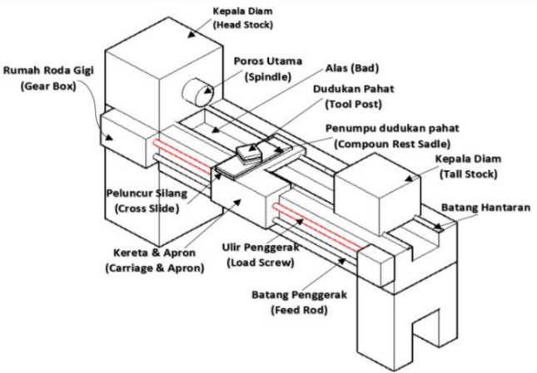

**Figure 1 Lathe** (Rochim, 1993)

**Vibration Machine Tools**

Vibration during the cutting process of machine tools or Chatter is a vibration that arises during the cutting process where the amplitude rises suddenly high at a certain cutting depth (TOMESCU, 2020). Chatter occurs if the machining parameter settings are not appropriate when cutting the workpiece so that the quality of the workpiece produced, tool life and machine life will decrease due to the chatter. The chatter diagram can be seen in Figure 2.

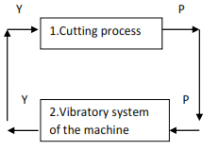

**Figure 2 Basic chatter diagram**

Figure (2) shows a closed diagram of the cutting process, the cutting process causes a cutting force (P) which causes vibration in the machine with amplitude (Y), continuously the process runs at unstable conditions causing the vibration to become even greater. The three principles of the cutting process that cause the chatter are regenerative chatter, modal coupling and velocity component (Koenigsberger & Tlusty, 2016).

**Vibration Level Standard**

Vibration is measured in the amount of acceleration, velocity, or displacement of vibration. Analysis of the basics of vibration signals is carried out on signal vibrations using RMS (root mean square), peak, or peak to peak units. Table 2 shows the standard vibration level for velocity which shows the recommended vibration value on the machine can be seen in Table 1.

**Table 1 ISO 2372 standard vibration level velocity levels** (Robichaud & Eng, 2009)

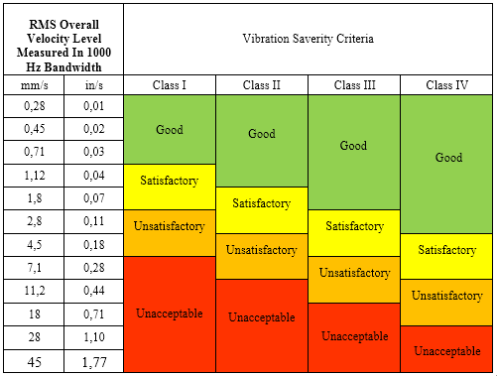

Description Table 1.

* Class I, small-sized engine powered (0-15 KW)
* Class II, medium-sized machines (15-75 KW)
* Class III (rigid), large-sized powerful machines (>75 KW) mounted on structures and foundations (rigid bearings)
* Class IV (soft), large-sized powerful machines (>75 KW) mounted on structures and foundations (flexible bearings)

**Surface Roughness**

Surface roughness tolerance standards can be seen in Table 2.

**Table 2 Average roughness price tolerance Ra** (Taufiq, 2006)

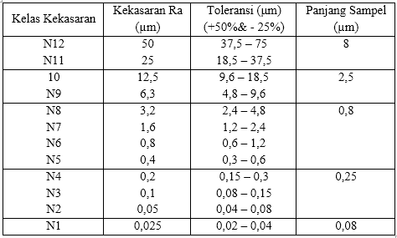

**Roundness**

ISO/R 1101 defines sphericity tolerance as a tolerance region in a cross-sectional plane bounded by two concentric circles with a radius difference equal to the tolerance price (Taufiq, 2001). The tolerances for geometric roundness can be seen in Figure 3.

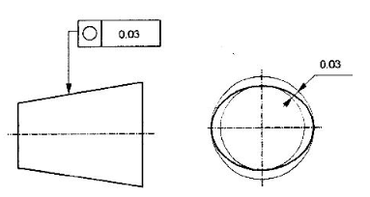

**Figure 3 Tolerance for geometric roundness**

**Research Steps**

The research steps carried out in this study can be seen in Figure 4.

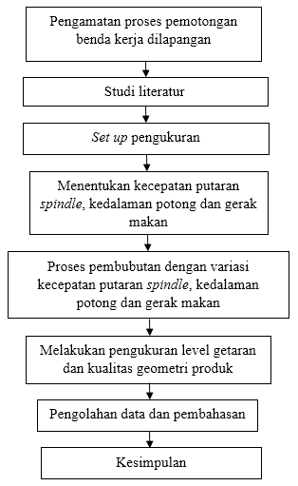

**Figure 4 Research steps**

Set Up Tools and Materials The preparation of measurements in this study are:

**Preparing the tool**

Before taking measurements, tools and materials are prepared. Tools prepared lathe, vibration meter, surface roughness tester, dial indicator, caliper and HSS tool.

**Preparing materials**

The workpiece used is Material ST 37 with a length of 150 mm and a diameter of 32 mm. For workpieces before the cutting process and after the cutting process can be seen in Figure 5 and Figure 6.

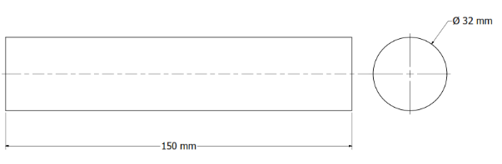

**Figure 5 Workpiece before cutting**

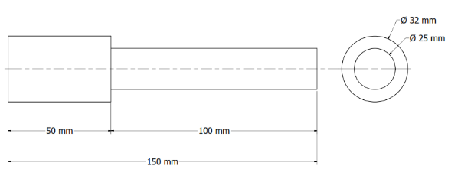

**Figure 6 Workpiece after cutting**

**Results and Discussions**

**Vibration level value measurement results**

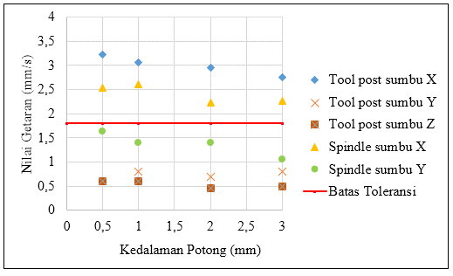The results of measuring the vibration level value at 60 rpm spindle rotation can be seen in Figure 7.

**Figure 7 Graph of the relationship of vibration values with 60 rpm spindle rotation**

From Figure 7 you can see a graph of the relationship between vibration values with spindle rotation of 60 rpm and cutting depths of 0.5 mm, 1 mm, 2 mm and 3 mm. The highest vibration level value in the tool post is on the x-axis of 3.23 mm/s with a cutting depth of 0.5 mm while the lowest vibration level value in the tool post is on the z-axis of 0.46 mm/s with a cutting depth of 2 mm. For the measurement position on the spindle, the highest vibration level value is on the x-axis of 2.6 mm/s with a cutting depth of 1 mm, while the lowest vibration level value is on the y-axis of 1.06 mm/s with a cutting depth of 3 mm.

From the results of Figure 7, the value of the vibration level at 60 rpm spindle rotation with variations in cutting depth shows that the lower the cutting depth, the greater the vibration.

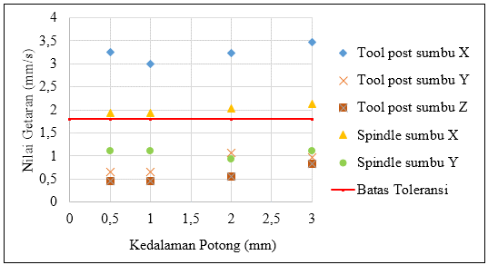The results of measuring the vibration level value at 215 rpm spindle rotation can be seen in Figure 8.

**Figure 8 Graph of the relationship of vibration values with spindle rotation 215 rpm**

From Figure 8 you can see a graph of the relationship between vibration values with spindle rotation of 215 rpm and cutting depths of 0.5 mm, 1 mm, 2 mm and 3 mm. The highest vibration level value in the tool post is on the x-axis of 3.46 mm/s with a cutting depth of 3 mm while the lowest vibration level value in the tool post is on the z-axis of 0.46 mm/s with a cutting depth of 0.5 mm and 1 mm. For the measurement position on the spindle, the highest vibration level value is on the x-axis of 2.13 mm/s with a cutting depth of 3 mm, while the lowest vibration level value is on the y-axis of 0.93 mm/s with a cutting depth of 2 mm.

From the graph above, it can be seen the relationship between spindle rotation with cutting depths of 1 mm, 2 mm and 3 mm, where the measurement results show an increase in vibration values from cutting depths of 1 mm to 3 mm. As for the cutting depth of 0.5, there is no visible relationship between cutting depth and rotation.

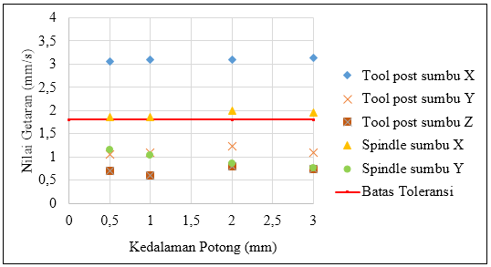The results of measuring the vibration level value at 330 rpm spindle rotation can be seen in Figure 9.

**Figure 9 Graph of the relationship of vibration values with spindle rotation 330 rpm**

From Figure 9 you can see a graph of the relationship between vibration values with spindle rotation of 330 rpm and cutting depths of 0.5 mm, 1 mm, 2 mm and 3 mm. The highest vibration level value in the tool post is on the x-axis of 3.13 mm/s with a cutting depth of 3 mm while the lowest vibration level value in the tool post is on the z-axis of 0.6 mm/s with a cutting depth of 2 mm. For the measurement position on the spindle, the highest vibration level value is on the x-axis of 1.96 mm/s with a cutting depth of 3 mm, while the lowest vibration level value is on the y-axis of 0.76 mm/s with a cutting depth of 3 mm. Figure 10 shows the relationship between cutting depth and spindle rotation, where the measurement results with a cutting depth of 0.5 to a cutting depth of 3 mm experience an increase in vibration value.

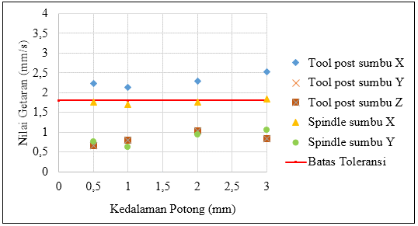The results of measuring the vibration level value at 1140 rpm spindle rotation can be seen in Figure 10.

**Figure 10 Graph of the relationship of vibration values (mm/s) with spindle rotation 1140 rpm**

From Figure 10 you can see a graph of the relationship between vibration values with spindle rotation of 1140 rpm and cutting depths of 0.5 mm, 1 mm, 2 mm and 3 mm. The highest vibration level value in the tool post is on the x-axis of 2.53 mm/s with a cutting depth of 3 mm while the lowest vibration level value in the tool post is on the z-axis of 0.66 mm/s with a cutting depth of 1 mm. For the measurement position on the spindle, the highest vibration level value is on the x-axis of 1.83 mm/s with a cutting depth of 3 mm, while the lowest vibration level value is on the y-axis of 0.63 mm/s with a cutting depth of 1 mm.

The measurement results in Figure 10 are almost the same as the measurement results in Figure 8, where the measurement results show an increase in vibration values from a cutting depth of 1 mm to 3 mm. As for the cutting depth of 0.5, there is no visible relationship between cutting depth and rotation.

**Surface roughness measurement results**

The results of measuring the surface roughness value at 60 rpm spindle rotation can be seen in Figure 11.

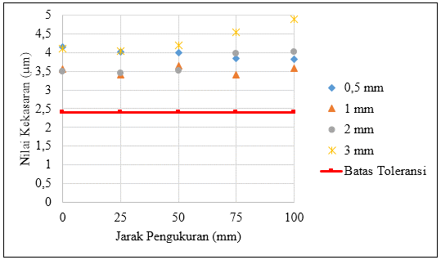

**Figure 11 Graph of the relationship of surface roughness values with 60 rpm spindle rotation**

From Figure 11, you can see the results of measuring the surface roughness value in the cutting process due to variations in cutting depth with a spindle rotation of 60 rpm. The result was obtained at a cutting depth of 0.5 mm, the highest surface roughness value at the 0 mm measurement position of 4.143 μm. For a cutting depth of 1 mm, the highest surface roughness value at the 50 mm measurement position is 3.637 μm. Meanwhile, for a cutting depth of 2 mm, the highest surface roughness value at the 100 mm measurement position is 4.021 μm. As for the cutting depth of 3 mm, the highest roughness value at the 100 mm measurement position is 4.883 μm. Based on Table 2 The surface elasticity value at 60 rpm spindle rotation has exceeded the permissible tolerance limit.

The results of measuring the surface roughness value at 215 rpm spindle rotation can be seen in Figure 12.

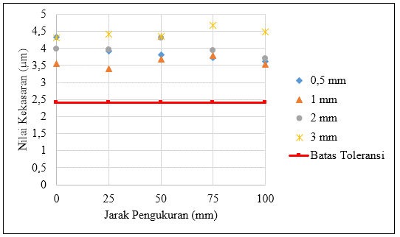

**Figure 12 Graph of the relationship of surface roughness values with spindle rotation 215 rpm**

From Figure 12, you can see the results of measuring the surface roughness value in the cutting process due to variations in cutting depth with a spindle rotation of 215 rpm. Results were obtained with a cutting depth of 0.5 mm, the highest surface roughness value at the 0 mm measurement position of 4.328 μm. For a cutting depth of 1 mm, the highest surface roughness value at the 75 mm measurement position was 3.801 μm.

However, for a cutting depth of 2 mm, the highest surface roughness value at the 50 mm measurement position is 4.313 μm. As for the cutting depth of 3 mm, the highest roughness value at the 75 mm measurement position is 4.685 μm. Based on Table 2, the surface roughness value at 215 rpm spindle rotation has exceeded the permissible tolerance limit.

The results of measuring the surface roughness value at 330 rpm spindle rotation can be seen in Figure 13.

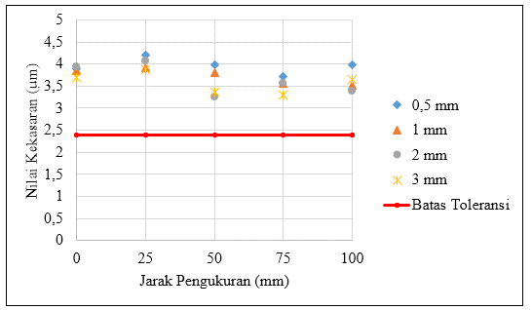

**Figure 13 Graph of the relationship of surface roughness values with spindle rotation 330 rpm**

From Figure 13, you can see the results of measuring the surface roughness value in the cutting process due to variations in cutting depth with a spindle rotation of 330 rpm. With a cutting depth of 0.5 mm, the highest surface roughness value at the 25 mm measurement position was 4.213 μm. For a cutting depth of 1 mm, the highest surface roughness value at the 0 mm measurement position is 3.843 μm.

As for the cutting depth of 2 mm, the highest surface roughness value at the 25 mm measurement position is 4.071 μm. As for the cutting depth of 3 mm, the highest roughness value at the 25 mm measurement position is 3.878 μm. Based on Table 2, the surface elasticity value at 330 rpm spindle rotation has exceeded the permissible tolerance limit.

The results of measuring the surface roughness value at 330 rpm spindle rotation can be seen in Figure 14.

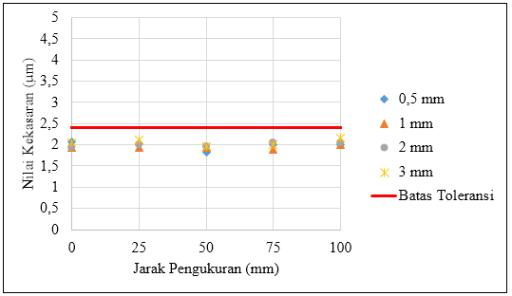

**Figure 14 Graph of the relationship of surface roughness values with spindle rotation 1140 rpm**

From Figure 14, you can see the results of measuring the surface roughness value in the cutting process due to variations in cutting depth with a spindle rotation of 1140 rpm. The result of 0.5 mm cutting depth is the highest surface roughness value at the 0 mm measurement position of 2.062 μm. For a cutting depth of 1 mm, the highest surface roughness value at the 100 mm measurement position is 1.993 μm. As for the cutting depth of 2 mm, the highest surface roughness value at the measurement position of 75 mm and 100 mm is 2.057 μm. As for the cutting depth of 3 mm, the highest roughness value at the 100 mm measurement position is 2,160 μm. Based on Table 2 The surface elasticity value at 1140 rpm spindle rotation is still within the permissible tolerance limit.

From variations in spindle rotation and cutting depth, surface roughness measurement values are still within tolerance limits at 1140 rpm spindle rotation with cutting depths of 0.5 mm, 1 mm, 2 mm and 3 mm. Meanwhile, for spindle rotations of 60 rpm, 215 rpm and 330 rpm, the surface roughness value has exceeded the permissible tolerance limit.

**Product roundness measurement results**

From the results of the measurement of roundness, the highest value of shernality deviation in the product is 0.02 mm while the lowest deviation value is 0 mm. Referred to from the ISO / R 1101 standard, the deviation value obtained from the results of the cutting process with a varied spindle rotation is still at the permissible tolerance limit of 0.03 mm.

**Product dimension error value measurement results**

The measurement results of the product dimensional error can be seen in Figure 15.

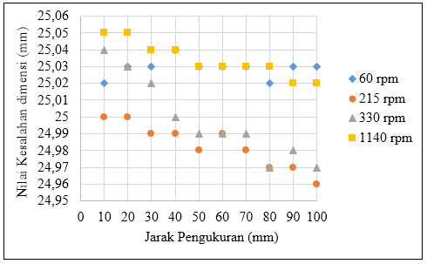

**Figure** 15 **Graph of product dimensional error values at 60 rpm, 215 rpm, 330 rpm and 1140 rpm spindle revolutions**

From Figure 15 can be seen the highest deviation value at 1140 rpm spindle rotation with a measurement value of 25.05 mm and the lowest deviation value at 215 rpm spindle rotation with a measurement value of 24.96 mm. Of all the variations in spindle rotation used in the cutting process, the value on the graph shows that the dimensional error value has decreased from a distance of 0 mm to 100 mm.

**Discussion**

Judging from Table 1, the vibration level value obtained from the measurement results has exceeded the permissible tolerance limit, which is 1.8 mm / s. When viewed from Table 1, the vibration on the lathe tool machine is already in the unsafe category. This can happen because the engine is not normal (reconditioned) so that the vibration during the cutting process has exceeded the tolerance limit and engine performance at the time of spindle rotation and a certain cutting depth is no longer optimal.

From the measurement of the vibration level value, it is known that the machining parameter also affects the vibration value during the cutting process. From the measurement results, the vibration value in the toolpost is higher than the vibration value in the spindle, this occurs because the rigidity of the machine compound and the source of vibration when cutting is closer in the toolpost than in the spindle so that the vibration that occurs in the tool post is greater than the vibration in the spindle. For the highest vibration value in the tool post is on the x-axis. The x-axis vibration value is higher than the vibration value at other measurement points. This happens because the cutting force is in the same direction as the x-axis so that the highest vibration occurs on the x-axis.

In addition, vibration during the cutting process is also caused by a regenerative chatter caused by the growl of the cutting process attached to the chisel, resulting in vibration and affecting the quality of the geometry of the resulting product. Such as surface roughness that becomes high, the level of roughness and roundness and dimensions of the product that change due to the occurrence of regenerative chatter.

Based on the variety of cutting parameters used, the most optimal cutting parameter with a low vibration level is in the 1140 rpm cutting process with a cutting depth of 1 mm with a vibration value of 2.1 mm / s while the most optimal cutting process produces the highest vibration level value is in the cutting process at 215 rpm with a cutting depth of 3 mm with a vibration value of 3.4 mm / s.

From the measurement results, the highest surface roughness value is at 215 rpm with a cutting depth of 3 mm, the surface roughness value is 4.449 μm. From the highest roughness results at 215 rpm spindle rotation with a cutting depth of 3 mm, it is related to the highest vibration results are at spindle rotation RPM with a cutting depth of 3 mm vibration value of 3.4 mm/s. As for the lowest surface roughness value at 1140 rpm spindle rotation with a cutting depth of 1 mm with a surface roughness value of 1.940 μm. This relates to the lowest vibration value among the rotation variations used is in the spindle rotation of 1140 rpm at a depth of 1 mm with a vibration value of 2.1 mm / s.

Referred to in Table 2, the surface roughness value obtained from variations in spindle rotation and cutting depth during the cutting process is a surface roughness value that still meets the tolerance limit at 1140 rpm spindle rotation, while at 60 rpm, 215 rpm and 330 rpm spindle rotations, the results of measurements have exceeded the permissible tolerance limits.

In the measurement of roundness, the measurement value is clockwise (cw) and counterclockwise (ccw) experiencing differences in measurement results, this occurs due to hystericis at the time of measurement. Hysteresis is one of the properties of getting along where hystericis is caused by measurements made in two directions. From the sphericity measurement data, the highest sphericity deviation value is 0.02 mm and the lowest sphericity deviation value is 0 mm. From these results, it shows the value of the sphericity deviation on the shaft that has been carried out by the cutting process with variations in spindle rotation of 60 rpm, 215 rpm, 330 rpm and 1140 rpm is still at the allowable tolerance limit of 0.03 mm

When measuring dimensional errors, measurement values with rotations of 60 rpm, 215 rpm, 330 rpm and 1140 rpm with a distance of 10 mm to 100 mm decrease in the dimensional value of the cutting results. This happens because during the cutting process there is a deflection that results in a change in the dimensions of the product. In addition, run out during the cutting process also results in changes in the dimensions of the product made.

The cutting process is carried out with variations in spindle rotation resulting in the desired product dimensions with a diameter of 25 mm. The result of the deviation from the measurement of product dimensional error is obtained the highest deviation value of 25.05 mm while for the lowest deviation value of 24.96 mm.

From the measurement results that have been carried out, the machine cannot be used in certain circumstances because the vibration value and surface roughness value have exceeded the permissible tolerance limit, so they cannot achieve the desired quality of product geometry. But the machine can still be used for cutting processes that do not necessarily have high geometric qualities

**Conclusion**

The conclusions obtained from this study are as follows:

From the results of the cutting process with the influence of machining parameters on vibration, the most optimal value with a low vibration level is obtained in the cutting process with a rotation parameter (n) of 1140 rpm and a cutting depth (a) of 1 mm resulting in a vibration value of 2.1 mm / s. And for the most optimal cutting process to produce the highest vibration level value is in the cutting process with a rotation parameter (n) of 215 rpm and a cutting depth (a) of 3 mm resulting in a vibration value of 3.4 mm / s. The vibration level measurement results obtained by the vibration level value have exceeded the permissible tolerance limit.

Based on variations in machining parameters, the optimal cutting process with geometric quality that is still within the permissible tolerance limit is the cutting process with a rotation parameter (n) of 1140 rpm. However, for the results of measuring the quality of product geometry with rotation parameters (n) 60 rpm, 215 rpm and 330 rpm, the quality results of product geometry obtained have exceeded the allowable tolerance limit

**References**

Alfianto, Rendi, & Wulandari, Diah. (2018). Studi Eksperimen Kecepatan Putar Spindle Dan Kedalaman Potong Terhadap Getaran Pahat Dan Tingkat Kekasaran Pada Proses Pembuatan Poros Menggunakan Mesin Bubut. *Jurnal Teknik Mesin*, *6*(2).

Ghionea, Ionuţ, Ghionea, Adrian, Cioboată, Daniela, & Ćuković, Saša. (2016). Lathe machining in the era of Industry 4.0: Remanufactured lathe with integrated measurement system for CNC generation of the rolling surfaces for railway wheels. *Product Lifecycle Management for Digital Transformation of Industries: 13th IFIP WG 5.1 International Conference, PLM 2016, Columbia, SC, USA, July 11-13, 2016, Revised Selected Papers 13*, 296–308. Springer.

Koenigsberger, Franz, & Tlusty, Jiri. (2016). *Machine tool structures*. Elsevier.

Muhammad Syahroni. (2018). *Pengukuran Kualiatas Geometri Mesin Perkakas Dan Produk Pada Rekondisi Mesin Perkakas Bubut Emco Maximat Super II Berdasarkan ISO 1708. Bengkulu, Jurusan Teknik Mesin Fakultas Teknik Universitas Bengkulu.*

Rahman, Fahrur. (2017). *Variasi Kehausan Pahat HSS Terhadap Catter (Vibrasi) Pada Mesin Perkakas Bubut Celtic 14. Bengkulu, Jurusan Teknik Mesin Fakultas Teknik Universitas Bengkulu.*

Raul, Raul, Widiyanti, Widiyanti, & Puspitasari, Rr Poppy. (2017). Pengaruh variasi kecepatan potong dan kedalaman potong pada mesin bubut terhadap tingkat kekasaran permukaan benda kerja ST 41. *Jurnal Teknik Mesin*, *24*(1).

Robichaud, J. Michael, & Eng, P. (2009). Reference standards for vibration monitoring and analysis. *Bretech Engineering Ltd*, *70*.

Rochim, Taufiq. (1993). *Teori & Teknologi Proses Pemesinan. Bandung, Institut Teknologi Bandung (ITB).*

Şahinoğlu, Abidin, & Rafighi, Mohammad. (2020). Investigation of vibration, sound intensity, machine current and surface roughness values of AISI 4140 during machining on the lathe. *Arabian Journal for Science and Engineering*, *45*, 765–778.

Takaya, Yasuhiro. (2014). In-process and on-machine measurement of machining accuracy for process and product quality management: A review. *International journal of automation technology*, *8*(1), 4–19.

Taufiq, Rochim. (2001). Spesifikasi, Metrologi dan Kontrol Kualitas Geometrik. *Bandung: Lab. Metrologi Industri, Departemen Teknik Mesin FTI-ITB*.

Taufiq, Rochim. (2006). Spesifikasi, Metrologi & Kontrol Kualitas Geometrik 2. *Bandung: ITB*.

TOMESCU, Mădălin. (2020). Analysis Of The Possibilities Of Reduction And Measurement Of Cutting Tool Vibrations During The Cutting Process. *Annals of’Constantin Brancusi’University of Targu-Jiu. Engineering Series*, (2).

Tornando, Hengki. (2018). *Analisa Level Getaran Roughing dan Finishing pada Proses Bubut Muka dan Dalam. Bengkulu, Jurusan Teknik Mesin Fakultas Teknik Universitas Bengkulu.*

Yoggy, Muhammad A dan Mahendra, Arya S. (2017). *Analisa Getaran Pahat Terhadap Kerataan Material Baja Mild Steel St 42 Pada Proses Bubut Konvensional. Surabaya, Jurusan Teknik Mesin Fakultas Teknik Universitas Surabaya.*