**Nasi Kapau as Gastronomic Tourism Attraction In West Sumatra**

**Siti Mardiyah, Putu Sucita Yanthy, I Ketut Antara**

Udayana University, Indonesia

Email: sitimardiyah08@student.unud.ac.id, putusucita@unud.ac.id, ketutantara@unud.ac.id

* Correspondence: sitimardiyah08@student.unud.ac.id

|  |  |
| --- | --- |
| **KEYWORDS** | **ABSTRACT** |
| Gastronomy tourism, Nasi kapau, West Sumatra | Nasi kapau is a famous culinary delight from West Sumatra. This cuisine is also well-known with the 'Uni' as the sellers. The 'Uni', or the female merchant, sells nasi kapau in a unique and distinguished way. Nasi kapau has developed into a culinary tourism attraction in West Sumatra in Los Lambuang and Nagari Kapau. This research aims to analyze the element of nasi kapau to improve the cuisine as a gastronomic tourism attraction in West Sumatra. This research uses a qualitative descriptive analysis method. In-depth interviews was done to five women that have experience in selling nasi kapau over 27 years. This research indicates the need for a development strategy to develop nasi kapau as a gastronomy tourism attraction. Storytelling is required to complete the missing gastronomy triangle to market nasi kapau. Collaborative governance is also essential in stakeholder collaboration in achieving research objectives. Empowering the community as human resources in tourism is also vital in developing nasi kapau as gastronomy tourism. Nasi kapau is already a renowned culinary attraction, but to elevate the cuisine into becoming gastronomic tourism attraction, certain measures are required as a strategic development to achieve this objective. |
|  |
|  | Attribution- ShareAlike 4.0 International (CC BY-SA 4.0)  **https://jurnal.syntax-idea.co.id/public/site/images/idea/88x31.png** |

**Introduction**

West Sumatra is one of the provinces that focuses on halal culinary tourism as a tourist attraction. In 2016, Indonesia dominated the World Halal Tourism Award, and West Sumatra won the World's Best Halal Culinary Destination (Indonesia Travel, 2020). Halal tourism is a tourism sector that targets a broader tourist market, focusing on Muslims and non-Muslims. Rendang is a well-known West Sumatran culinary dish that is very popular and a tourist’s favorite. In 2021, the Ministry of Tourism and Creative Economy designated five traditional Indonesian culinary icons: Soto, Rendang, Sate, Nasi Goreng, and Gado-gado (Pariwisata, 2021). According to Vita Datau, rendang is a leading culinary example with a strong philosophy; meat represents parents providing welfare for their children, and coconut milk reflects the intellectual community as a link and influence (Messakh, 2017). As a halal tourist destination, West Sumatra has diverse and halal culinary delights. Apart from Rendang, there are other traditional foods typical of West Sumatra, namely: sate padang, dendeng balado, itiak lado mudo, sour padeh fish, lamang, sala lauak, kacimuih, pinyaram, karupuak sanjai, bareh randang, galamai, curd, talua tea, and bika talago (Sari, Turgarini, & Handyastuti, 2019).

Gastronomy is essential in increasing a destination's uniqueness and attractiveness. Gastronomy is related to tourists' experiences subscribing to typical food at a destination. Gastronomic tourism does not only focus on food but also on elements such as history, cooking ingredients, storytelling, and culture. Hence, culinary delights in West Sumatra can be developed into gastronomic tourism to increase uniqueness and exciting tourist experiences. There are much more variety of West Sumatran culinary delights, apart from rendang, one of them is nasi kapau. Nasi kapau won the second place in the most popular traditional food in the Anugerah Pesona Indonesia (API) event in 2022 (Ainil, 2016). Nasi kapau is also the most sought-after specialty food for visitors to Bukittinggi, not only national but also international tourists (Imran, 2022). On the YouTube channel, Food vloggers from Canada, Luke Martin and Trevor James, visited the city of Bukittinggi to review the credentials of nasi kapau. They gave the nasi kapau a score of 9.5 out of 10. Nasi kapau is a typical rames rice from the Kapau area, Agam district (Yusrizal, 2022). Nasi kapau has been around since the 19th century; the first time nasi kapau was sold by Minangkabau women at the Payakumbuh market was in 1911 (Setya, 2020). The unique thing about nasi kapau is the business typically run by th Minangkabau women. Women were left to migrate and started a business selling recipes from their area, Nagari Kapau (Nabila, 2022).

The Minangkabau people's tradition of migrating and trading has made nasi kapau available in various markets in West Sumatra, including the Bukittinggi and Agam areas. Kapau rice looks similar to nasi Padang, which is usually more widely known and easier to find. The difference between the two lies in the way of presentation, the position of the seller, and the type of vegetables and curry (Andryanto, 2021). When serving Kapau rice, the seller usually has a long spoon to take the available side dishes and serves them on a tiered wooden table (Sari, 2019).

Nasi Kapau does not have Nasi Kapau ambassadors, nor is it a West Sumatra provincial government concern. Hence, it is different from Nasi Padang, which has a Nasi Padang ambassador, and the coronation was given directly by the Deputy Governor of West Sumatra. Nasi kapau became known because of a video from a YouTube food traveler vlogger named Nex Carlos; in 2017, he uploaded a video of eating nasi kapau at Los Lambuang, Bukittinggi. This video was watched 1,743,010 times; Nasi Kapau is better known and is increasingly sought after by tourists visiting Bukittinggi. However, the origin of nasi kapau from Nagari Kapau, Agam Regency, has not become a tourist attraction (Al Amien & Najmi, 2023).

This study uses the concept of Indonesian gastronomy and the theory of sustainable tourism. Gastronomy can be used as a representation of cultural experience, cultural identification, status, and communication at a tourist destination (Frochot, 2008). In the tourism sector, food can be used as an icon or characteristic of a destination. Indonesian gastronomy consists of food, history, and culture. Sustainable tourism is one of the basic principles of tourism development. According to Sharpley (2006), sustainable tourism aims to balance the tourism environment, local community needs, and tourist needs (Sulistyadi, Eddyono, & Entas, 2019)

**Research Methods**

This research was conducted using a qualitative approach. This study aims to find and explore strategies for developing gastronomic tourism in Agam Regency. This research method can help researchers interpret, record, and interpret the phenomena and problems that arise. This qualitative research was used because the research location in Agam Regency is still in the development stage for its tourism sector, so other research methods need to be adequate. Qualitative research methods help researchers in classifying, compiling, and describing research using various methods such as in-depth interviews, observations of research objects, and literature studies. This qualitative research will refer to the perspective of the informant. In analyzing this research, adequate data is needed, as well as informants and the depth of the researcher in analyzing the research using a descriptive and deductive approach.

**Results and Discussions**

West Sumatra is divided into three regions known as luhak nan tigo, namely Luhak Agam, Luhak Limapuluh Kota, and Luhak Tanah Datar. This area is a *darek* or highland area. Nagari Kapau is included in Luhak Agam, a highland area that produces the most extensive land use, namely rice fields or wetland agriculture, with ​​297.07 Ha and the smallest area of ​​6.79 Ha. Agam Regency has a variety of culinary delights, including *gulai itiak lado mudo*, *limpiang lapek bugih, palai rinuak, gulai pukek, pensi dishes, kamang* crackers, and *cangkiang* crackers. Highlanders generally eat and drink warm food. One warmth you get through food is the spicy taste of chilies. Spicy flavors can provide warmth and increase temperature. The food of Bukittinggi and its surroundings usually uses hot chilies from Alahan Panjang (Afrilian, Yulianda, & Afriani, 2021).

Nasi kapau is rames rice from Nagari Kapau, Agam Regency, West Sumatra. Nasi Kapau is one of the businesses of the Nagari Kapau community. Proficiency in cooking since the era of struggle with side dishes and curry, which has its characteristics, makes nasi kapau worthy of being a business. The first person selling nasi kapau was the Dangkek Paninjauan jorong, then followed by other jorong (Aminuddin, 2018). In the 60s, the Kapau people traded in the upper and lower markets of Bukittinggi city. Generally, people who buy nasi kapau at the lower market only buy *gulai cubadak* and a few side dishes, and the rice is brought from home. However, the time when nasi kapau traders sell differs between the upper and lower markets. Most nasi kapau traders in the lower market sell nasi kapau, not only in the Bukittinggi market. On Thursdays and Sundays in Padang Luar, Mondays in Baso, and Fridays in Piladang (AULIYA, 2021).

According to UNWTO, the concept of Indonesian gastronomy is that food has ingredients with a history that can be retold. There are rituals or ceremonies in a culture. Nasi Kapau is related to the celebration of farmers who celebrate the harvest by eating together. Eating together is known as eating *bajamba*. Apart from that, rice kapau is also related to the activities of migrating Minangkabau people (Caren, 2023).

The word gastronomy first appeared in modern times, precisely in French, written by Jacques Berchoux in 1804 (Hjalager & Richards, 2003). Gastronomy is the study of the relationship between culture and food. Gastronomy is a product of the cultivation of agricultural activities so that a food's color, aroma, and taste can be traced to its origin from the environment where the raw materials are produced (Barrera & Alvaradi, 2008). In relation to tourism, gastronomy can represent cultural experience, identification, status, and communication at a tourist destination (Frochot & Kreziak, 2008), In the tourism sector, food can be used as an icon or characteristic of a destination.

Gastronomy has two functional dimensions, which are basic human needs, namely eating, and the second is characteristic. In Indonesia, most tourist destinations rely on natural potential, and no one has developed gastro destinations that attract tourists. Gastronomy and culinary can improve the image of a destination so that it becomes a tourist attraction (Iqbal, 2019). West Sumatra is the leading destination for the Indonesian tourism ministry, and being crowned the World's Best Halal Culinary Destination can unlock the tourism potential of West Sumatra to become a tourist destination. In addition, easy-to-find halal food in West Sumatra adds to the market potential of tourists who can visit West Sumatra (Satriyani & Syarif, 2013).

Indonesian gastronomy has elements that can increase the attractiveness and competitiveness of a destination. These elements can be seen in the following triangle concept of Indonesian gastronomy:

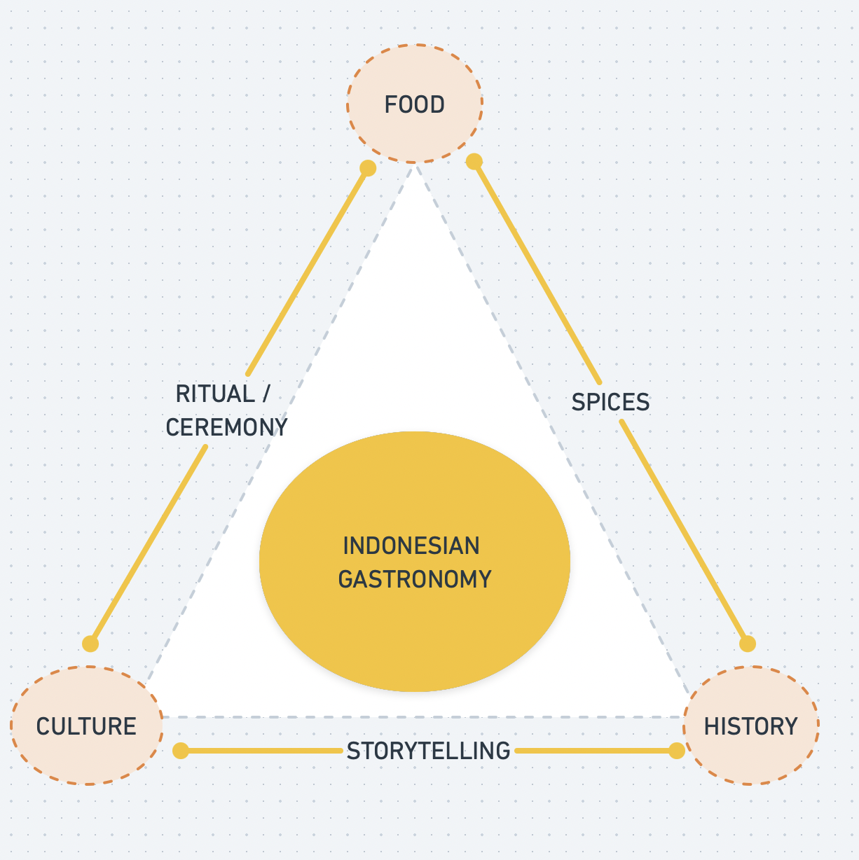

**Figure 1 *Triangle Concept of Indonesian Gastronomy***

Source: UNWTO Global Report on Gastronomy (2012)

The concept of Indonesian Gastronomy above illustrates the close relationship between food, history, and culture. This chapter will focus on food, spices, and history only. Bukittinggi is known for its Gadang clocks, high markets, cultural tourism, and natural tourism, making the city of Bukittinggi a tourist city in West Sumatra. However, the packaging and gastronomic presentation are still not neatly arranged, especially the nasi kapau. The history of nasi kapau is no longer known to the current second to third generations who are still actively trading nasi kapau. Hence, it is due to a lack of storytelling, but nasi kapau has a history that can be developed into a form of packaging for nasi kapau (Resty, 2022).

**Spices**

According to the Kamus Besar Bahasa Indonesia (KBBI), *spices* are defined as various types of aromatic plant products that give food a special smell and taste. Spices have several roles and social meanings, including spices as a food flavor enhancer, corpse preservative, medicine, sex quality enhancer, and as a means of worship (Gardjito et al., 2019). In the 16th century, spices were used as a universal medium of exchange because there was no standardized currency. In the past, pepper was used to free slaves and pay trade customs between European countries (Gardjito et al., 2019). West Sumatra has many coconuts; since 1292, coconut trees have grown along the coast of West Sumatra.

Nasi kapau uses spices that are identical to the yellow color. In nasi kapau and Minangkabau dishes, this spice is called langkok-langkok and is the basic seasoning for nasi kapau. *Langkok-langkok* includes galangal, turmeric, turmeric leaves, bay leaves, limes, lemongrass. *Langkok-langkok* can be found in traditional markets in West Sumatra.

Generally, *langkok-langkok* is divided into two forms: the whole form and the form that has been refined or has been ground. Apart from *langkok-langkok*, there are red and yellow basic spices in nasi kapau, including processed coconut, namely coconut milk.

1. Galangal is one of the endemic plants of Southeast Asia. Galangal is often used in traditional Southeast Asian dishes, especially Thai and Indonesian ones. In Minang cuisine, galangal is a mandatory ingredient and is always used. Its use is usually in *geprek* because the texture is hard and difficult to mash with other ground spices. This is done to give off an aroma when sauteed with ground spices as an aromatic ingredient, along with lemongrass, lime, bay, and turmeric leaves. Galangal has a citrus taste and a distinctive aroma that gives food a fresh taste. This is very useful for Minang dishes, which generally contain coconut milk and can balance the fatty taste. The spice that lives in this soil has a distinctive and sharp aroma to enrich the taste.
2. Turmeric is also a vegetable root commonly used in Indonesian cooking. Turmeric's main function in cooking is as a coloring agent that appeals to the tastes of its audience. In Minang cuisine, turmeric gives a bright orange color when ground with other basic spices plus chili. As is often seen in nasi kapau dishes, most curry dishes are orange, which arouses buyers' taste. Besides its main function, turmeric provides a bitter and spicy taste in the throat, like pepper. The ratio of quantity used between turmeric and other root spices is usually in the middle, less than ginger but more than galangal. Regarding taste, turmeric does not contribute too much to a dish but plays a big role as a natural coloring in Minang cuisine, especially curry.
3. Apart from using the roots of the turmeric plant in Minang cuisine, turmeric leaves are also used as an aromatic ingredient to add complexity to the taste of a dish. In Minang cuisine, turmeric leaves are tied and slightly squeezed to release their aroma when cooked with other basic spices. When cooked, turmeric leaves give off a floral, bitter aroma and can strengthen the taste of the spice, provide a layer of fresh taste and eliminate the fishy smell. Apart from rendang, *gulai* and *kalio* in nasi kapau, turmeric leaves are also used as a filling for *tambunsu*, tofu and eggs to remove the fishy aroma from beef intestines. Turmeric leaves in Indonesia are mostly used only in Minang and Malay dishes. Turmeric leaves are also called natural flavoring because they enrich food taste. Turmeric leaves are a mandatory aromatic ingredient when cooking red meat to neutralize the fishy smell of the meat. Thus, every meat dish in Minang cuisine always uses turmeric leaves.
4. *Salam leaves* are plants that have a myriad of health benefits. These leaves have the physical characteristics of being elongated and pointed at the ends, rough textured and thick leaves. This leaf was believed to repel negative energy in the room in ancient Greek and Roman times. In addition, this leaf is also widely used in cooking to add aroma to dishes. These leaves are often used as a seasoning for Indonesian cuisine. Bay leaves are mainly used in soup dishes. In Minang cuisine, they can be used fresh or dry, even though the aroma will be milder. The use of bay leaves is usually put directly at the start of cooking so that the aroma can penetrate well into the dish. As with turmeric leaves, bay leaves can also function as a fishy smell remover in meat. These leaves are a mandatory ingredient when sautéing the basic ground spices, both the yellow spices used to make curries, *kalio* and *randang* and the white spices, which are usually used to make *soto padang*, chicken pop, and touco curry.
5. Lime puruik or kaffir lime is a citrus commonly used in Minang cuisine. This fruit provides a sour and fresh taste like an orange. Its use can increase the appetite of those who enjoy dishes that use this ingredient. This fruit is suitable for various dishes, including stir-fries, soups, and curry. This fruit is usually used when the food is almost cooked, and then the water is squeezed to liven up the taste of the dish. In coconut milk dishes, puruik lime plays a big role in providing a fresh aroma and taste. Unlike lime, lime contains a strong starch aroma without giving off a bitter or sour taste. Nevertheless, this fruit can provide a fresh fruit taste to help balance fatty dishes. Apart from being used to enhance and freshen the taste of spices, *puruik* lime is also used for the process of marinating proteins in Minang dishes, especially fresh fish, which is usually fishier and functions to remove mucus, red meat which aims to remove the fishy smell and tenderize the meat and is also often used. For chicken, the fruit and the leaves of the lime tree are also often used in coconut milk dishes. Its use is only kneaded and immediately put in during sautéing the spices. Lime leaves give a sharper aroma compared to a fresh taste like the fruit.
6. Lemongrass or *Sarai* is a type of grass that has a distinctive and fresh aroma. This plant is very commonly used in Southeast Asian cuisine. Lemongrass is an aromatic ingredient, especially in Thai, Vietnamese, Malaysian and Indonesian cuisine. The aroma of lemongrass is extracted from the bottom of the stem close to the roots and is white. The aroma can be maximized in that section. The aroma emitted by lemongrass comes from the essential oils contained in it. In contrast to Thai cuisine, the use of lemongrass in Minang cuisine is only crushed to release its aroma. In contrast, this plant is generally ground with other spices in Thai cuisine. The aroma of lemongrass adds a unique touch to dishes and adds a refreshing citrus aroma. Most lemongrass is only used in Minang cuisine because the texture of lemongrass is rough and coarse, making it difficult to mash and giving a fibrous texture to the ground spices. Even though it is not from the citrus plant family, lemongrass contains limonene compounds found in many citrus peels. The aroma of this fruit makes the use of lemongrass attractive and makes Minang cuisine more complex.
7. The Minang people familiarly call Ginger S*ipadeh*. Sipadeh can be interpreted in Indonesian as spicy. Ginger gives a spicy taste like pepper to dishes. Ginger can also remove the fishy smell in dishes. Ginger is included in the root spice, which has a shape similar to galangal but has a different taste. The spiciness of ginger is not spicy like chili but rather a warm taste. Processing of ginger in Minang cuisine is usually also mashed with onions and chilies. In addition to giving a warm taste, ginger can neutralize the aroma but does not give its distinctive aromas, such as lemongrass and galangal. Ginger is a common ingredient always used in red and white ground spices.

In addition to those basic ingredients, Nasi Kapau contains coconut milk. Coconut in West Sumatra is one of the most commonly found crops. Coconut milk is processed from coconut, and there is concentrated and not concentrated coconut milk. In 1784 the history of Sumatra, there were two important plants: rice and coconut. Coconut milk can make food that lasts longer because the Minangkabau people are constantly migrating. Thus, coconut is the main basic ingredient generally used in every dish in West Sumatra.

**History**

In the 18th century in West Sumatra, there was a war, namely the Padri War. The war that occurred during the Dutch colonial period involved the Minangkabau people's conflict between the Adat community and the Padri community. Padri (group of scholars), this war took place around the kingdom of Pagaruyung. This war occurred due to conflict in religious matters. This war involved the Netherlands in 1821-1825.

The Dutch ensured that there were no adult men in a Nagari or village in West Sumatra so they could take over power while pitting the Padri and Adat communities against each other. This left Minangkabau women and children alone and made adult men who did not want to go to war to migrate. This overseas route provided an opportunity for Minangkabau women who were left behind to support themselves and the families left by their men during the war.

*Merantau* or migrating is a tradition of the Minangkabau people, one of the causes of which is the Padri War. The Minangkabau people have overseas routes, namely four river lanes in Sumatra: the Rokan route, the Kampar route, the Indragiri route and the Batanghari route to Negeri Sembilan, Malaysia (Rahman in Mer, 2020). Apart from that, Nagari Kapau was one of the defense areas of the Padri people who fought against the colonial army. Nagari Kapau women started trading at the market and owned a *lapau* under a large tent or umbrella.

Women in Agam, West Sumatra, brought their wares to the market so that Nasi Kapau began to spread in various areas. In the past, West Sumatra had an active train route, so it was found that the distribution of nasi kapau was in line with the train line and on the same route as people who migrated. In 1911, *Lapau* kapau was found in the Payakumbuh market and has developed (Rahman in Mer, 2020).

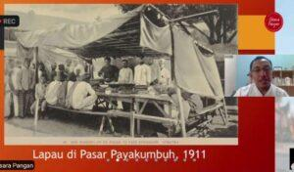

**Figure 2 Lapau kapau that has developed in Payakumbuh**

**Source: Seni berjalan, 2020**.

Based on the results of an interview with Reno Andam Suri (2023), women who sell rice kapau sell in different location and moving all the time. This follows Balai day; Balai day is a market day different for every West Sumatra region. This activity has been happening since the Dutch era, before using carts. During the Dutch era, using the train, this train arrived in Payakumbuah and passed Nagari Kapau. The remaining railroad tracks are still on the right side, known as the Situjuah market. In the Situjuah market area, the Kapau people sell rice from Nagari Kapau. Nasi Kapau is known because the seller of Nasi Kapau brings Nasi Kapau around and can be enjoyed on Balai Day.

**Culture**

In West Sumatra, there is a tradition of eating using your hands. In Bukittinggi, especially, people have the habit of eating together on the floor without tables and chairs. This tradition is also related to eating habits, one of which is prioritizing older people to eat first. When eating Bajamba, Minangkabau people have side dishes and snacks, usually especially served and arranged based on the event. According to Fadly Rahman (2023), nasi kapau cannot be separated from eating *bajamba*. From the results of an interview with Fadly Rahman

Nasi kapau cannot be separated from the traditions of eating together, for example, *bajamba*. Furthermore, this is a form of ritual among the agricultural communities of West Sumatra. Especially in the Agam region, when harvesting, they will eat together and enjoy dishes that later became known and developed as typical Kapau food with their spices and processing (Interview, 16 June 2023).

Then it developed into *lapau-lapau*, a tradition of wandering accompanied by traveling without a vehicle. Every area in Kapau has stalls to fill their stomachs, and these stalls are relied on by migrants to rest for a while and to eat. This has become a special destination in Kapau. This is the forerunner to becoming los lambuang. In field observations, people did not know about this culture or tradition as part of nasi kapau.

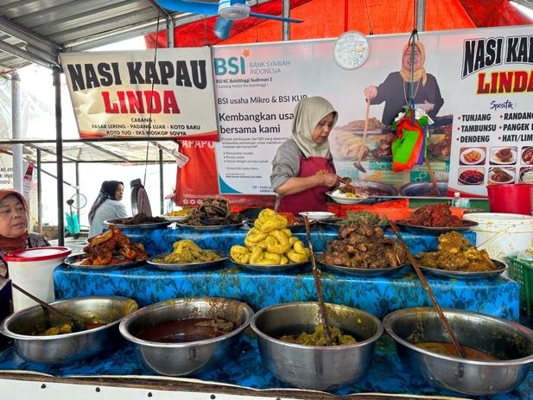

**Figure 3 Arrangement of nasi kapau**

**Source: 2023 research photo**

Nasi kapau is served in an arrangement, as shown in Figure 3. In serving it, nasi kapau entrepreneurs use a large wooden spoon. This makes it easier to take side dishes, especially curry, which is at the bottom of the list. The serving of nasi kapau is accompanied by warm water in a glass, dipped in a small hand-washing basin for each person who enjoys it. Nasi kapau is served in an arrangement like Figure 3. In serving it, nasi kapau entrepreneurs use large wooden spoons. This makes it easier to take side dishes, especially curry, which is at the bottom of the list. The goulash is served at the bottom, and the dry ones at the top, then arranged with balado-balado. The serving of nasi kapau is accompanied by warm water in a glass, dipped in a small hand-washing basin for each person who enjoys it. Nasi kapau has a distinctive characteristic in its curry, namely that it contains bamboo shoots, *cempedak*, and Singgalang radish. However, currently Singalang radish is rarely found. The rice used in nasi kapau is Kuriak Kusuik rice.



**Figure 4 The output of Nasi Kapau as a Gastronomic Tourism**

**Nasi kapau as a Gastronomic Tourism Product**

Nasi Kapau has many devotees, which can be seen in the number of servings that usually run out of more than 100, especially on weekends and national holidays. nasi kapau connoisseurs come from various regions throughout Indonesia and foreign countries. In developing nasi kapau as a gastronomic tourism product, development is needed with development principles adapted from UNWTO and the European Travel Commission (ETC) Handbook on Tourism Product Development (ETC, 2011 in Morrison, 2019):

1. Appropriate scale: The development of Nasi Kapau has a significant positive impact on tourism in Bukittinggi. This can be seen in the enjoyment of tourists who enjoy Nasi Kapau. In addition, based on an interview on 2 June 2023 with Nadiatul, a visitor from Riau, he chose to visit the city of Bukittinggi at the weekend because of its culinary specialties, especially Nasi Kapau.
2. Authenticity: Nasi kapau, as a gastronomic product, has authentic spices and rice ingredients produced by Nagari Kapau, as well as spices that are sold in the city of Bukittingi. Also, Nasi Kapau has a history and culture that describes its people. Community support: Community members are not against development and support the development course.
3. Competitive differentiation: In this case, Nasi Kapau has not developed substantially different from what is found in competitive destinations.
4. Creativity and innovation: In this development, Nasi Kapau has innovations related to the side dishes served based on market demand. As before, fish curry with fish eggs is now replaced with tambunsu. In addition, Nasi Kapau, as a gastronomic tour, is a form of innovation and creativity.
5. Destination vision: Bukittinggi has consistent development every year, and evaluations in the tourism sector are carried out regularly. Also, the vision of making Bukittinggi a tourist city has been realized with support such as renovations to sidewalks, a zoo, and active social media for the Bukittinggi tourism office to introduce its destinations. Nevertheless, in Nagari, Kapau is still developing for tourism. Hence, the people, especially sellers, go to Bukittinggi to get many tourists.

As a person born in Riau, I have heard a lot that tourism in West Sumatra is one of the good tourist attractions in Indonesia, one of which is the city of Bukittinggi, which is famous for its special food and tourist attractions. Therefore, I often use Bukittinggi as a tourist destination (Interview, 2 June 2023).

1. Integration: The development of nasi kapau, in this case, the side dishes which are developed periodically, are integrated with the food ingredients available in the city of Bukittingi.
2. Market Needs and Feasibility: Visitors who come to Bukittinggi need a wider and more strategic place to eat Nasi Kapau. In an interview with Sarah, the diversity of side dishes and the cleanliness of nasi kapau play an important role in diners choosing to eat nasi kapau. However, the suitability of the location is still not optimal. This is illustrated by visitors to the Nasi Kapau place, which is still cramped, making it less comfortable because of the many enthusiasts and lovers of Nasi Kapau.
3. Positioning: The development of nasi kapau as a gastronomic product is in line with the designation of destinations as tourist cities and cultural cities in West Sumatra.
4. Sustainability: The development of nasi kapau as a gastronomic product does not damage the environment or the social and cultural order of the City of Bukittinggi.
5. Tourism stakeholder support: The lack of stakeholder support can be seen in the location and condition of Los Lambuang or the nasi kapau business premises in Nagari Kapau. Has not created good cooperation between entrepreneurs and tourism stakeholders, especially the tourism agency.

In UNWTO's theory of sustainable tourism (2005), tourism must utilize environmental resources, respect the socio-cultural authenticity of the community, and ensure long-term economic feasibility. Nasi kapau, as a product of gastronomic tourism in Bukittinggi, has utilized the resources found in the Bukittinggi region and its surroundings, such as Agam Regency in the eastern region. In addition, Nasi Kapau gastronomic tourism is a form of preserving traditional values ​​found in Nagari Kapau. Knowing the history, origins and culture of Nasi Kapau is a cultural asset built and lived to advance the Nagari Kapau area. Thus, Nasi Kapau as a tourism product benefits stakeholders, such as entrepreneurs, employees, and all those involved in the Nasi Kapau business, to get economic benefits and improve social services.

In developing Nasi Kapau as a product of gastronomic tourism, Nasi Kapau requires several implementations that can be applied to optimize Nasi Kapau as a product of gastronomic tourism. Nasi Kapau requires a strategy to be used in developing gastronomic tourism. Nasi kapau as a gastronomic product, has three gastronomic elements: spices, history and culture. Thus, the implementation needed to develop Nasi Kapau as a tourism product is storytelling, collaborative governance, and community-based tourism.

### Storytelling

In the Indonesian gastronomic triangle concept, food has culture, history, spices, and storytelling. Storytelling is a way to convey a story. This is needed for nasi kapau in the development of gastronomic tourism. In the gastronomic tourism activities of nasi kapau, there is currently a lack of storytellers who can tell the origins behind nasi kapau.

Storytelling is needed in tourist guidebooks. Tourist guidebooks are one of the media that can be used to introduce Nasi Kapau gastronomic tourism to tourists. The Bukittinggi city tourism office can provide a brief story about nasi kapau, not just pictures of nasi kapau. A tourist guidebook that can be accessed digitally to facilitate information about nasi kapau on various media platforms.

Someone needs to tell a story, and the storyteller guide can be used as a standard guide for the storyline. In addition, a storyteller should be from the local community so that they are more believable and can preserve culture. Consistency in a story, especially history, is needed so that the story does not have different plots. Thus, story instructions are needed to develop a tourism product written in a travel guidebook and told by the local community.

The development of Nasi Kapau requires knowledge and understanding of the local Nagari Kapau community towards tourism. With community participation and contribution to tourism, development can be done better. Gastronomic tourism requires storytelling as a form of narrative to preserve it. Thus, storytelling is a strategy for developing Nasi Kapau as a gastronomic tourism product.

### Collaborative Governance

In developing Nasi Kapau, collaboration between stakeholders and internal government agencies is needed apart from needing a storyteller. In Ansel and Gash's (2007) collaborative governance theory, there are several processes for collaboration. This section will discuss the collaboration flow for developing nasi kapau in Bukittinggi. In Figure 5, there are conditions for starting with the strengths, resources, and knowledge used for participation.

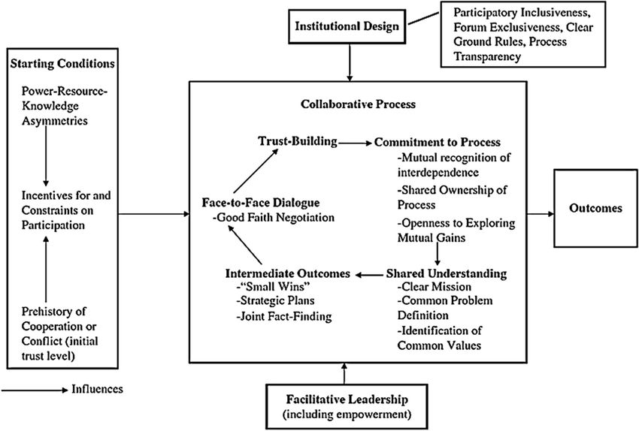

**Figure 5 *Collaborative Governance***

Resource: Ansell and Gash (2007).

In developing nasi kapau as a gastronomic product, collaboration to avoid conflict is necessary to process collaboration. The collaboration process can start with a discussion forum between stakeholders. Collaboration between the Bukittinggi city tourism office and Agam Regency is needed to develop nasi kapau tourism. This is because field observations found that the development of nasi kapau had stopped due to ownership of nasi kapau. The Agam Regency tourism office is trying to focus on nasi kapau entrepreneurs in the Nagari Kapau area, Agam Regency, even though there is no attraction to support there. On the other hand, the Bukittinggi city tourism office cannot develop because nasi kapau is a typical Nagari Kapau, Agam Regency food.

Local community development

Community empowerment, especially women towards politics in developing Nasi Kapau as a gastronomic tourism product in Bukittinggi, is still invisible. Community is one effort to provide empowerment. Thus, nasi kapau entrepreneurs can develop rice-kapau as a gastronomic tour in Bukittinggi with a community. The community formed is expected to have a good impact on the environment, society and economy in accordance with sustainable tourism. *Sustainable tourism* is an output that can be produced in the development of Nasi Kapau gastronomic tourism. In addition, it is hoped that Nasi Kapau gastronomic tourism can develop to preserve culture.

**Conclusion**

Nasi kapau is a well-known cuisine from Nagari Kapau, Agam Regency in West Sumatra. However, nasi kapau is known for Bukittinggi cuisine especially in Los Lambuang. Moreover, West Sumatra has many cuisine that identically uses coconut milk. Regarding the gastronomy elements such as history, culture, and the spices West Sumatra’s cuisine is not identified yet. Gastronomy become the essential elements in increasing and increasing the uniqueness and interest of a destination. In this way, culinary delights in West Sumatra can be developed into gastronomic tourism to add uniqueness and interesting experiences for tourists.

Nasi kapau become the gastronomy tourism attraction due to its uniqueness and its gastronomy elements. This research shows that a place that accommodates Nasi Kapau is needed as a destination for gastronomy tourism in Agam Regency. This is due to the inconsistent and uneven distribution of Nasi Kapau sellers, making it difficult for buyers to be able to access Nasi Kapau as a tourist attraction in Agam Regency. Improvement of attraction, amenities, accesibitily and ancillary in realizing Nasi Kapau as an attraction is needed. In addition, the strategy for developing Nasi Kapau as a gastronomic tourist attraction requires storytelling, collaboration from stakeholders, and community empowerment

**References**

Afrilian, Pepy, Yulianda, Harry, & Afriani, Atika. (2021). Strategi Promosi Wisata Kota Bukittinggi Melalui Kuliner Nasi Kapau. *Indonesian Journal Of Tourism And Leisure*, *2*(2), 107–117.

Ainil, Mardiyah. (2016). *Analisis Faktor-Faktor Yang Mempengaruhi Proses Pengambilan Keputusan Pembelian Konsumen Terhadap Nasi Kapau Di Kota Bukittinggi*. Universitas Andalas.

Al Amien, Fadel Marta, & Najmi, Najmi. (2023). Kehidupan Sosial Ekonomi Pedagang Nasi Kapau Di Los Lambuang Bukittinggi (1987-2020). *Jurnal Kronologi*, *5*(1), 404–418.

Auliya, Sulthon. (2021). *Persepsi Wisatawan Domestik Terhadap Wisata Kuliner Nasi Kapau Di Los Lambuang Bukittinggi*. Universitas Gadjah Mada.

Caren, Setyawan. (2023). *Pengaruh Memorable Culinary Tourism Experiences Terhadap Revisit Intention Yang Dimediasi Oleh Tourist Satisfaction Pada Pengunjung Warung Nasi Kapau Di Kota Bukittinggi*. Universitas Andalas.

Frochot, Isabelle, & Kreziak, Dominique. (2008). Customers’ Perceptions Of Ski Resorts’ Images: Implications For Resorts’ Positioning Strategies. *Tourism And Hospitality Research*, *8*(4), 298–308.

Gardjito, Edy, Limantara, Arthur Daniel, Ridwan, Ahmad, Subiyanto, Bambang, Heryanto, Budi, & Sudarmanto, Hery Lilik. (2019). Analysis Of The Embankment Stability With Flat Concrete Sheet Pile (Fcsp). *Journal Of Physics: Conference Series*, *1364*(1), 12056. Iop Publishing.

Hjalager, Anne Mette, & Richards, Greg. (2003). *Tourism And Gastronomy*. Routledge.

Iqbal, M. (2019). *Gambaran Perilaku Penjamah Makanan Nasi Kapau Di Pasar Lereng Kota Bukittinggi Provinsi Sumatera Barat Tahun 2019*.

Nabila, Rizki Illahi. (2022). *Penerapan Metode Pelatihan Off The Job Training Tentang Kualitas Pelayanan Di Nasi Kapau Evi*. Universitas Muhammadiyah Sumatera Barat.

Resty, Adriani. (2022). *Analisis Faktor-Faktor Yang Mempengaruhi Keputusan Pembelian Dan Kepuasan Konsumen Dalam Mengkonsumsi Olahan Produk Peternakan Di Nasi Kapau Los Lambuang Pasar Lereng Kota Bukittinggi*. Universitas Andalas.

Sari, Putri Andan. (2019). *Atraksi Wisata Gastronomi Di Desa Kapau Kabupaten Agam Sumatera Barat*. Universitas Pendidikan Indonesia.

Sari, Putri Andan, Turgarini, Dewi, & Handyastuti, Indriyani. (2019). Gastronomic Tourism Attractions In The Kapau Village, Agam Regency, West Sumatra. *Gastronomy Tourism Journal*, *5*(2), 29–41.

Satriyani, Rina, & Syarif, Wirnelis. (2013). Kepuasan Konsumen Di Kedai Nasi Kapau Uni Lis Bukittinggi. *Journal Of Home Economics And Tourism*, *4*(3).

Sulistyadi, Yohanes, Eddyono, Fauziah, & Entas, Derinta. (2019). *Pariwisata Berkelanjutan Dalam Perspektif Pariwisata Budaya Di Taman Hutan Raya Banten*. Uwais Inspirasi Indonesia.