**Ethnobotany of Medicinal Plants for Infectious Diseases**

**in the Besemah Tribe, Lahat Regency, South Sumatra Province, Indonesia**

**Nina Tanzerina, Desti Safitri, Harmida, Nita Aminasih, Juswardi**

Universitas Sriwijaya, Indonesia

Email: [ntanzerina@gmail.com](mailto:ntanzerina@gmail.com)

* Correspondence: [ntanzerina@gmail.com](mailto:ntanzerina@gmail.com)

|  |  |
| --- | --- |
| **KEYWORDS** | **ABSTRACT** |
| Ethnobotany, Besemah tribe, medicinal plants, infectious diseases, Battra | Knowledge about medicinal plants in the Besemah tribe community in Jarai District and Sukamerindu District, Lahat Regency, South Sumatra Province, has long been known and used for generations and stored as local wisdom of the community. The use of medicinal plants as one of the community's solutions to cure infectious diseases, with natural medicinal materials the side effects caused are relatively less. This study aims to inventory and identify the types of medicinal plants and types of medicinal plants typical of the Besemah tribe, how to process, how to use, and how to use specifically to treat infectious diseases in the Besemah tribe in Jarai District and Sukamerindu District, Lahat Regency, South Sumatra Province. This research will be conducted from January to March 2023. The study was conducted using quantitative descriptive methods by conducting interviews with 9 traditional medicine (battra) as sources of information. The results showed that plants used as medicine by the Besemah tribe community as many as 94 species of plants from 47 families to treat 29 infectious diseases. There are seven species of typical plants of the Besemah tribe, namely Fixed kadam (Hadgsonia macrocarpa (Blume) Cogn.), Mite (Debregeasia longifolia (Burm.f) Wedd), Memban bird (Donax canniformis (G.Forst) K.Schum), Temperingat (Rubus moluccanus L.), Poultice (Monophyllaea horsfieldii R.Brown), As cold as the forest (Fissistigma fulgens (Hook.f & Thomson) Merr.), Memaye (Leea indica (Burm.f.) Merr), and the typical way of processing is that the stem is cut, the water is collected and drunk directly. The most widely used plant part is the 38% leaf part. The most processing method is used by boiling 46% and the most use method by drinking 53%. |
|  |
|  | Attribution- ShareAlike 4.0 International (CC BY-SA 4.0)  **https://jurnal.syntax-idea.co.id/public/site/images/idea/88x31.png** |

**Introduction**

Ethnobotany is a branch of science that studies the use of plants as traditional medicine and the interaction of social traditions (Sarumaha, 2019). The use of plants as traditional medicine is one of the ways used by the community to overcome health problems (Riconadi, Arbiastutie, Mariani, Sisillia, & Yusro, 2020).

Infectious diseases are diseases caused by pathogenic microorganisms such as bacteria, fungi, parasites and viruses (Novard, Suharti, & Rasyid, 2019). The development of science and technology, people prefer natural treatment. Drugs derived from natural ingredients are relatively safe to avoid side effects that can harm the body (Widiastuti, Kiromah, & Ledianasari, 2017).

The Besemah tribe is one of the largest tribes in the South Sumatra region. The Besemah tribe is widespread and covers several cities such as Pagar Alam, Bengkulu and Lahat. The Besemah tribe community in Lahat Regency occupies areas in Jarai District and Sukamerindu District and for generations has used the plants around their homes for consumption or as a source of income. In addition, it is also used by the surrounding community as a traditional medicine ingredient to cure various diseases (Bedur, Pascal, & Suan, 2005).

Jarai District and Sukamerindu District, Lahat Regency have a high potential for medicinal plants to treat infectious diseases, so this research needs to be carried out to answer the need for information related to infectious disease medicinal plant data, medicinal plants used and traditional medicinal herbs used. This study aims to inventory and identify the types of medicinal plants and plants typical of the Besemah tribe, how to process, how to use, and how to use typical uses to treat infectious diseases in the Besemah tribe in Jarai District and Sukamerindu District, Lahat Regency, South Sumatra Province.

**Research Methods**

This research will be conducted from January to March 2023. Data collection was carried out in Jarai District, namely in Pamasalak Village, Talang Pisang Village, Nantigiri Village, Jemaring Village and Sukamerindu District, namely in Sukaraja Village, Gunung Liwat Village, and Karang Caya Village, Lahat Regency, South Sumatra. Herbarium making and plant identification were carried out at the Biosystematics Laboratory, Department of Biology, Faculty of Mathematics and Natural Sciences, Sriwijaya University.

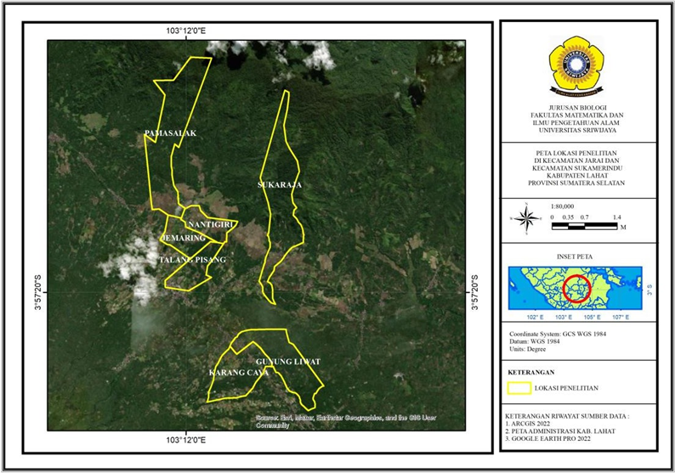

**Figure 1 Map of research locations in Jarai and Sukamerindu sub-districts, Lahat Regency**

**Tools and Materials**

The tools used in this study were stationery, audio recording devices, sprayers, plant scissors, sewing needles, cameras, ovens, information boards, knives or machetes, rulers, threads, fieldnotes, plastic bags, cardboard, herbarium paper 30x40 cm, label paper, newspapers, quiisoeners, gloves, rapia rope, and plywood while the materials used were 70% alcohol and samples of medicinal plants.

**How it Works**

**Interview**

Interviews were conducted directly to 9 traditional medicine (battra) of the Besemah tribe community in Jarai District (Pamasalak Village, Talang Pisang Village, Nantigiri Village, Jemaring Village) and Sukamerindu District (Sukaraja Village, Gunung Lewat, and Karang Caya Village) Lahat Regency, South Sumatra. The interview method used is a semi-structured interview.

**Plant Identification**

Plant sample identification was carried out at the Biosystematics Laboratory, Department of Biology, Faculty of Mathematics and Natural Sciences, Sriwijaya University and Herbarium of Andalas University Padang.

**Results and Discussions**

Based on the results of the study, the total number of medicinal plants from 9 local traditional medicine (batra) who are the indigenous people of the Besemah tribe, is as many as 94 types of medicinal plants, consisting of 47 families used to treat 29 infectious diseases as in Table 1 below.

The most sources of medicinal plants are obtained from the yard of 51 types of houses and from forests as many as 21 types and the least from rice fields 1 type.

**Table 1 Types of Infectious Disease Medicinal Plants used by the Besemah Tribe Community**

|  |  |  |  |  |
| --- | --- | --- | --- | --- |
| No | Plant Name | | Source of Acquisition | Types of disease |
| **Local Name** | **Scientific Name** |
|  | Reeds | *Imperata cylindrica* L. | Curbside | Cough with phlegm, intestinal worms, hepatitis, lymph nodes |
|  | Tamarind | *Tamarindus indica* L. | Yards | Oral candidiasis, diphtheria |
|  | Bangle | *Zingiber cassumunar* Roxb. | Yards | Pneumonia |
|  | Onion sprinkle gife/ Chives | *Allium tuberosum* Rottl. ex Spreng | Yards | Typhoid |
|  | Onion | *Allium ascalonicum* L. | Buy | Toothache |
|  | Garlic | *Allium sativum* L. | Buy | Mumps, lymph nodes, toothache |
|  | Iron star fruit | *Averrhoa bilimbi* L. | Yards | Coughing up phlegm |
|  | Bengkoang | *Pachyrhizus erosus* L. | Garden | Diphtheria |
|  | Brotowali | *Tinospora cordifolia* L. | Yards | Chickenpox, intestinal worms, dengue, hepatitis, scabies, ringworm, malaria |
|  | Reed/bamboo | *Bambusa vulgaris* Schrad. ex Wendl | Forest | Mumps |
|  | Yellow reed | *Bambusa vulgaris striata* McClure | Forest | Hepatitis, rabies, tetanus |
|  | Hibiscus | *Hibiscus rosa-sinensis* L. | Yards | Boils, toothache |
|  | Cape mountain | *Gynura segetum (*L.) Merr | Forest | Elephantiasis |
|  | Clove | *Syzygium aromaticum* L. | Buy | Toothache |
|  | Dedap | *Erythrina variegeta* L. | Garden | Elephantiasis |
|  | Durian | *Durio zibethinus* Murr. | Garden | Boils, mumps, scabies, ringworm |
|  | Agarwood | *Aquilaria malaccensis* Lamk. | Forest | Chickenpox, measles |
|  | Gambir | *Uncaria gambir* (Hunter) Roxb. | Forest | Coughing up phlegm, Ulcers |
|  | Circle | *Cassia alata* L. | Yards | Scabies, ringworm, panu |
|  | Inay water/henna water | *Impatiens balsamina* L. | Yards | Nail fungus |
|  | Inay rod | *Lawsonia inermis* L. | Yards | Nail fungus |
|  | Ginger | *Zingiber officinale* Rosc. | Yards | Cough, Cough with phlegm, typhoid |
|  | Red ginger | *Zingiber Officinale* Roxb. Var. rubrum Rosc | Yards | Malaria, pneumonia |
|  | Guava | *Psidium guajava* L. | Yards | Cough, worms, diarrhea, dengue, malaria, muntaber |
|  | Guava bol | *Syzygium malaccense* L. | Yards | Diarrhea |
|  | Guava klampok / Forest guava | *Syzygium densiflora*  (Blume) Miq. | Forest | Diarrhea, muntaber |
|  | Distance | *Jatropha curcas* L. | Yards | Measles,diarrhea,diphtheria, muntaber |
|  | Lime | *Citrus aurantifolia* Swingle. | Yards | Cough, Cough with phlegm, diphtheria, mumps, Nail fungus, elephantiasis, ringworm, panu, pediculosis |
|  | Kaffir lime | *Citrus hystrix* D.C. | Yards | Muntaber |
|  | Black cumin | *Nigella sativa* L. | Buy | Pneumonia, tuberculosis |
|  | Juar/Johar | *Senna siamea* Lam. | Caragan | Chickenpox |
|  | Cotton | *Ceiba pentandra* (L.) Gaertn. | Forest | Ulcers, Chickenpox |
|  | Cinnamon | *Cinnamomum burmanni*  (Nees & T. Nees) Blume | Garden | Mumps |
|  | Eucalyptus | *Melaleuca leucadendra* L. | Forest | Cough, hepatitis |
|  | Basil | *Ocimum sanctum* Linn*.* | Yards | Warts |
|  | Chicken pailan flower | *Celosia argentea* L. | Yards | Tuberculosis |
|  | Candlenut | *Aleurites moluccana* (L.) Willd. | Garden | Cough with phlegm, ulcers, oral candidiasis, mumps, scabies, ringworm, panu |
|  | Kepayang | *Pangium edule* Reinw | Garden | Hepatitis |
|  | Charm | *Chromolaena odorata* L. | Curbside | Mumps |
|  | Kisik | *Luffa acutangula* L. | Yards | Dengue, Malaria |
|  | Cat's whiskers | *Orthosiphon stamineus* Benth. | Yards | Dengue, hepatitis, Malaria, pneumonia |
|  | Turmeric | *Curcuma domestica* Val. | Yards | Cough, Chicken pox, worms, measles, diarrhea, diphtheria, nail fungus, elephantiasis, vaginal discharge, scabies, ringworm, spurt, panu, pneumonia, tetanus |
|  | White Turmeric | *Curcuma zedoaria*  Christm.Roscoe | Yards | Cough with phlegm, vaginal discharge |
|  | Siamese pumpkin | *Sechium edule* (Jacq.) Sw. | Yards | Malaria |
|  | Galangal | *Alpinia galanga* L. Swartz | Yards | Nail fungus, muntaber, panu, pneumonia |
|  | Aloe vera | *Aloe vera* L. | Yards | Warts |
|  | Linggou | *Benincasa hispida* (Thunb.) Cogn. | Yards | Dengue, muntaber, tuberculosis, typhoid |
|  | Radish | *Raphanus sativus* L. | Buy | Scabies |
|  | Macang/Bacang | *Mangifera foetida* Lour. | Garden | Warts |
|  | Mahogany | *Swietenia mahagoni* (L.) Jacq | Forest | Cough with phlegm, scabies, ringworm |
|  | Memaye | *Leea indica* (Burm.f.) Merr | Forest | Hepatitis, warts |
|  | Parroting birds | *Donax canniformis* (G.Forst) K.Schum | Forest | Cough with phlegm, dengue fever |
|  | Noni | *Morinda citrifolia* L. | Yards | Diphtheria, pediculosis |
|  | Neem | *Azadirachta indica* Juss. | Forest | Chickenpox |
|  | Yellow jackfruit | *Tylophora villosa* Blume | Yards | Ulcers, mumps, hepatitis, pneumonia |
|  | Niogh Green/  Green coconut | *Cocos nucifera* Linn Var. viridis | Yards | Dengue, mumps, pneumonia, tuberculosis |
|  | Fractures | *Euphorbia tirucalli* L. | Yards | Toothache |
|  | Shard rupture | *Strobilanthes crispus* Bl. | Yards | Malaria, pneumonia |
|  | Centella asiatica | *Centella asiatica* (L.) Urban | Yards | Typhoid |
|  | Pelawi | *Alstonia scholaris* (L.) R.Br | Yards | Ulcers, malaria, toothache |
|  | Petai cine | *Leucaena glauca*  (Linn.) Benth. | Garden | Worms |
|  | Areca nut | *Areca catechu* L. | Garden | Boils, chickenpox, measles, mumps, lymph nodes |
|  | Banana kepok | *Musa paradisiaca* L. | Garden | Scabies, tetanus, typhus |
|  | Aring grass | *Eclipta alba* Hassk. | Yards | Scabies, ringworm |
|  | Greeting | *Syzygium polyanthum*  (Wight.) Walp. | Yards | Diarrhea, muntaber |
|  | Sambau/Grassroots | *Eleusine indica* (L.) Gaertn. | Curbside | Boil |
|  | Sambiloto | *Andrographis paniculata* Burm.f. | Yards | Malaria |
|  | Sangsile / Papaya | *Carica papaya* L. | Yards | Cough with phlegm, malaria |
|  | As cold as a hillbilly/  Cocor duck | *Kalanchoe pinnata*  *(*Lam.) Press | Yards | Boil |
|  | As cold as the forest | *Fissistigma fulgens* (Hook.f & Thomson) Merr. | Forest | Hepatitis |
|  | Basil/Basil | *Ocimum basilicum* L. | Yards | Typhoid |
|  | Seltop/Ciplukan | *Physalis angulata* L. | Yards | Boils, scabies, ringworm |
|  | Originally / Nusa Indah | *Mussaenda pubescens* Ait.f. | Yards | Hepatitis |
|  | Lemongrass | *Andropogon nardus* L. | Yards | Cough, chicken pox, nail fungus, vaginal discharge, tetanus |
|  | Cassava | *Pohl's manihot utilicima* . | Garden | Worms |
|  | Betel | *Piper betle* Linn. | Yards | Cough with phlegm, ulcers, chicken pox, vaginal discharge, ringworm, spurt, rabies, toothache, tetanus, tuberculosis |
|  | Red betel | *Piper ornatum* N.E.Br. | Yards | Chickenpox, dengue, mumps, hepatitis, nail fungus, scabies, ringworm |
|  | Sungkai | *Peronema canescens* Jack. | Forest | Chickenpox |
|  | Soft poultice | *Adenia lobata* (Jacq.) Engl. | Forest | Boil |
|  | Poultice sheet | *Monophyllaea horsfieldii* R.Brown | Forest | Boil |
|  | Manau sugarcane | *Saccharum officinarum* L. | Yards | Chickenpox, oral candidiasis, scabies, ringworm, pediculosis |
|  | Black sugar cane | *Saccharum officinarum* L. | Yards | Typhoid |
|  | Telusugh ughat | *Plantago major* L. | Yards | Hepatitis, lymph nodes |
|  | Tobacco | *Nicotiana tabacum* L. | Paddy | Elephantiasis |
|  | Temperingat | *Rubus chrysophyllus* Reiwn. ex Miq. | Forest | Cough |
|  | Temulawak | *Curcuma zanthorrhiza* L. | Yards | Cough with phlegm, scarlet fever, mumps, vaginal discharge, pneumonia |
|  | Eggplant Oil | *Solanum melongena* L. | Garden | Chickenpox, elephantiasis |
|  | Stay awake | *Hadgsonia macrocarpa* (Blume) Cogn. | Forest | Hepatitis, pneumonia, tuberculosis |
|  | Stay hooked | *Spatholobus littoralis* Hassk | Buy | Hepatitis |
|  | Stay carefree | *Calamus manan* Miquel | Forest | Hepatitis |
|  | Keep the stump/  Sembung Rambat | *Mikania micrantha* Kunth | Yards | Muntaber, tuberculosis |
|  | Mite | *Debregeasia longifolia* (Burm.f) Wedd | Forest | Diarrhea |
|  | Sweet potato | *Ipomoea batatas* L. | Garden | Ulcers, dengue fever |
|  | The sane | *Pterocarpus indicus* Willd. | Yards | Cough with phlegm, diarrhea |

**Typical plants of the Besemah tribe**

Some typical plants of the Besemah tribe found in Lahat Regency are, Fixed kadam (*Hadgsonia macrocarpa* (Blume) Cogn.), Mite (*Debregeasia longifolia* (Burm.f) Wedd), Memban bird (*Donax canniformis* (G.Forst) K.Schum), Temperingat (*Rubus moluccanus* L.), poultice (*Monophyllaea horsfieldii* R.Brown), As cold as the forest (*Fissistigma fulgens* (Hook.f & Thomson) Merr.), and Memaye (*Leea indica* (Burm.f.) Merr).

1. **Stay awake (*Hadgsonia macrocarpa* (Blume) Cogn.)**

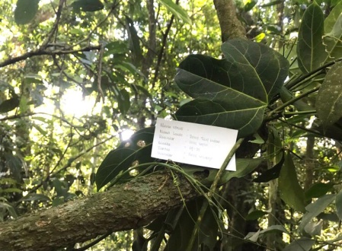

**Figure 1 Stay awake (*Hadgsonia macrocarpa* (Blume) Cogn.) :**

Fixed kadam (*Hadgsonia macrocarpa* (Blume) Cogn.), a characteristic of kadam fixed plants found in Lahat Regency are 3-lobed leaves, the upper surface of the leaves is green, woody stems, climbing and has branches that usually spread to large trees or plants around it. The Besemah tribe community uses kadam fixed plants to treat various kinds of infectious diseases. The stem is used to treat hepatitis, pneumonia and tuberculosis which is taken water from the stem while the fruit remains on the inside of the seed used to treat hepatitis.

According to (Swargiary & Brahma, 2017), *Hadgsonia* has antioxidant activity and has the potential to be developed because it has large seeds with high oil content. H seed oil*. macrocarpa* in Borneo is used to treat swelling in the chest (Perry & Metzger, 1980). The inside of the seeds in Negaland-India is used to treat bacterial infectious diseases of the feet (Changkija, 1999).

1. 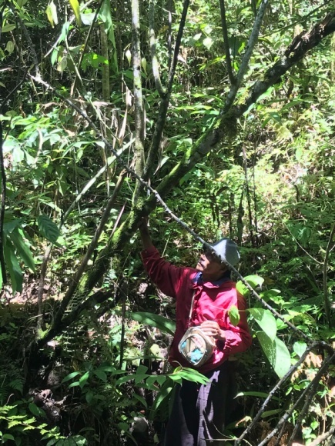**Tetungau (*Debregeasia longifolia* (Burm.f) Wedd)**

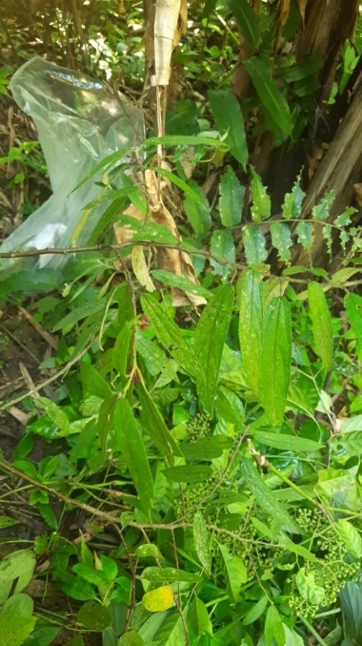**Figure 2 Tetungau (*Debregeasia longifolia*)**

Tetungau (*Debregeasia longifolia* (Burm.f) Wedd) It is a shrub found in moist forests, green leaves with leathery leaf texture and has orange-yellow fruits when ripe. According to (Mahmoud, 2019), *D. longifolia* belongs to the Urticaceae group, is a small tree with a height of about 5 m, whitish flowers, orange-yellow fruits when ripe, growing in moist shade. The leaves are dense, jagged, and the upper surface is green.

The Besemah tribe treats diarrheal diseases by cutting Mite stems and then collecting water and drinking. (Mahmoud, 2019), mentioned that *D. longifolia* contains phenolic compounds and flavonoids with potential antioxidant activity used by scabies, skin disease drugs, and digestive disorders. According to (Jamir, Tsurho, & Zhimomi, 2015), in Negaland-India utilizing the fruit and bark parts of *D. longifolia as a* digestive remedy and skin disease. According to (Bo, Hanqing, & Dayuan, 2003), in China the fruit of *D. longifolia* is edible and the root is used as an herbal remedy to cure rheumatism.

1. 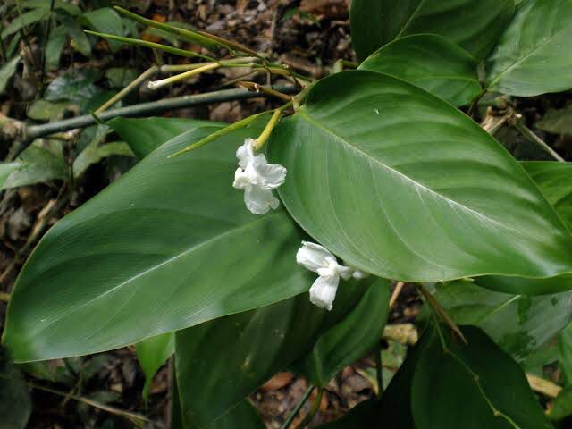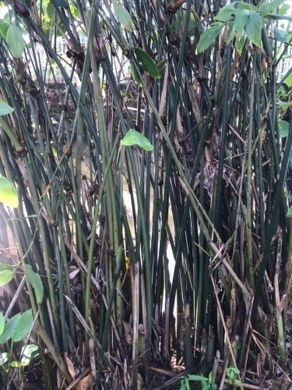**Parroting birds (Donax canniformis (G.Forst) K.Schum)**

**Figure 3 Tire burung (*Donax canniformis*)**

Bird bandaging (*D. canniformis*) herbaceous plants with a height of 1-2 m have rounded stems and dark green color, usually found in moist places, at the edge of water, and in forests. Single leaves of wide ovate shape to oblong. It has flowers with corola of white color. According to (Silalahi & Wakhidah, 2020), *D. canniformis comes* from Andaman Island. The stem is branched and produces many leaves. Petals 7–20 cm, base rounded, upper surface of leaves smooth dark green and lower surface light green and has white flowers.

The Besemah tribe people use the stem of *D. canniformis* to treat coughing up phlegm while the leaves are used to treat dengue fever. According to (Daud, Hassan, Hashim, & Taher, 2011), *D. canniformis* contains secondary metabolite compounds such as alkaloids, phenolics, flavonoids, glycosides, tannins, terpenoids, steroids, and saponins that are spread throughout the plant. The chemical content of flavonoids can capture free radicals that damage body cells, as anti-inflammatory, antioxidant, antibiotic substances that can prevent diseases due to viral / bacterial infections, and reduce stress.

According to the research of (Afifah, Mahrudin, & Irianti, 2022), the Bakumpai Dayak community in Bantuil Village utilizes the young leaves of *D. canniformis* to reduce eye and stem pain to treat coughs, canker sores, and fever. The people of Serampas Jambi use the fruit to treat abscesses (Hariyadi and Ticktin, 2012). In Malaysia using the stem part to treat fever (Ngah, 2011). In the Philippines a decoction *of D.canniformis*  root is used as an antidote to snake bites and blood poisoning, the juiced part of the root is used to fight fungal infections (Lachman, Mohamad, & Teo, 2003).

1. **Temperingat (*Rubus moluccanus* L.)**

Temperingat (*R. moluccanus* L.) used by the Besemah tribe community to treat cough disease by using part of the stem that is cut then floated water and drunk. Research that has been conducted by (Khoirunnisa & Ratnaningsih, 2016), temperingat (*R. moluccanus*) as one of the typical medicinal plants of the Besemah tribe, the stem part is believed by the community to treat cough disease and it is suspected that temperingat stem fluid in the vascular bundle has metabolite compounds.

According to (Bakar, Ismail, Isha, & Ling, 2016), *R.moluccanus* L. contains a wide variety of compounds such as phenolics, flavonoids, kerotenoids, and anthocyanins. Various compounds have been reported such as quinic acid, pyruvate, furfural, ß-tocopherol, γ-sitosterol, and hydroxymethylfurfural. This plant extract can be used as an antioxidant, antibacterial as well as antiacetylcholinesterase. This plant also has antifungal and anthelmintic activity comparable to standard drugs such as, amoxicillin, ketaconazole and albendazole (Anasuri, Damu, Pulipaka, & Tekurala, 2017).

1. **Tapal selembar (*Monophyllaea horsfieldii* R.Brown)**

Tapal selembar (*Monophyllaea horsfieldii* R.Brown) found wild in the forest of Sukamerindu District in a humid place. It has heart-shaped leaves, reinforced pinnate leaves, flat leaf edges, smooth leaf surface and dark green color, brownish spherical leaf stems, light green petioles, has fibrous roots and has white flowers. The characteristic that a sheet poultice has is that it has only one leaf in one stem and has flowers that grow above the base of the petiole. According to (Tsukaya, 1997), *Monophyllaea* is a plant that has only one leaf, a large leaf (about 30 cm long).

temperinggatt.jpg*SHEET POULTICE.jpg*merupakan tumbuhan yang termasuk kelompok Gesneriaceae. Banyak anggota dari Gesneriaceae namun yang diketahui kandungan kimianya baru sedikit. Sekitar 300 senyawa yang berhasil diisolasi dari spesies Gesneriaceae seperti flavonoid, lignan, steroid, xanton, fenolik, kuinon, terpen, dan glukosida fenolik. Beberapa spesies telah digunakan untuk pengobatan tradisional dan beberapa senyawa memiliki aktivitas biologis sebagai antimikroba, antioksidan, antiradang, dan antitumor.

1. 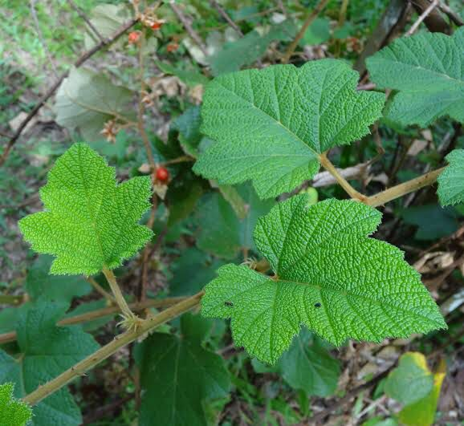 (b)

**Figure 4**

**a).Temperingat (*R. moluccanus*) b). Tapal selembar (*M. horsfieldii* sedingin hutan (*Fissistigma fulgens* (Hook.f & Thomson) Merr.)**

Sedingin hutan (*F. fulgens)* found wild in the forests of Sukamerindu District, has epiphytic habitats in other plants. As cold as the forest has a single leaf, the upper surface of the leaf is slippery, and baerwarna dark green with a tapered tip. The stem is woody, has a rounded shape and brownish color. According to (Rehman, Rehman, Naz, Mumtaz, & Jianglin, 2021), *F. fulgens* in Peninsular Malaysia is known for larak root, wrong forest root or sengolok root, this plant can usually be on top of trees with a height of 4-6 m and is sometimes found on forest edges. The upper surface of the leaves is green, the lower surface has fine hairs and brownish color. The flowers are fragrant with a melon-like aroma, the flower buds split into three petals like stars and are brown.

The Besemah tribe community uses the cold leaves of the forest to treat hepatitis by mixing the cold leaves with the leaves of the kepayang and then pasted, mentioned that it is cold in the forest as a typical medicinal plant of the Besemah tribe that can be used to treat lymph swelling and several types of cancer. In Malaysia, *Fissistigma*  leaves are boiled and used as a poultice (paste) to treat foot pain (Rehman et al., 2021). Studies on alkaloids of *F. fulgens* have been conducted by (Awang & Hadi, 2000), obtained compounds aporphine, alkaloids oxsoaporphine, protoberine, anonaine, argentinine, discretamine, liriodenine.

1. **Memaye (*Leea indica* (Burm.f.) Merr)**

Memaye (*L.indica*) is a shrub plant found in the forest. It has woody, branched, spherical stems. Compound leaves, jagged leaf edges, pointed leaf tips and green in color.Memaye is used by the Besemah tribe community for traditional medicinal materials, the root part of the memaye is used to treat hepatitis and the fruit part is used to treat warts. According to (Bangar et al., 2019) Phytochemical screening *of L. indica* shows that there are ingredients such as alkaloids, flavonoids, saponins, tannins, glycosides, and steroids. Traditionally *L. indica* can be used as an antibacterial, antidiarrheal, antinflammatory, dysentery, vertigo, antidiabetic, and skin disease drug. According to (Raghavendra et al., 2018), *L. indica* is widely used in traditional medicine in Indonesia and other countries such as Thailand, India, Nepal, and Malaysia to treat diseases such as diabetes, wounds, body aches, dysentery, fever, and fractures.

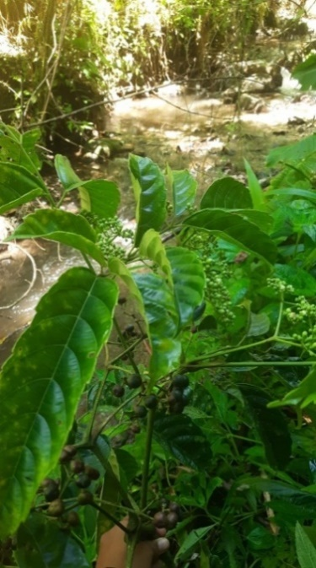

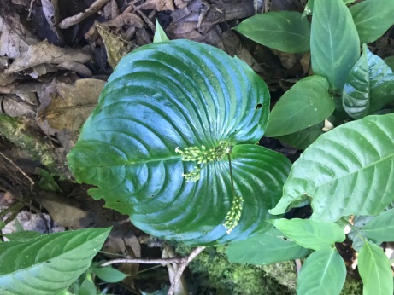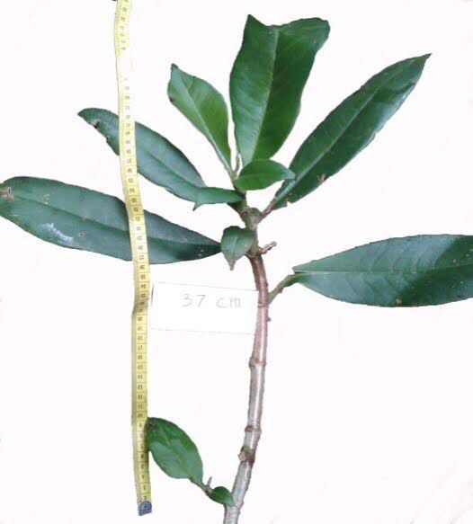

1. (b)

Figure 5. a). Sedingin hutan (*F. fulgens)*) b). Memaye (*L.indica*)

1. **How to Treat and Use Herbs and organs used**

The most widely used processing method is by boiling as many as 65 types or 46%, processing by boiling is believed by the Besemah tribe community that the content contained in plant parts will come out more optimally if used as medicine. According to (Sukarniati, 2021), processing by boiling is safer because it can kill germs, bacteria or pathogens in plants and compounds contained in plants come out more. In addition, the boiling process can reduce the bland and bitter taste compared to being eaten directly.

**Figure 6 Percentage of processing and use methods**

The most widely used method is by drinking, which is 83 types of plants by 53% and the least way of use, which is soaked and stepped on only 1 type of plant. According to (Riconadi et al., 2020), The use of medicinal plants by drinking is used for treatment from within the body and is believed to show a faster reaction in healing a disease because the active compounds of plants taken are more quickly absorbed by the body. The use of medicinal plants by stepping on the foot used by the Besemah tribe community is different from other regions, so that the method of use becomes typical of the Besemah tribe. Medicinal plants used by stepping on the bark of dedap stems and eggplant oil are roasted and then stepped on to treat elephantiasis.

.

**Figure 7 Medicinal plant parts used by the Besemah tribe community**

The most widely used plant part is the leaf part which is 38%. The leaves are often used in traditional medicine because they are easier to obtain and the processing process using the leaves is easier. According to (Rizal, Kartika, & Septia, 2021), the use of leaf parts in traditional medicine, whether it is processing or compounding medicinal materials, is easier than stems, roots, rhizomes or other parts. Leaves are easy to find. In addition, the use of leaves will not damage other parts of the plant because the leaves are easy to grow back and can be used sustainably.

**Conclusion**

Based on the results of the research that has been done, the following conclusions are obtained medicinal plants obtained as many as 94 species of plants from 47 families to treat 29 types of infectious diseases. Typical plants of the Besemah tribe are still kadam *(Hadgsonia macrocarpa* (Blume) Cogn.), temite (*Debregeasia longifolia* (Burm.f) Wedd), bird banning (*Donax canniformis* (G.Forst) K.Schum), temperingat (*Rubus moluccanus*  L.), sheet poultice (*Monophyllaea horsfieldii* R.Brown), forest cold (*Fissistigma fulgens (*Hook.f &; Thomson) Merr.), memaye (*Leea indica* (Burm.f.) Merr), and the typical way of use is stepped on and the typical way of processing the stem is cut, the water is collected and drunk directly. The most processing method is by boiling (46%) and the most use method by drinking (53%).

**References**

Afifah, Khoirus Esti, Mahrudin, Mahrudin, & Irianti, Riya. (2022). Kajian Etnobotani Donax canniformis K. Schum.(Bamban) Di Suku Dayak Bakumpai Desa Bantuil Kabupaten Barito Kuala Berbentuk Buku Ilmiah Populer. *JUPEIS: Jurnal Pendidikan dan Ilmu Sosial*, *1*(4), 81–90.

Anasuri, Santhosh, Damu, Uma Shankar, Pulipaka, Shankaraiah, & Tekurala, Madhuri. (2017). Phytochemical investigation and antimicrobial anthelmintic activities of the leaves of Rubus moluccanus Linn. *Journal of Pharmacognosy and Phytochemistry*, *6*(6), 1392–1396.

Awang, Khalijah, & Hadi, A. Hamid A. (2000). Alkaloids From Fissistigma Fulgens Merr.(Annonaceae). *Malaysian Journal of Science*, *19*, 41–44.

Bakar, Mohd Fadzelly Abu, Ismail, Nur Amalina, Isha, Azizul, & Ling, Angelina Lee Mei. (2016). Phytochemical composition and biological activities of selected wild berries (Rubus moluccanus L., R. fraxinifolius Poir., and R. alpestris Blume). *Evidence-based Complementary and Alternative Medicine: Ecam*, *2016*.

Bangar, Pooja, Chaudhury, Ashok, Tiwari, Bhavana, Kumar, Sanjay, Kumari, Ratna, & Bhat, Kangila Venkataramana. (2019). Morphophysiological and biochemical response of mungbean [Vigna radiata (L.) Wilczek] varieties at different developmental stages under drought stress. *Turkish Journal of Biology*, *43*(1), 58–69.

Bedur, Marzuki, Pascal, Eka, & Suan, Ahmad Bastari. (2005). Sejarah Besemah: dari zaman Megalitikum, Lampit Mpat Mardike Duwe, Sindang Mardike ke kota perjuangan. *(No Title)*.

Bo, Qin, Hanqing, Wang, & Dayuan, Zhu. (2003). Investigation on the chemical constituents of Debregeasia longifolia. *Natural Product Research and Development*, *15*(1), 21–23.

Changkija, Sapu. (1999). Folk medicinal plants of the Nagas in India. *Asian folklore studies*, 205–230.

Daud, Jamaludin Mohd, Hassan, Husna Hawa Mohd, Hashim, Ridzwan, & Taher, Muhammad. (2011). Phytochemicals screening and antioxidant activities of Malaysian Donax grandis extracts. *European Journal of Scientific Research*, *61*(4), 572–577.

Jamir, H., Tsurho, Kruolalie, & Zhimomi, Atoka. (2015). Some indigenous medicinal plants and its uses in zunheboto district, Nagaland. *Int J Dev Res*, *5*, 5195–5200.

Khoirunnisa, Adzmi, & Ratnaningsih, Ika Zenita. (2016). Optimisme dan kesejahteraan psikologis pada mahasiswa pendidikan dokter Fakultas Kedokteran Universitas Diponegoro. *Jurnal empati*, *5*(1), 1–4.

Lachman, T., Mohamad, T. R., & Teo, S. P. (2003). Sensorless position estimation of switched reluctance motors using artificial neural networks. *IEEE International Conference on Robotics, Intelligent Systems and Signal Processing, 2003. Proceedings. 2003*, *1*, 220–225. IEEE.

Mahmoud, Nuha Mohamed Osman. (2019). Debregeasia longifolia: biochemistry, functions and utilization. *Wild fruits: composition, nutritional value and products*, 371–377.

Ngah, Tok. (2011). Characterization of plant resource at Kampung Parit. *Scientific Research and Essays*, *6*(13), 2606–2618.

Novard, M. Fadila Arie, Suharti, Netti, & Rasyid, Roslaili. (2019). Gambaran bakteri penyebab infeksi pada anak berdasarkan jenis spesimen dan pola resistensinya di laboratorium RSUP Dr. M. Djamil Padang tahun 2014-2016. *Jurnal Kesehatan Andalas*, *8*(2S), 26–32.

Perry, Lily May, & Metzger, Judith. (1980). *Medicinal plants of east and southeast Asia: attributed properties and uses.* MIT press.

Raghavendra, U., Fujita, Hamido, Bhandary, Sulatha V, Gudigar, Anjan, Tan, Jen Hong, & Acharya, U. Rajendra. (2018). Deep convolution neural network for accurate diagnosis of glaucoma using digital fundus images. *Information Sciences*, *441*, 41–49.

Rehman, Shazia, Rehman, Nadia, Naz, Mehvish, Mumtaz, Ayesha, & Jianglin, Zhang. (2021). Application of grey-based SWARA and COPRAS techniques in disease mortality risk assessment. *Journal of healthcare engineering*, *2021*.

Riconadi, Riconadi, Arbiastutie, Yanieta, Mariani, Yeni, Sisillia, Lolyta, & Yusro, Fathul. (2020). Studi pemanfaatan tumbuhan obat sebagai tonik oleh pengobat tradisional di Desa Karya Bakti Kecamatan Sungai Betung Kabupaten Bengkayang. *Jurnal Hutan Lestari*, *8*(3).

Rizal, Syamsul, Kartika, Trimin, & Septia, Ghina Aulia. (2021). Studi Etnobotani Tumbuhan Obat di Desa Pagar Ruyung Kecamatan Kota Agung Kabupaten Lahat Sumatera Selatan. *Sainmatika: Jurnal Ilmiah Matematika dan Ilmu Pengetahuan Alam*, *18*(2), 222–230.

Sarumaha, Murnihati. (2019). Studi Etnobotani Tanaman Obat Keluarga di Desa Bawolowalani Kecamatan Telukdalam Kabupaten Nias Selatan. *Jurnal Education and development*, *7*(4), 266.

Silalahi, Marina, & Wakhidah, Anisatu Z. (2020). Donax canniformis (G. Forst.) K. Schum. Marantaceae. *Ethnobotany of the Mountain Regions of Southeast Asia*, 1–8.

Sukarniati, Lestari. (2021). Determinants of Local Original Income The Era of Special Autonomy for the Government. *Universitas*, *11*(1), 93–107.

Swargiary, A., & Brahma, D. (2017). Phytochemical analysis and antioxidant activity of Hodgsonia heteroclita (Roxb). *Indian J Pharm Sci*, *79*(2), 212–219.

Tsukaya, Hirokazu. (1997). Determination of the unequal fate of cotyledons of a one-leaf plant, Monophyllaea. *Development*, *124*(7), 1275–1280.

Widiastuti, Tri Cahyani, Kiromah, Naelaz Zukhruf Wakhidatul, & Ledianasari, L. (2017). Identifikasi etnobotani tanaman obat yang dimanfaatkan oleh masyarakat kecamatan Sempor kabupaten Kebumen. *Jurnal Ilmiah Kesehatan Keperawatan*, *13*(2).