EXTRACT DATE JUICE AND HEALTHY DATE MILK

**Aditya Wulung1, Prakoso Arifin2**

1,2 Universitas Al-Azhar Jakarta, Indonesia

E-mail: [adityaw243@gmail.com](mailto:adityaw243@gmail.com), [Prakoso3438@gmail.com](mailto:Prakoso3438@gmail.com)

* Correspondence: [adityaw243@gmail.com](mailto:adityaw243@gmail.com)

|  |  |
| --- | --- |
| **KEYWORDS** | **ABSTRACT** |
| Extract date juice; Healthy date milk, entrepreneur | The entrepreneurial potential of date juice and date milk in Indonesia is very large, because there are so many benefits for the health of the body and the word dates are synonymous with Islam, Indonesia has a Muslim majority population. This entrepreneurial project also wants to explain how healthy the content of date palm juice is. Drinking date juice every day is very good, which will provide nutrition throughout the day. The benefits of dates, as raw materials for date juice and date milk for body health are numerous, namely (Source: USDA National Nutrient Data Base) supporting bone health and strength, overcoming intestinal disorders, helping to treat anemia, tackling allergies, assisting in the recovery process for dengue fever. , energy booster, maintaining a healthy nervous system, improving memory and brain work systems, preventing insomnia, maintaining heart health, controlling diarrhea, preventing stomach cancer, source of antioxidants, prevent blood clots. The aim of this entrepreneurial project is to present and introduce and make the culture of drinking healthy drinks, namely date milk or date juice, a daily drink. The choice of date milk and date juice products apart from the many benefits, the products have the advantage of being ready to drink both date milk and date juice which are still fresh. |
|  |
|  | Attribution-ShareAlike 4.0 International (CC BY-SA 4.0)  **[https://jurnal.syntax-idea.co.id/public/site/images/idea/88x31.png](https://creativecommons.org/licenses/by-sa/4.0/)** |

**Introduction**

Sales of dates in Indonesia are very large and scattered in various regions. The opportunity for business opportunities based on date raw materials is very large, this has become a motivational trigger for the author to carry out an entrepreneurial project selling date juice and date milk.

Date milk has been widely circulated in the market, but most of it is still on a household or homemade scale because this drink has a very short shelf life, namely 6-10 hours at room temperature, 2-4 weeks in the refrigerator and 1-2 months in the freezer. Most of the palm juice circulating in the market is in the form of a thick concentrate and drink it mixed with water first. While the product that the author presents is date juice in ready-to-drink form without preservatives.

The author will promote the benefits of date milk and date juice as well as the benefits of dates. Sales of date milk and date juice products will be carried out both offline and online and in such a way as other drinks at mall outlets, whats app groups, groups and restaurants and others.

The opportunity to sell this drink is huge because drinks based on fruit raw materials are also in great demand, even contemporary drinks made from tea or artificial sweeteners, whose benefits are very far from date milk and date juice are selling well in malls(Abdelzaher Radwan, El-Salhy, Mostafa, & Ali, 2022).

The challenge is to produce date milk and date juice in a medium capacity scale, namely 10-30 liters at a time. Because the existing equipment can only produce 1.5 liters.

There are several brands of date milk that already exist, but we took 4 (four) brands, those are:

1. Kurlaban

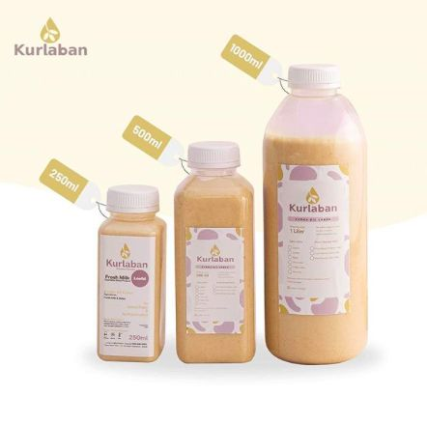

Date milk with flavour are original regal, coffee latte and earl gray. It can be purchased through resellers or directly online to Instagram. Available in 250 ml, 500 ml and 1000 ml sizes.

2. Susu Kurma Bazzel

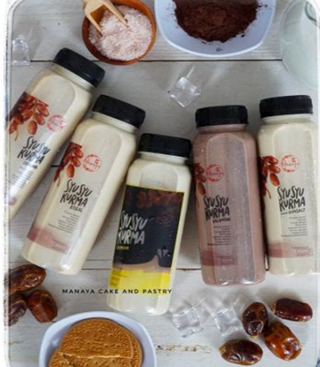

Susu kurma ini dibuat dengan beberapa jenis kurma. Di antaranya kurma majdool, ajwa, dan sukari.

Date milk is available in 250 ml and 500 ml, original and regal flavors. Purchases can be via Instagram and WhatsApp.

3. Sushu Kitchen

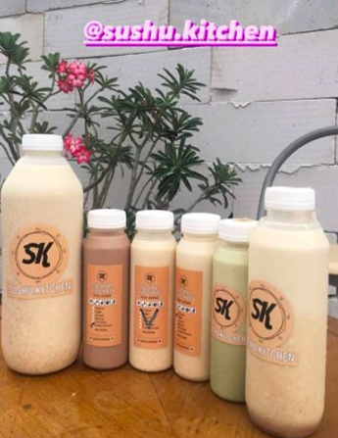

This date milk is made with original, almond, chocolate, matcha and biscuits flavors. There is a choice of 250 ml, 500 ml and 1000 ml of date milk. The price of date milk here starts from IDR 15,000 for a 250 ml size to IDR 65,000 for a 1000 milliliter package.

4. Sukurbee

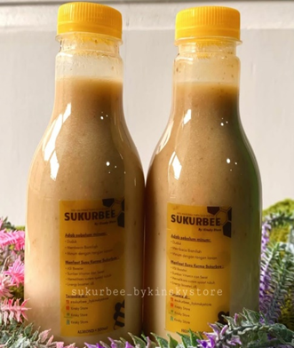

Sukurbee is home-made date milk, there are 2 flavors, namely almond and honey bee. Meet the needs of daily energy intake, the price of Rp. 18,000 (250ml), Storage time:

In Freezer: 1-2 Months

In Refrigeration: 2-4 Weeks

In Room Temperature: 6 Hours

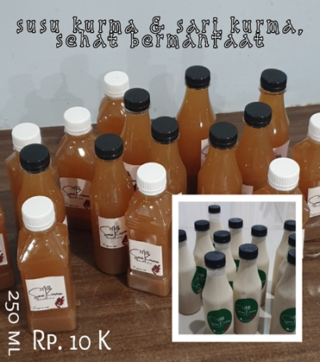

Adt date milk is date milk made with the composition of sukari dates, UHT fresh milk and honey. No preservatives with the right and hygienic composition. Suitable for consumption every day to increase the intake of nutrients needed by the body, the original taste costs Rp. 10,000 for a 250 ml pack, Storage information: Room temperature 8 hours, in the fridge 20 – 30 days and freezer 45 – 60 days. Equipped with legal aspects of halal label licensing, P-IRT (Home Industry Food) and BPOM (National Agency of Drug and Food Control).

The difference between existing date milk products and the Adt brand is the legal aspect of licensing where the existing products do not yet have halal label certification, P-IRT and BPOM while Adt will be equipped with the certificate.

**Benefits of having permission of PIRT, Halal and BPOM**

Every product that is intentionally produced, whether on a small or large scale, should have a permit. Because it will be related to the legal aspect of the product itself. When it comes to the benefits of PIRT, Halal and BPOM permits, of course there are a number of things to be gained, namely:

1. Fulfilling the Legality Aspect

The first benefit that will be obtained is the ownership of permits (both PIRT, Halal and BPOM), making the product fulfill the legality aspect. Of course we all understand how important it is to pay attention to the legality of a product. Because products that are legal and have permission are certainly classified as products that are safe to use.

1. Increasing Consumer Confidence in Products

Ideally, consumers will choose products that they believe are safe for use or consumption. This can be obtained if the product has a permit, either in the form of PIRT, Halal and BPOM. If the product is classified on a large scale, then halal and BPOM are indicators that consumers always pay attention to. Therefore, ownership of product permits will help increase consumer confidence in the product itself. This also ultimately affects the level of product sales in the market.

1. Become an Indicator of Product Quality

The third benefit that is no less important is that the ownership of the permit will become part of the product quality indicator. Why is that? Because in order to obtain permits, both halal and BPOM, of course these products must be produced in clear procedures and meet standards. So indirectly this gives an indication that the product has met standardization and quality.

**Extract Dates juice**

There are several brands of date juice that already exist, but the author takes 4 (four) brands, namely:

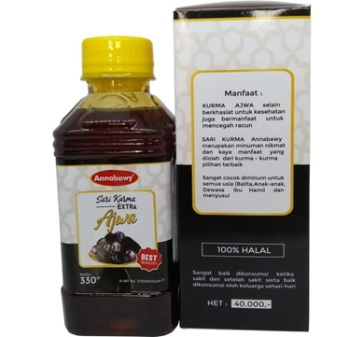

1. Extract Kurma Ajwa Juice

Date juice without added sugar, for those of you who love sweet taste, there's nothing wrong with replacing sugar consumption with this one date juice. The sweet taste produced by date juice without added sugar comes from Ajwa dates which are known as premium dates. By consuming this Ajwa date juice produced by Annabawy, you can control blood sugar without sacrificing the sweet taste. Starting from IDR 24,000.00, fill in 330 gr.

1. Extract Kurma Platinum

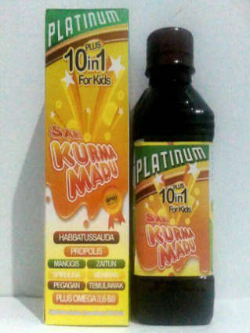

Some parents have problems with children who have difficulty eating. This is certainly not good for growth. Don't worry, just give this date juice from Al Jazira to your child. Enriched with buffoonery, this product can increase your little one's appetite, especially for children aged 1 year. So, you could say this date juice is effective for increasing their weight. Prices start from Rp. 23,000 (360 gr).

1. Extract Kurma Amira

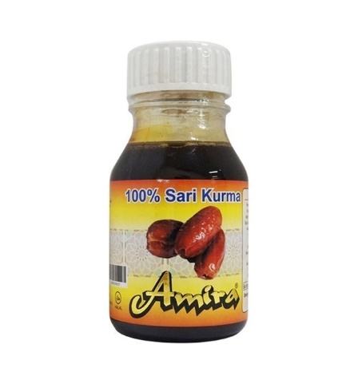

When fasting, sometimes the body feels weak, especially during the day. So that the body stays strong when fasting, try to consume Amira date juice at dawn and breaking the fast. This product is a very good source of energy during fasting because it can provide ready-to-use energy quickly.

The nutritional content of date palm juice is also quite high. That way, this product is very good for consumption by those of you who have busy activities. You also become more excited about the day, and don't get tired easily. Price Rp. 65,000 (350 gr).

1. Extract Dates Honey

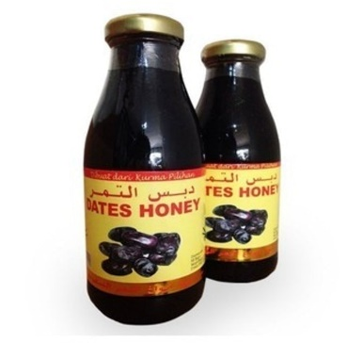

Dates honey has the largest packaging among other products. So, this product is perfect for those of you who need date juice to be consumed by all family members. You don't need to restock repeatedly, okay? Price Rp. 27,000 (624 gr)

Regarding quality, there is no doubt about this palm juice! Apart from being packaged in glass bottles, this product uses real dates as its raw material. In fact, this palm juice is also equipped with HACCP certification. The certificate is proof that the raw materials for this product are safe and free of harmful substances for the body

The difference between the existing date juice products and the Adt brand is that the existing product is in a thick form so it cannot be consumed directly but must be mixed with water first, while the Adt brand products are in a dilute form and can be drunk immediately so it is practical and can be carried like a drink in general

.

**Project Plan and Excellence**

Dates as a raw material for date juice and date milk are types that have many benefits, taste good and are competitively priced. Packaging of date essence and date milk which will be made in the form of rectangular or round bottles with standard food grade, 250 ml packaging is suitable for one drink, in the future it will be equipped with a halal label or BPOM permit

Every entrepreneur is required to carry out analysis, strategy and must know the conditions in the market, the advantages and disadvantages, one of the methods is by conducting a SWOT analysis, which is shown in table 1 below.

Table 1. Entrepreneurial SWOT Analysis

|  |  |
| --- | --- |
| **Strength** | **Weakness** |
| hygienic packaging | New arrivals |
| complete licensing | Not popular |
| competitive price | Community support is still low |
| healthy, useful |  |
| **Opportunity** | **Throat** |
| Market share is huge | Low mentality and spirit |
| synonymous with Muslims | Big investors and strong networks |
| IT technology and social media are very supportive |  |
| local product |  |

**Research Methods**

**Implementation**

Production plan

A. Raw materials and equipment

1) Sukari dates or the like as much as 250 grams

2) 250 ml plastic bottles, 10 bottles in total

3) Honey, to taste

4) Mineral water, as much as 3 liters

5) Gas stove, one with two burners

6) Fine sieve, one fruit

7) Stirrer, one fruit

B. Location

The manufacturing location is currently being carried out at home, namely in the Kemang Pratama Bekasi area, in the future if it develops and becomes large it will be carried out in a shophouse in the Jakasetia Bekasi area, with equipment, such as stoves, blenders and others.

C. Production Process

After the raw materials are available in the production area, the production stages are as follows with a production base of 10 bottles.

1. The process of producing date milk

1. Peel the seeds of dates 30 minutes
2. Dates are boiled for 2 hours, then drained
3. Then blended, the time needed for the blender process is 20-30 minutes, then filtered for 5 (five) minutes.
4. The rest of the filter is blended again and mixed with the results of the first filter, added UHT milk and honey for 5 minutes.
5. The result of the blender is filtered again and poured into a 250 ml bottle, 45 minutes

2. Palm juice production process

1. Peel the seeds of dates 30 minutes
2. Dates are boiled for 30-40 minutes, then filtered
3. The rest of the filter is boiled again for 20 minutes and mixed with the results of the first filter.
4. Then filtered again, pressed (press) until all the water comes out into the container, then poured into a 250 ml bottle, 5 (five) minutes.

**Results and Discussion**

**Production Process Realization**

At the practical stage of implementing entrepreneurial projects there are slight differences and changing the production process for cost and time efficiency and does not reduce product quality(Ali, Al-Khalifa, Farouk, & Shaheen, 2018). Changes in the production process include date milk and date juice. These changes are as follows:

* 1. Peel the seeds of dates about 3 minutes
  2. The dates are boiled after the water boils, the stove is turned off and left to stand until the temperature drops to 40 degrees C, then drained.
  3. Then blended and filtered process.
  4. The rest of the filter is blended again and mixed with the results of the first filter, added UHT milk and honey for making date milk.
  5. The results of the blender are filtered again and poured into 250 ml bottles, 30 minutes for 100 bottles.

For making date juice, after the temperature drops to 40 degrees C, it is poured into a container and pressed (pressed) until all the water is separated from the dates..

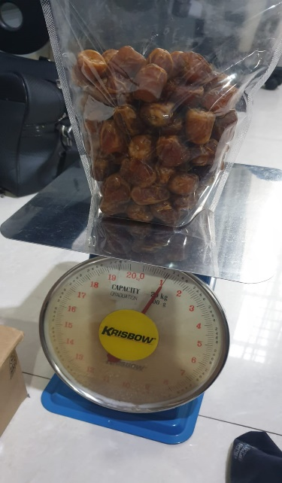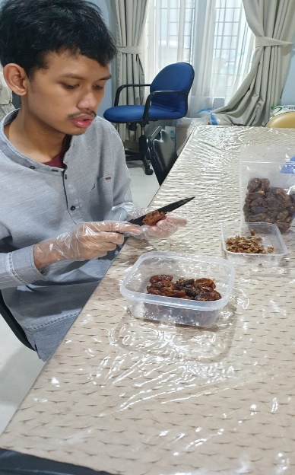

Figure 1. Preparatory Steps for Weighing and Peeling Dates

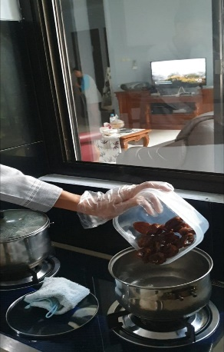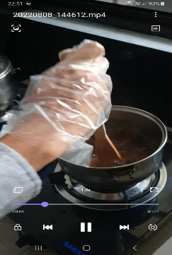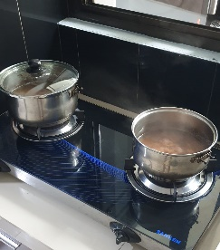

Figure 2. Process of Boiling Dates

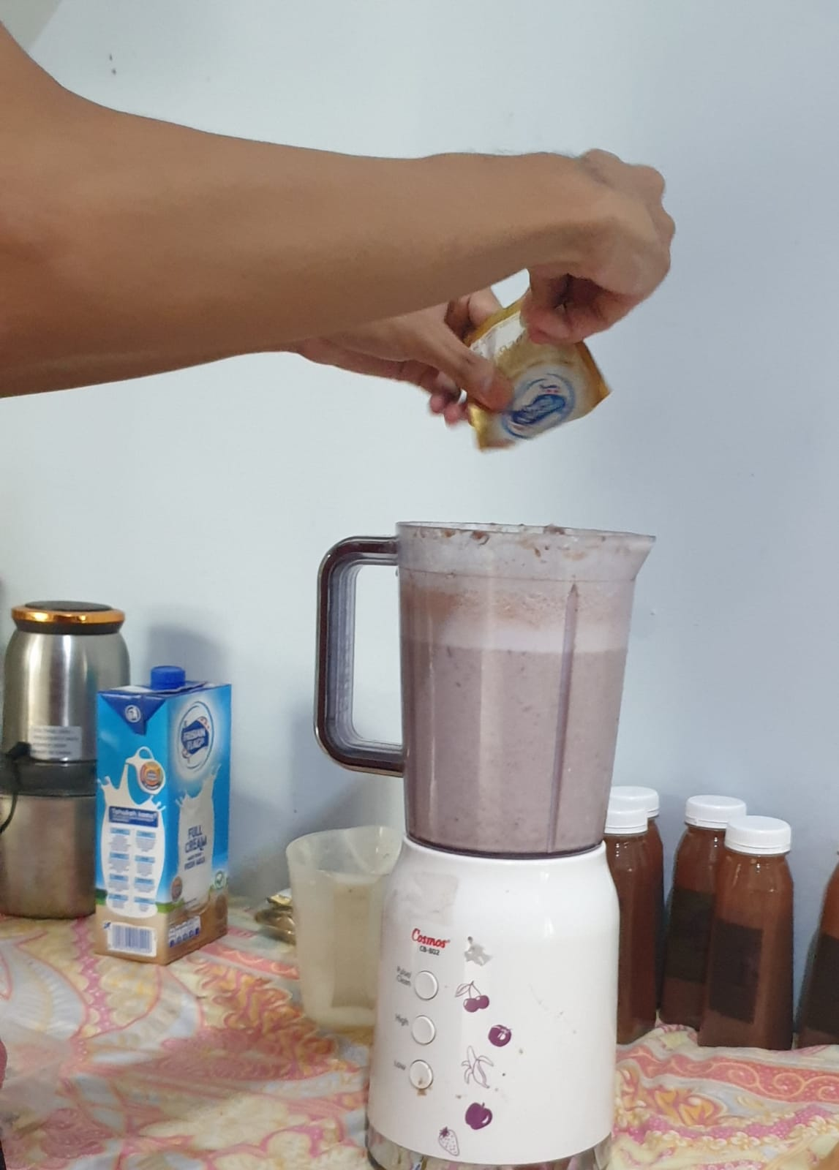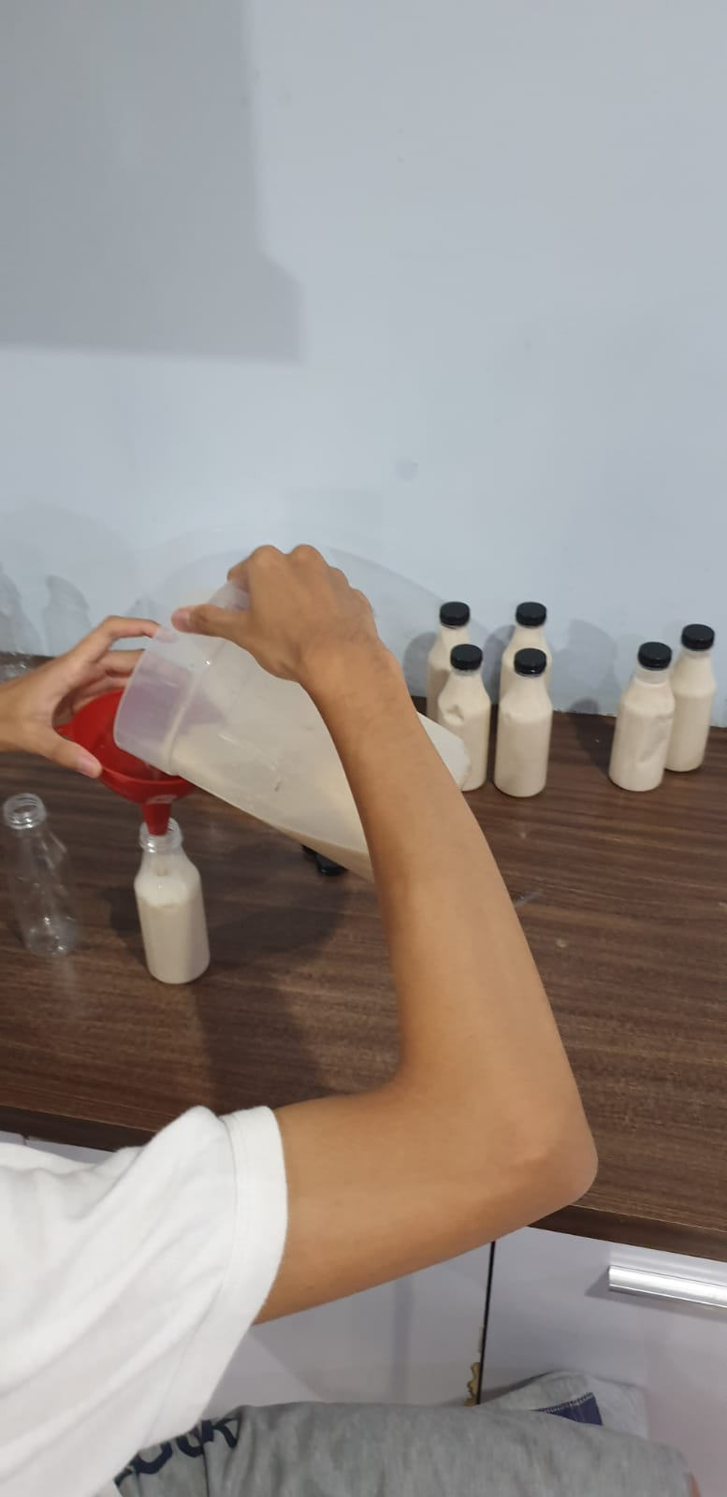

Figure 3. Blender process and filling into the bottle

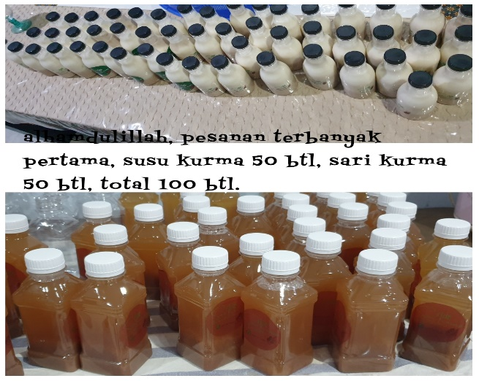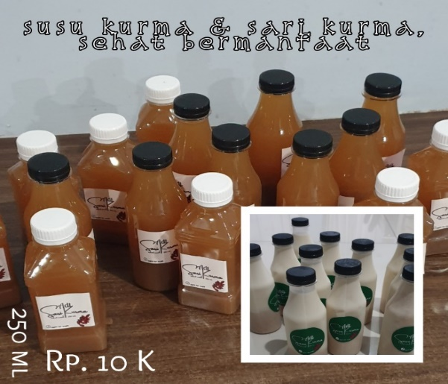

Figure 4. Production of Date Sari and Date Milk

**Promotion and Marketing**

After the entrepreneurial project is implemented, a real promotion is carried out by sending it to the WhatsApp group, line and Instagram in the form of an offer flyer, the promotion also asks for testimonials. Providing a 50% discount price, free shipping for free testers during soccer and English outdoor class events. Ask consumers to give testimonials about the taste and quality of this date juice and date milk after drinking it. Sales through offline and online as well as the mosque community, residents, friends.

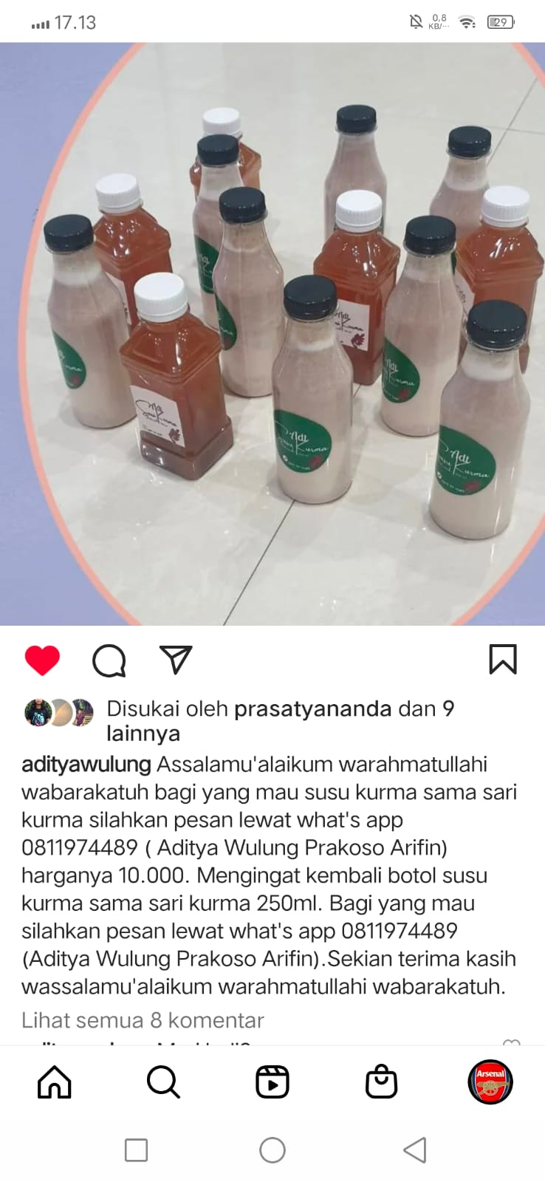

Figure 5. Promotion and Marketing via Instagram

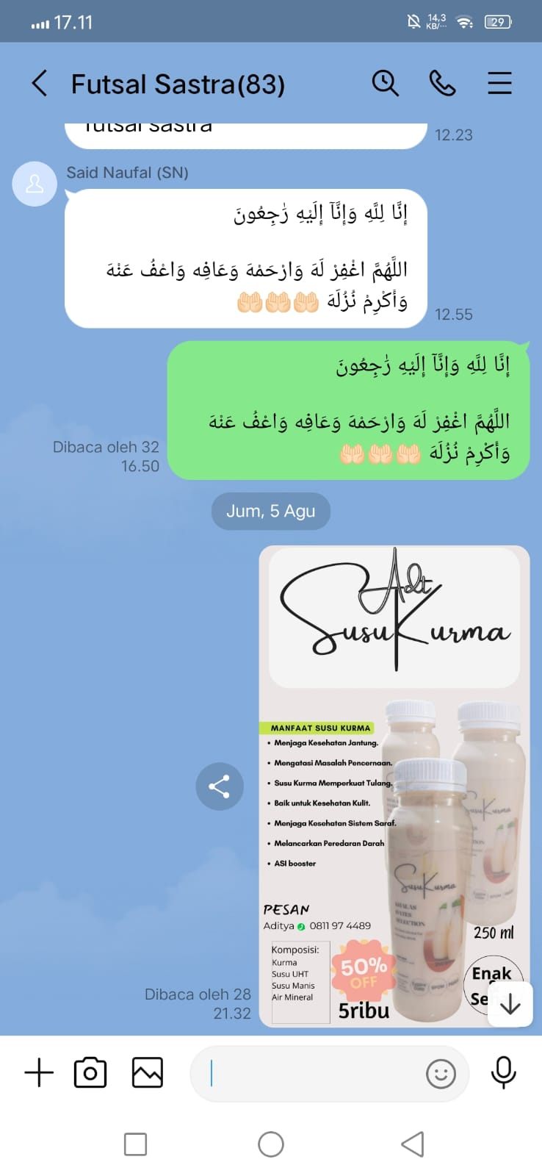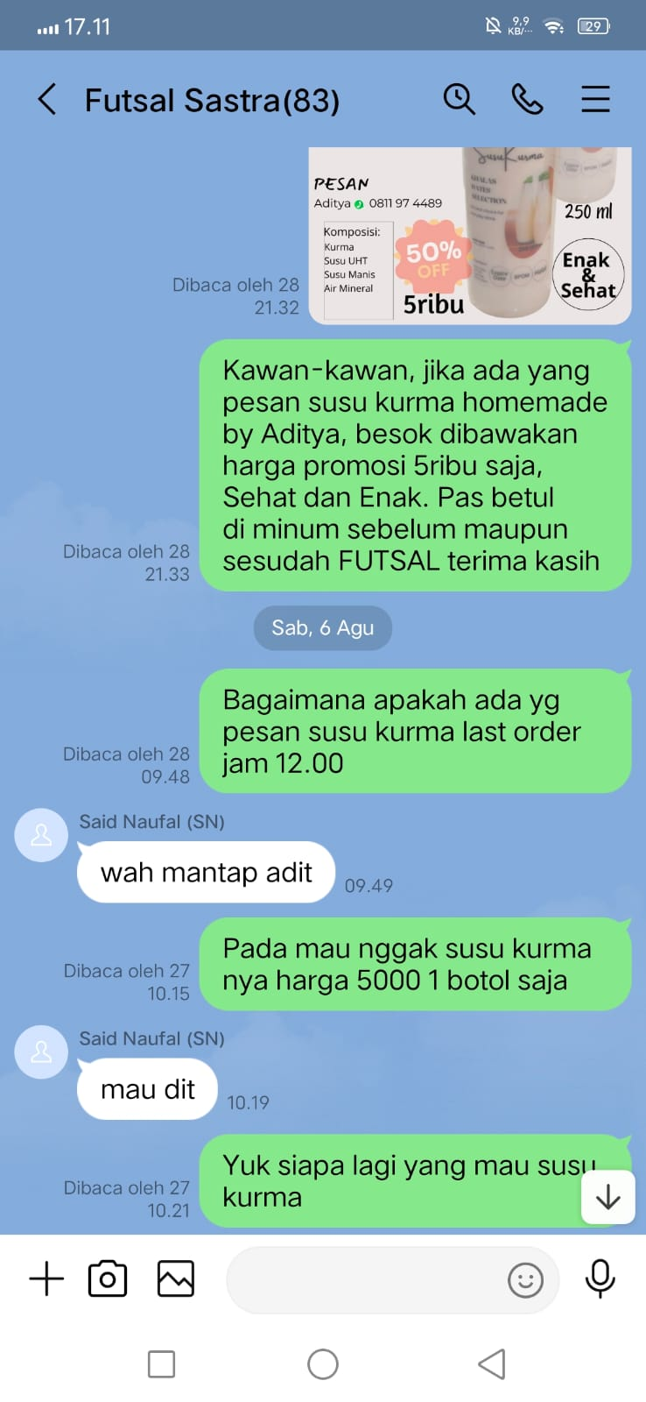

Figure 6. Promotion and Marketing via Line



Figure 7. Promotion and Marketing via Whatsapp

**Target Market Segment**

Sari Kurma, synonymous with Muslims so consumers in general are Muslims. In fact, after carrying out promotions and sales, there were several market segments that could not be realized, such as a study on the dawn of consumption that had been provided by the mosque committee, as well as other market segments that could not be followed in the August-December period.

The author has carried out promotions and sales through online media and the most effective is WhatsApp because this media is a combination of online and offline. The author meets and socializes and then offers consumers via whatsapp. The market segment for the dhuha recitation event is also effective because there are a large number of attendees and through the study coordinator offered date juice and date milk at a discounted price.

**Sales Summary**

Table 2. Sales Summary

|  |  |  |  |  |  |
| --- | --- | --- | --- | --- | --- |
|  | Month-Year | spending capital | Omzet | Profit | Balance |
| 1 | Agustus 2022 | 280.000 | 390.000 | 110.000 | 110.000 |
| 2 | September 2022 | 0 | 0 | 0 | 0 |
| 3 | Oktober 2022 | 1.163.500 | 1.790.000 | 626.500 | 626.500 |
| 4 | November | 1.111.500 | 1.710.000 | 598.500 | 598.500 |
| 5 | Desember | 770.000 | 1.100.000 | 330.000 | 330.000 |
|  |  | Total | 4.990.000 | 1.665.000 | 1.665.000 |

From the recapitulation data, it is obtained that total sales (turnover) for 5 months with effective sales of 4 months because September is a semester break, the recapitulation is Rp. 4,990,000 with a profit of Rp. 1,665,000 about 30%.

Whereas at the time of the proposal the total target for 6 months was IDR 10,437,500 with details

Packing Dates = Rp. 2.000.000

Date milk = Rp. 4.687.000

Sari date = Rp. 3.750.000

The entrepreneurial project of healthy palm juice and date milk does not sell packing of dates because the added value is small, so if sales of packing of dates are omitted the target of date milk and date juice is Rp. 8,437,000 and this is sales for 6 months so the average per month is Rp.1,407,000. x 4 = Rp. 5,628,000.

Entrepreneur sales of date juice and healthy date milk for 4 months is IDR 4,990,000, vs the proposal target of IDR 5,628,000 = (IDR 4,990,000/ IDR 5,628,000) x 100 = 88.7% is still good enough for entrepreneurs beginner.

**Conclusion**

Based on the results and discussion of the research, it can be concluded that the mission and goals of making healthy palm juice and date milk are achieved which are healthy and beneficial drinks(Muzaifa, Lubis, & Arifullah, 2019). Beverages that have been widely circulated in the market are generally made on a home or homemade scale. if the equipment and marketing system are well formed then production on a large scale can be carried out. By looking at the current situation which is the current drink trend, date juice and date milk are very likely to become favorite drinks because they contain great benefits for the body's nutritional needs.

**References**

Abdelzaher Radwan, Essam, El-Salhy, Abd El Fattah, Mostafa, Rafat, & Ali, Ahmed. (2022). Effect of Spraying Some Nutrients on Fruiting of Sewy Date palm (Phoenix dactylifera L.) Under New Valley Conditions. *New Valley Journal of Agricultural Science*, *2*(3), 158–168.

Ali, Hatem, Al-Khalifa, Abdel Rahman, Farouk, Amr, & Shaheen, Mohamed. (2018). Effect of maturation stages on flavor profile and antioxidant activity of date palm fruits (Phoenix dactylifera) grown in Saudi Arabia. *International Journal of Pharmacology*, *14*(3), 407–414.

Muzaifa, Murna, Lubis, Yanti Meldasari, & Arifullah, M. (2019). Kajian Pembuatan Infused Water dari Buah Kurma (Phoenix dactylifera) dengan Penambahan Jeruk Nipis (Citrus aurantiifolia). *Jurnal Teknologi Dan Industri Pertanian Indonesia*, *11*(2), 84–89.

<https://inibaru.id/hits/bukan-arab-inilah-negara-penghasil-kurma-terbesar-di-dunia>

<https://food.detik.com/info-kuliner/d-5245220/5-rekomendasi-tempat-beli-susu-kurma-yang-manis-gurih>

<https://www.orami.co.id/magazine/manfaat-sari-kurma>.